Construction Professional Services 2 (CPS2) RM6356

Supplier Engagement Session 13th May 2025

Supporting Annex documents

All of the questions from the supplier engagement session held on 13th May (as well as those emailed after the webinar) have been downloaded and answers provided. Questions have been grouped together for ease.

The responses provided reflect our current position. This information is provided in good faith to provide prospective suppliers with information and data about the CPS2 agreement and does not constitute a firm commitment or promise

The final requirements for the procurement will be published in the Invitation to Tender, and no information published here shall supersede the published procurement documentation.

As part of our ongoing market engagement, we welcome questions and feedback from interested bidders and we will continue to regularly update this Q&A log. To ensure we can respond in a timely and consistent manner please note the deadline for submitting questions during the market engagement phase will be 30th June 2025.

Contents

Annex A : Technical ability certificate 2
Annex B : Who can bid? 8
Annex C : Draft Slides 13
Annex D : DPS Agreements vs Frameworks 19
Annex E : Acronyms 21

Annex A : Technical ability certificate
Further information on the TAC process will be outlined in the planned 'how to tender' webinar and full details will be provided in the final tender pack.

We have provided the exemplar template to allow bidders to familiarise themselves.

Please note: This is just an example template for information only. The final requirements for the TAC will be published in the Invitation to Tender, and no information published here shall supersede the published procurement documentation.

Attachment 2b [Lot 1] Technical ability certificate
RM[xxxx] [insert procurement title]
Instructions
We require you to demonstrate that you have delivered the services within the scope of this requirement. For the assessment of your technical ability the relevant services are listed within section A of this technical ability certificate (TAC). You are required to submit [enter number required] certificate[s][for lot 1].
You are required to complete section A.
The customer must verify that the information you have provided in section A is true and accurate by completing and signing section B.
The form of the TAC is set out below.
You must submit the completed certificate(s)[for lot 1] by uploading to question [x.xx.x] within the online procurement specific questionnaire (PSQ) in the eSourcing tool (qualification envelope).
Please note that we reserve the right to contact the customer listed in the certificate to verify the information provided. You must notify the customer that they may be contacted by us.
Mandatory requirements
- the TAC must evidence a contract that you have delivered in the 3 years prior to the publication of the tender notice for this competition[, or an ongoing contract you are currently delivering that has been ongoing for a minimum of six months].
- for the avoidance of doubt, the TAC must evidence a contract that started after (Enter date 3 years prior to contract notice)
- [if the contract is ongoing you must be delivering the services. You cannot use a contract where you have not yet started to deliver the services].
- the TAC must evidence a contract with a minimum value of [enter value] (ex VAT).
- [projects only need to have been completed within the time limit stated above. It is acceptable for the project to have commenced prior to [enter date 3 years prior to the publication of the tender notice].
- [contracts must have been successful in implementation and mobilisation and have become operational].
- [contracts must have clearly demonstrated services for which the supplier is in sole control of all underlying infrastructure and technologies (with the exception of some third party subscription services made available to the customer and directly related to the Services listed in section A)].
- [contracts must demonstrate at least [enter the minimum number of services the supplier is required to select] of the services listed in section A].
- the contract can be from the public, private, or Third Sector (e.g. charity).
- examples of call-off contracts awarded under framework contracts will be considered valid, but framework contracts themselves will not be valid.
- no attachments other than the certificates are permitted. Any additional documents submitted will be disregarded.
- examples may cover situations where your organisation was acting as prime contractor, key subcontractor or part of a consortium. [Where you relied on other such entities to perform the contract, you need to tell us who they were and describe the function that each such other entity performed under the contract].
- [customer contacts provided must not have been employed or appointed by your organisation, or from within your associated group of companies, within the past 3 years prior to the publication of the tender notice].
- [if you delivered services for a client who has since left the customer organisation you worked for, they cannot sign-off on the TAC. A TAC must be signed by an existing employee of the company for whom the work was undertaken].
- [although physical customer signatures on the TACs would be preferable, we recognise that this might be problematic for some customers. Therefore, if a customer is unable to print a completed Certificate, a digital signature is an acceptable alternative].
- [if you are bidding on multiple lots, it is permissible to re-use the same customer contract example on TACs for each lot, provided that it covers each lot’s requirements. However, a separate TAC must be submitted for each lot for which you are bidding, using the relevant TAC template, which must be signed-off separately by the customer].
- you will need to replicate the Attachment 2b template for [Lot 1] where you are submitting multiple TACs.
- you must not submit more than the maximum number of [enter number required] TACs.
- you must upload a zip folder containing [both of your TACs] to question x.x.xx within the online procurement specific questionnaire (PSQ) in the eSourcing tool (qualification envelope)
- [enter any additional criteria here].
Assessment methodology: Technical ability will be marked pass/fail
Pass: satisfies the condition of participation
Fail: does not satisfy the condition of participation
Your tender will not satisfy the condition of participation if:
- a TAC does not meet all the mandatory requirements set out above.
- you do not tick the relevant boxes to confirm that you have provided the services as detailed within section A.
- you have not completed all of the information requested in the technical ability certificate.
- your customer has not provided the required certification information in section B.
- we contact the customer to verify the information provided and they cannot or will not verify the information. It is vital that you select a customer that is prepared to verify the information you have provided and be contactable in the event that clarification is required.
- if you fail to submit the required number of [enter number required] TACs.
- if you fail to demonstrate at least [enter number required] of the Services listed in Section A, in your TAC.
- If your TAC does not evidence a contract with a minimum value of [enter value] (ex VAT).

If your tender fails to satisfy the condition of participation, your tender will be disregarded and will not progress in the competition. We will tell you your tender has been disregarded and why.

Section A - To be completed by the bidder
Name of bidder: | [bidder’s name]
Technical ability - details of the contract, to be certified by the customer in section B.
Name of customer: | [customer name]
Name of supplier:  If you were not the prime contractor please state whether you were a key subcontractor or part of a consortium.  Where you are relying on the capacity of another entity to demonstrate technical ability e.g. you are relying on a key subcontractor or consortia member (an associated person) then they should be named as the supplier.  Where you want to rely on the capacities of other entities, you shall prove to us that you will have at your disposal the resources necessary.  You need to complete Attachment 4a and provide the supplier information from the CDP for each associated person. Refer to Attachment 2 How to tender | [supplier name] [additional information]
Contract title: | [contract title]
Contract start date: | [dd/mm/yyyy]
Contract end date / anticipated end date: | [dd/mm/yyyy]
FTS Contract Award Notice or Contract Details Notice reference or Contracts Finder reference  (for Public Sector Contracts only – enter N/A if not applicable) | FTS Contract Award Notice or Contract Details Notice reference or Contracts Finder reference  [e.g. 2011/S 239-387260]
Please tick the boxes below to confirm which services you provided to the customer under this contract.
Your completed certificate must feature ticks against [enter the minimum number of services the supplier is required to select] or more of the services listed below.

𐄂 [enter relevant services, as drafted in the specification and in consultation with the category team]

𐄂 [continue listing services from the specification to ensure that the scope of the contract example requirement is sufficiently covered. this must be done in consultation with the category team]

Lot XX: [Enter Lot Title]
Column A | Column B
- Enter relevant services
- Enter relevant services
- Enter relevant services
- Enter relevant services
- Enter relevant services
- Enter relevant services
[Insert more rows if required]

RM#### – [enter procurement title] – [lot 1]
Section B - To be completed by the customer
Technical Ability Certificate - Customer contact details
Customer contact name: | [name of customer contact]
Customer address: | [customer address]
Customer direct line: | [customer telephone number]
Customer email: | [customer email]
Customer confirmation:
We hereby certify that, to the best of our knowledge and belief, the supplier has satisfactorily supplied the services and delivered the deliverables and the outcomes described above at Section A in accordance with the contract. | Authorised signature (either double-click on signature box below to digitally sign or copy & paste in an image file of your signature):  
Liability for customer certifying Technical Ability Certificate:
In signing this Technical Ability Certificate, I confirm that I have the necessary authority to do so on behalf of the organisation for which the works and services were provided and I am aware that my personal data will be processed for the purposes of evaluation.
Whilst the information in this certificate has been provided in good faith in the belief that it is truthful and accurate, the customer does not assume any responsibility or any liability nor make any guarantee, representation or warranty as to the contents of this certificate. The customer shall not be liable for and hereby excludes liability for any loss, damage (including any special, exemplary, indirect, incidental, consequential damages, costs or associated legal fees) that may be suffered as a result of use of the certificate and its content, to the fullest extent permitted by law.
Nothing in this certificate shall affect, or constitute a waiver of, the customer's rights or remedies in relation to the contract.

Annex B : Who can bid?

Details of who can submit a tender will be outlined in the final tender documents however we have provided some additional draft detail below.

Please note : The final requirements for the procurement will be published in the Invitation to Tender, and no information published here shall supersede the published procurement documentation.

4. Who can submit a tender
You can submit a tender:
● as a single legal entity, see paragraph [4.3] (Submitting a tender as a single legal entity)

● with named subcontractors to deliver parts of the call-off contracts. This applies whether you are bidding as a single legal entity or as a consortium. See paragraph [4.4] (Subcontracting) and paragraph [5] (Submitting a tender with subcontractors)
● together with other legal entities as part of a consortium. See paragraph [4.5] (Consortium proposals) and paragraph [6] (Submitting a tender as the lead bidder of a consortium)
4.1. Restrictions

You cannot tender as a single entity and as a consortium member in the same lot.
You cannot be a member of more than one consortium for the same lot.
Bidders are permitted to bid as a single entity or as a consortium member and be a named subcontractor in another tender in the same lot.]
If you are bidding as a single entity on one lot and as the lead bidder for a consortium on another lot, you will need to set up a separate account for each bidding entity within the eSourcing tool. You will need to submit your tenders as follows:
● your bid as a single entity, submit your tender in the eSourcing tool in the name of your organisation
● your consortium tender, you will need to create an account in the eSourcing tool in the name of the consortium
If you are submitting tenders as the lead bidder for more than one consortium, each consortium will need a separate account in the eSourcing tool.]
4.2. Involvement in multiple tenders
You must ensure that your involvement in multiple tenders does not result in any potential or actual conflicts of interest, supplier capacity problems, restrictions or distortions in competition, improper behaviour, or collusion.
It is important that bidders are able to satisfy at all stages of the competition that appropriate arrangements are in place to ensure that there is no risk of potential or actual conflict or collusion. If you, or any of your associated persons, consortia members or subcontractors are involved in any way with other tenders, CCS reserves the right to make any further enquiries it deems necessary under the circumstances.
CCS may require bidders to take certain steps that we consider necessary and enter into particular reasonable arrangements to mitigate a conflict of interest. Failure to do so may result in your tender being disregarded.
4.3. Submitting a tender as a single legal entity
The tender must be submitted by you as the organisation that will be responsible for providing the deliverables.
You, the bidder will sign the framework award form and enter into the framework contract.
Each call-off contract will be signed and managed by you and the buyer.
4.4. Subcontracting
If you are submitting a tender and intend to use subcontractors to deliver call-off contracts, you as the bidder must submit the tender.
You, the bidder, will sign the framework award form and enter into the framework contract.
Each call-off contract will be signed and managed by you and the buyer.
See paragraph [5] for the details and information we require you to submit for each subcontractor.
4.5. Consortium proposals
The terms consortia or consortium may be used throughout the ITT to refer to a situation where two or more organisations choose to submit a joint tender.
If you are considering bidding as a consortium, you should take your own legal advice on the structure of the consortium, and where appropriate to ensure suitable arrangements are in place between consortium members.
In the event of a consortium-based tender, we will require the tender to be submitted by:
● a special purpose vehicle (SPV) (see paragraph [4.6]) or
● a lead bidder on behalf of a jointly bidding consortium (see paragraph [4.7])
4.6. SPV
Where a special purpose vehicle (SPV) already legally exists, the consortium will designate the SPV as the lead bidder to complete the tender in its name and ‘voice’ (except where the instructions in this ITT specifically state otherwise).
The SPV will sign the framework award form and enter into the framework contract. Each call-off contract will be signed and managed by the SPV and the buyer.
The SPV will be contractually responsible for delivery of the framework contract and each call-off contract.
The SPV will need to create an account in the eSourcing tool in the name of the SPV.
The SPV will register and complete all supplier information on the Central Digital Platform (see paragraph [9]).
4.7. Lead bidder on behalf of the consortium
Where multiple suppliers are coming together to form a consortium but have not formed a SPV, then the consortium will nominate a lead bidder to complete and submit the tender.
The lead bidder shall be the representative for the other members of the consortium and shall be responsible for the preparation and submission of the tender in the consortium's name and ‘voice’ (except where the instructions in this ITT specifically state otherwise, e.g., conditions of participation).
Unless an SPV is being created prior to entry into the framework contract, the lead bidder will be contractually responsible for the delivery of the framework contract and each call-off contract.
The lead bidder will sign the framework award form and enter into the framework contract. Each call-off contract will be signed and managed by the lead bidder and the buyer.
See paragraph [6] for the details and information we require you to submit for each consortia member.
4.8. Change of arrangements
All tenders must be submitted with arrangements in place at the time of the tender submission deadline with confirmed details for all subcontractors and consortium members. If this is not the case, we may consider your tender incomplete and may disregard your tender.
CCS must be immediately notified via the eSourcing tool of any proposed changes in relation to the membership of a consortium and use of subcontractors within the period between the tender submission deadline and award of the framework contract. You must clearly set out the nature of the change and the reason for the change. If you do not, we may disregard your tender due to it being non-compliant.
If the proposed change is approved by us (which will be at CCS’s absolute discretion), we may require you to resubmit parts of your tender to make a further assessment of your tender submission.
Depending on the nature and extent of the changes, CCS reserves the right to reject any proposed changes and disregard your tender. If your tender is disregarded, it will not progress in the competition. We will tell you your tender has been disregarded and why.
5. Submitting a tender with subcontractors
5.1. If you are intending to use subcontractors to deliver the call-off contracts you need to provide us with an exhaustive list of all your intended subcontractors who you will use to deliver any call-off contracts. This applies to all subcontractors that are known about at the time of tender submission. This does not include every supplier with whom you have a commercial relationship (for example an existing supply contract where there is no intention to specifically subcontract all or part of any call-off contracts to that supplier).
5.2. You need to tell us about subcontractors of all tiers in the supply chain. Subcontractors of all tiers encompasses everyone from the tier 1 subcontractors down to those further down the supply chain who will be supplying the deliverables being used to deliver any call-off contract.
5.3. If any subcontractor is being relied upon to satisfy a condition of participation, they will also be an associated person and be considered as an associated person in the assessment of the tender. You need to tell us who these subcontractors are.

5.4. You also need to tell us which subcontractors are also key subcontractors as defined in the framework contract. You need to tell us this so that your key subcontractors can be listed in the framework award form should you be awarded a framework contract. Please read Joint Schedule 6 (Key Subcontractors) for more information.
A key subcontractor is any subcontractor (including a subcontractor who is also an associated person):
a) which is relied upon to deliver any work package within the deliverables in their entirety; and/or
b) which, in the opinion of CCS or the buyer performs (or would perform if appointed) a critical role in the provision of all or any part of the deliverables; and/or
c) with a subcontract with a contract value which at the time of appointment exceeds (or would exceed if appointed) 10% of the aggregate charges forecast to be payable under the call-off contract
5.5. Please note a subcontractor can also be an associated person and a key subcontractor.
5.6. In Attachment 4a you need to provide the following details for each subcontractor:
● name
● organisation identifier, name of the register and registration number
● registered office address
● supplier classification
● is the subcontractor also a key subcontractor?
● is the subcontractor also an associated person?
5.7. In Attachment 4a if the subcontractor is also a key subcontractor you also need to provide:
● a brief description of their intended role in the performance of the contract, including:
○ what role they will play in the delivery of the call-off contracts
○ their % share of the total contract value

● [confirmation that you have submitted the supplier information pdf for each subcontractor who is also a key subcontractor as downloaded from the Central Digital Platform as part of the tender. See paragraph [9]. This is so we can meet our obligations under PPN 009 Tackling modern slavery as the procurement has been deemed high risk in relation to modern slavery.
5.8. In Attachment 4a if the subcontractor is also an associated person you also need to provide:
● details on the specific condition(s) of participation you are relying on them for and confirm you have incorporated the relevant information into the procurement specific questionnaire. See paragraph [8] Tender documents
● confirmation that you have submitted the supplier information pdf for each subcontractor who is also an associated person as downloaded from the Central Digital Platform as part of the tender. See paragraph [9]
6. Submitting a tender as the lead bidder of a consortium
6.1. You need to provide the details of all consortia members in Attachment 4a.
6.2. If any consortia member is being relied upon to satisfy the condition of participation relating to [the technical ability certificates][the contract examples] they will also be an associated person. They will be considered a consortia member for the assessment of the tender.
6.3. In Attachment 4a you need to provide the following details for each consortia member:
● name
● organisation identifier, name of the register and registration number
● a brief description of the consortia members intended role in the delivery of call-off contracts and their % share of the total contract value
● is the consortia member also an associated person?
● confirmation that you have submitted all the consortia members core supplier information as downloaded from the Central Digital Platform as part of the tender. See paragraph [9].
● confirmation that you have submitted a completed Attachment 4b Consortia workbook (including the declaration). See paragraph [8]
6.4. In Attachment 4a if the consortia member is also an associated person you also need to provide:
● details on the specific technical elements [in the technical ability certificates][in the contract examples] you are relying on them for and confirm you have incorporated the relevant information into the procurement specific questionnaire
6.5. Each consortia member will need to complete Attachment 4b, including the declaration. It is your responsibility to ensure any completed Attachment 4b’s are completed correctly and are submitted with the tender.
6.6. All consortia members are required to satisfy the conditions of participation set out in Attachment 4b and the financial risk condition of participation in their own right.

Annex C : Draft Slides
A small number of draft / backup slides were loaded in error and were subsequently removed. For transparency we have included the slides below. Please note bidders should not rely on the accuracy of these draft slides.

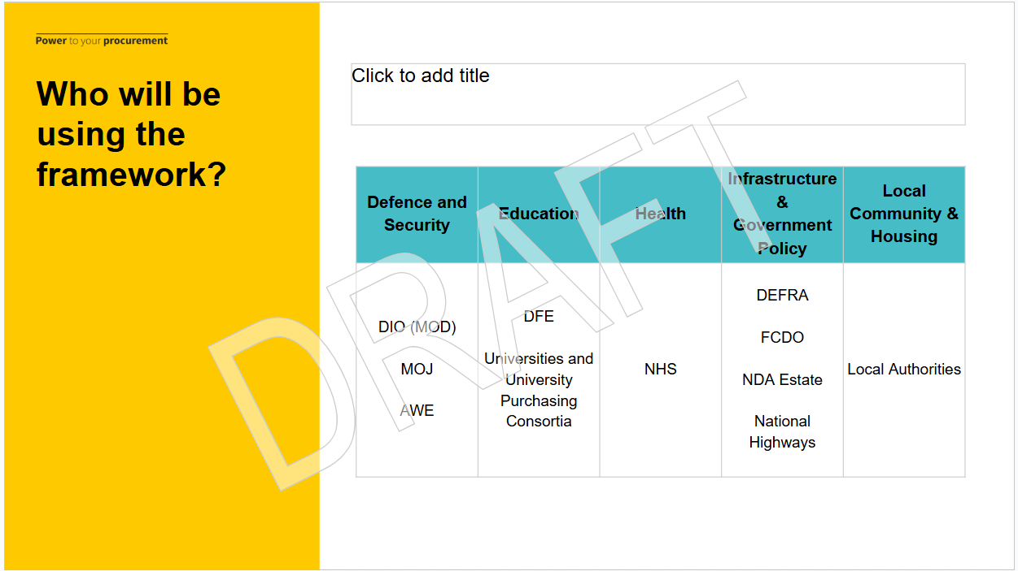
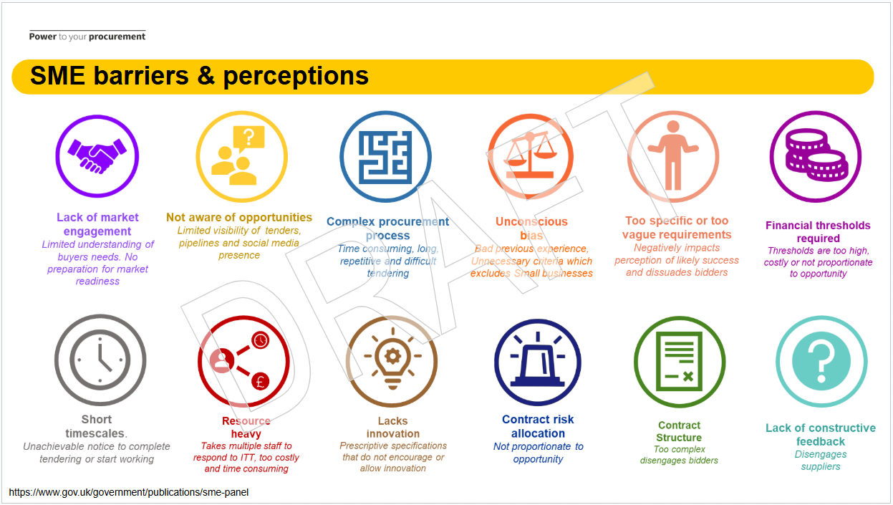
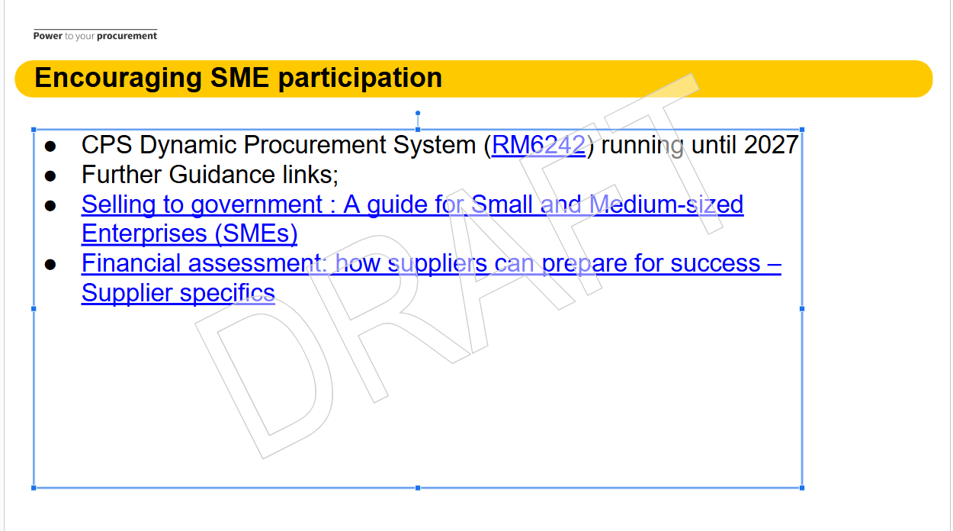
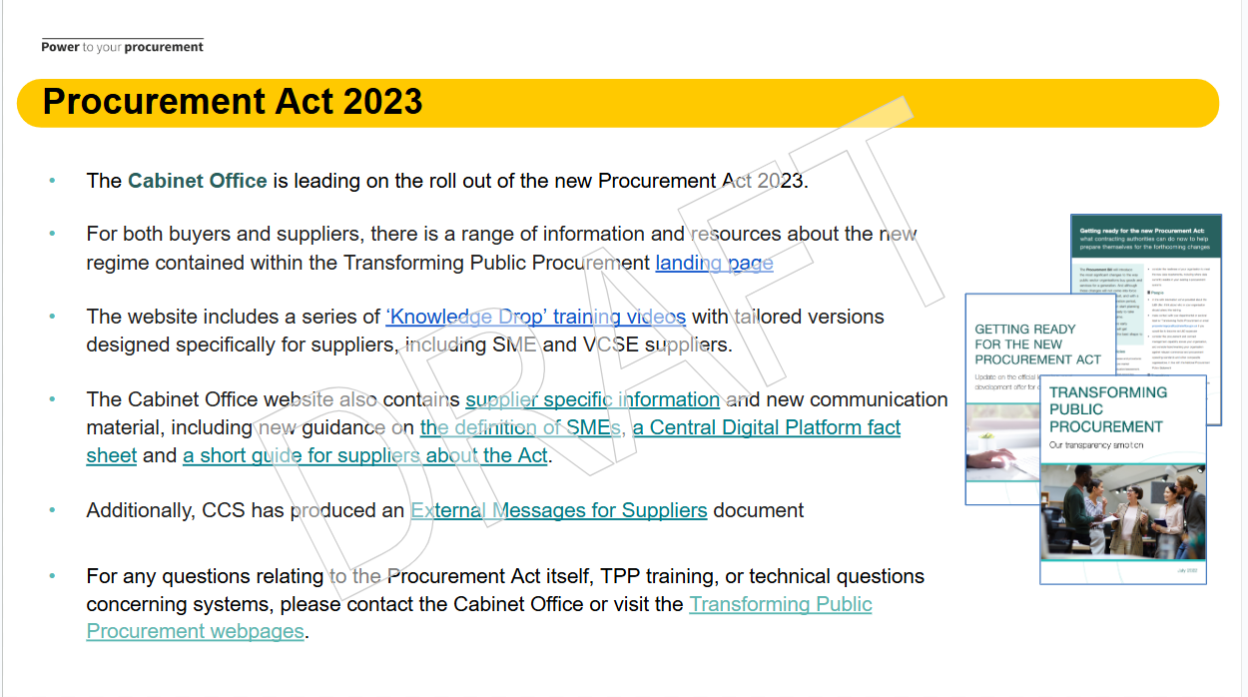
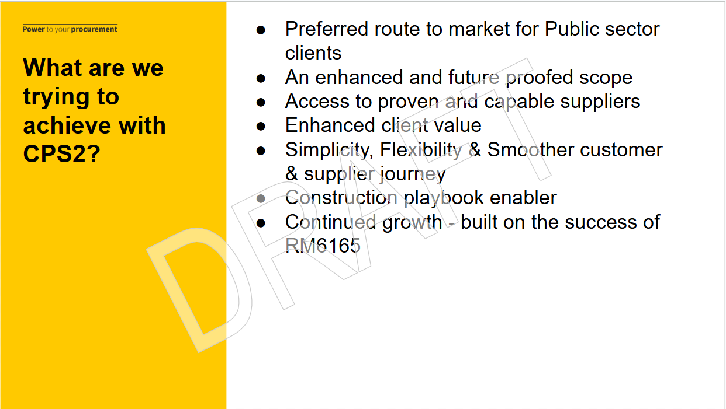
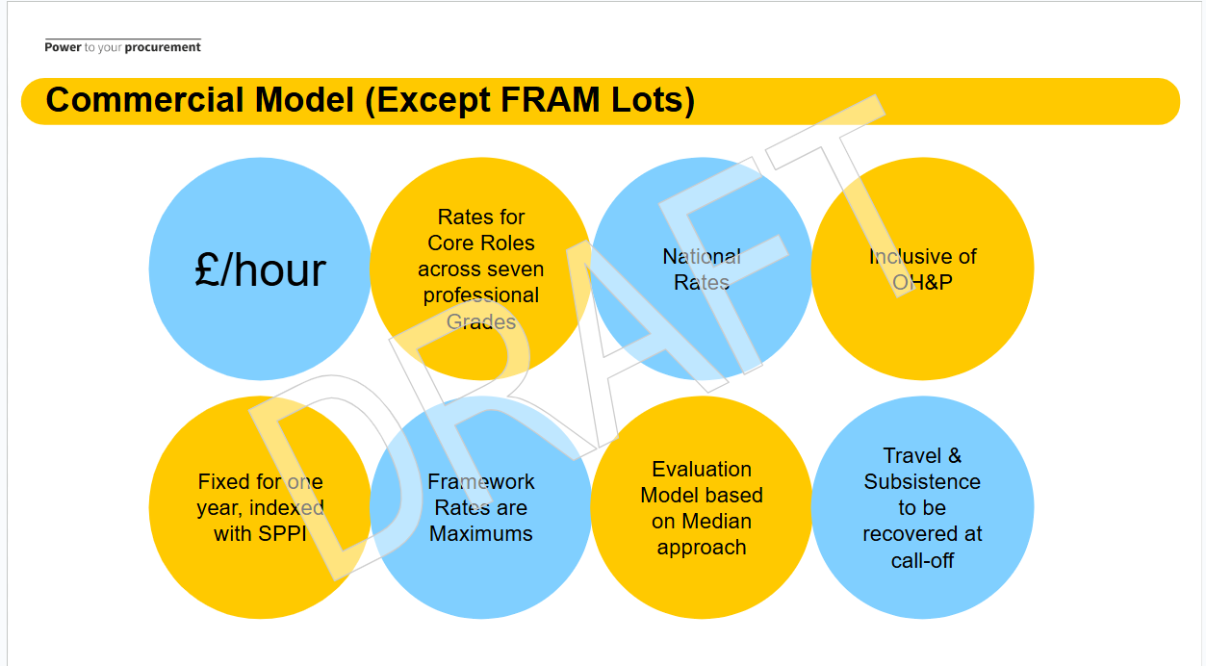
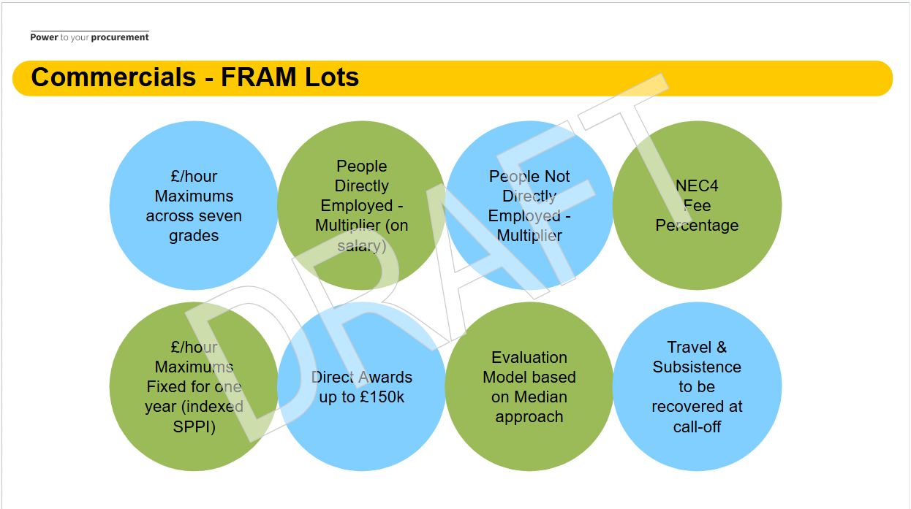
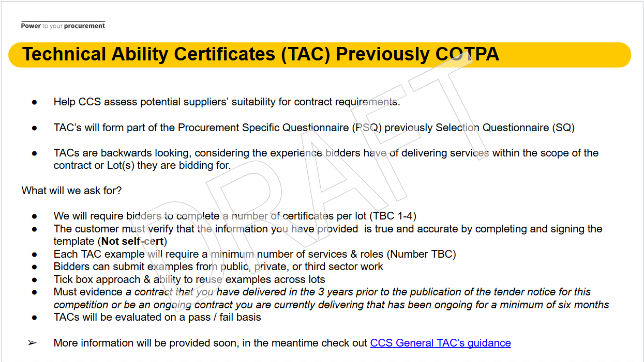
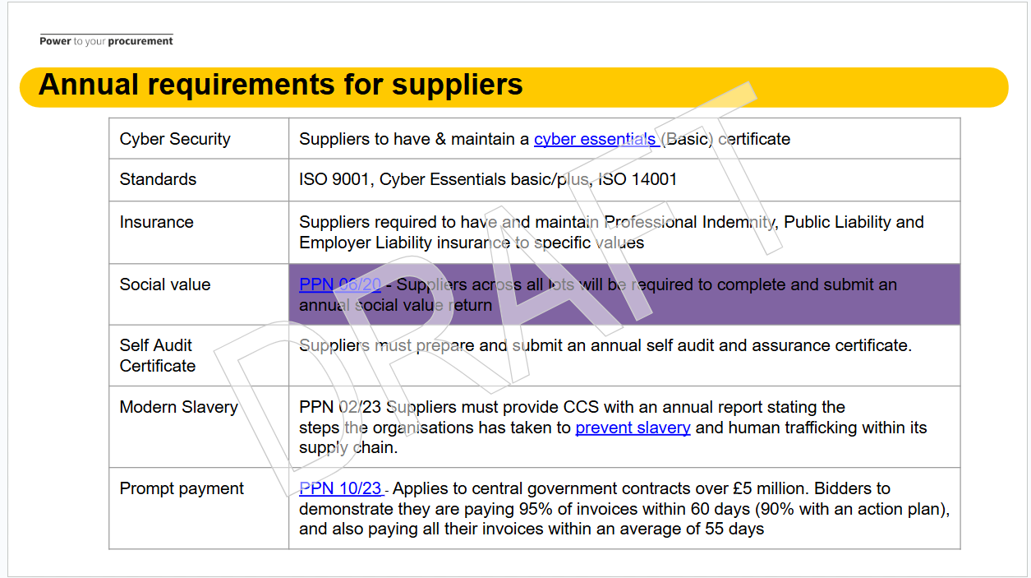
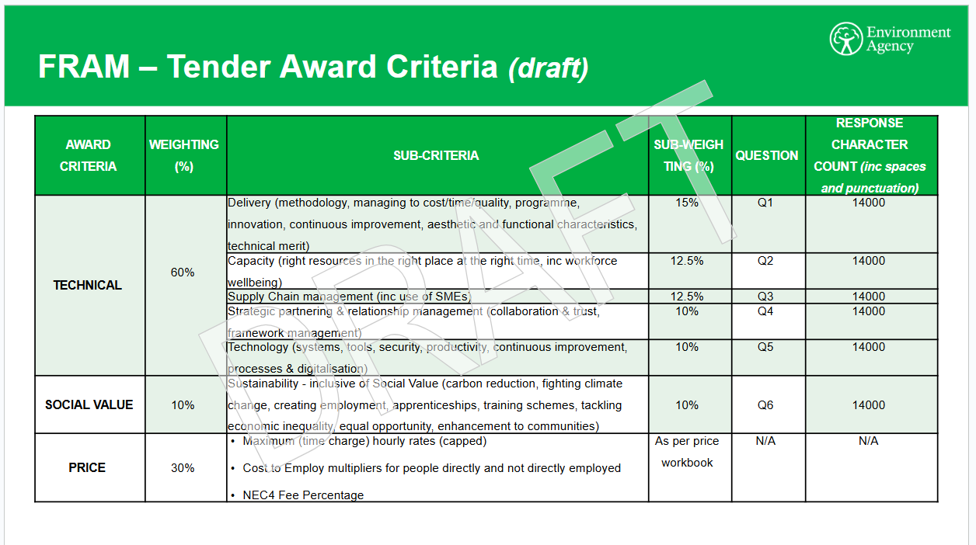
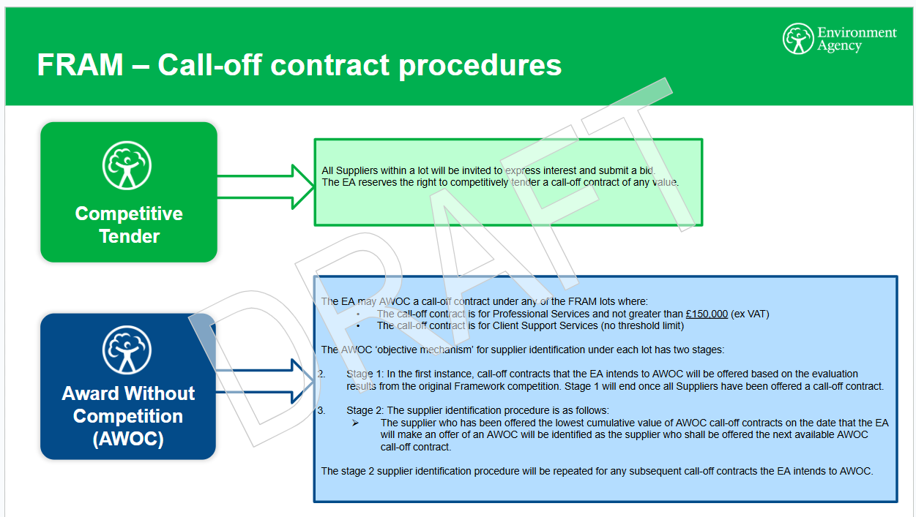

Annex D : DPS Agreements vs Frameworks

A Dynamic Purchasing System (DPS) is a type of commercial agreement available through Crown Commercial Service (CCS). A DPS offers a range of services and products and works in a similar way to a CCS framework. The main difference is that suppliers can join at any time during the agreement’s life.

Further information on ’what is a DPS’ can be found via the links below;

https://www.crowncommercial.gov.uk/news/what-is-a-dynamic-purchasing-system
https://www.crowncommercial.gov.uk/news/what-is-a-framework-procurement-essentials

Suppliers interested in the Construction professional services DPS (RM6242) can find out more via this link https://www.crowncommercial.gov.uk/agreements/RM6242

Registration is free and there is no limit on the number of suppliers who can join this DPS Marketplace

To find out how to become a supplier on this commercial agreement, download the 'Bid pack' from the link below, and read the 'Read First RM6242 - DPS Needs'.

https://supplierregistration.cabinetoffice.gov.uk/dps/RM6242?nav=0

Table 1 : Comparison of DPS vs Framework agreement features

DYNAMIC PURCHASING SYSTEM | FRAMEWORK AGREEMENT
Suppliers can join at anytime | Suppliers can join within a limited application window
No direct award of contracts | Buyers sometimes can direct award (framework dependant)
Pricing determined at the contract award stage | Pricing fixed at the point of tender
Unlimited suppliers may join | Number of suppliers decided before procurement

Annex E : Acronyms
We understand that procurement can be confusing. Organisations often use different terms to describe the same thing. With that in mind, we designed this glossary to make buying with us and navigating our website easier. It is not designed to be an extensive list of all procurement terms.

https://www.crowncommercial.gov.uk/glossary

Additional terms specifically relating to the 13th May CPS2 webinar are detailed below.

- ACA - Association of Consultant Architects
- AWOC - Award without competition
- BIM - Building Information Modeling
- BRM - Building Regulations and Mandatory guidance
- CAS - Common assessment standard
- CDM - Construction (Design and Management) Regulations 2015
- COTPA - Certificate of Technical and Professional Ability (Now replaced with TAC)
- CRP - Carbon Reduction Plan
- DIO - Defence Infrastructure Organisation
- DUNS - Data Universal Numbering System
- DV - Developed Vetting
- ESND - Estates, Security & Network directorate
- FAC-1 - Framework Alliance Contract 1
- FCDO - Foreign, Commonwealth and Development Office
- FRAM - Flood Risk and Asset Management
- FVRA - Financial Viability Risk Assessment
- ISO - International Organization for Standardization
- JCT - Joint Contracts Tribunal
- MPP - Major Programmes and Projects
- NDA - Nuclear Decommissioning Authority
- NEC - New Engineering Contract
- PA23 - Procurement Act 2023
- PPC - Project partnering contract
- PSQ - Procurement specific questionnaire
- RIBA - Royal Institute of British Architects
- SC - Security Check (SC Clearance)
- SPPI - Services Producer Price Index
- TAC - Technical Ability Certificates
- TAC-1 - Term Alliance Contract
- TPP - Transforming Public Procurement

