

RM6171

Lot 6 Auction Services


Buyer Guidance

Introduction
To many of us, the world of auctioneering is not a familiar one. When it comes to buying these services, it can be very difficult to know where to start. This guide aims to give you an overview of the key elements to consider when designing your procurement.
Modern auction services are now commonly carried out online. This means that auction houses can more efficiently run auctions, attracting a wider audience and running auctions more frequently.

Specification and Evaluation Considerations
When considering your specification and award questions, you should consider how potential bidders will attract buyers to their auction websites. Give thought to the following:
- How you will test a potential bidder’s ability to attract the right kind of buyers to their auctions?
- How will potential bidders will measure traffic through their websites demonstrating high rates of interest and growth in numbers?
- How will potential bidders provide the best buying experience to their customers
- How will potential bidders ensure the appropriate return is received on items? This could cover areas such as;
  - preparation to present items in the best condition,
  - offering alternative approaches to achieve best value e.g.:
    - dismantling and selling as parts,
    - recycling, disposal (waste for energy)

Pricing Methods
When designing your pricing structures for evaluation, there are two key commission elements to consider, Buyers Premium and Vendor Commission. There are other ancillary items to consider but we will come to those later.
Buyers Premium – this is the commission that the buyer of an item at an auction will pay to the auctioneer. As a rule of thumb, the higher the Buyers Premium, the less a buyer will be willing the pay for that item
Vendor Commission – this is the amount that the auctioneer will retain before passing the sums raised back to you, the Contracting Authority.
Auctioneers will cover their costs and achieve their margins through the application of both these types of commission. They are closely linked so when designed your evaluation approach, so you should consider applying an evaluation weighting score to each of these commission elements.
The following simple model shows how these two commission types can affect the overall price achieved for an item at auction:
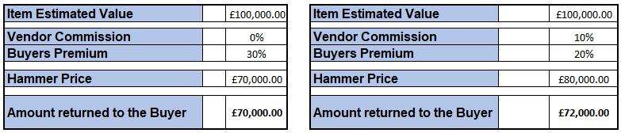
In the first example, whilst on the face of it, paying no commission to the auction company and getting 100% of the hammer price back may seem good value for money, the Buyers Commission will need to be higher and therefore likely to achieve a lower hammer price. The second example shows how a mixture of both types could achieve a better return.

Storage Costs
You should consider if you will allow additional storage costs, especially for long term storage and how long you will need things in storage for. If this is not allowed for, auctioneers may have to increase their commission rates to allow for this uncertainty. This is especially relevant for items that are subject to court cases where the items cannot be sent for sale (or returned to the owner) until the case has been completed.

Transport Costs and Valuation Fees
Typically these costs are covered by auctioneers through the commission rates mentioned previously. Generally, it would only be necessary to call these out in pricing models if you require a more transparent pricing model.
Rates for transportation are set out in the rate card for Lot 6 of RM6171.
Valuation fees would be typically based on a percentage of the valuation amount. It is worth bearing in mind that the costs in valuations will vary considerably depending on the level of skill required by a valuation expert. The example we often use is the skills required to value a Rolex watch and ensure it is genuine are far greater that the skills to value a broken bicycle.

