

Supplier Access Information

RM6237– Low Value Purchase System



Contents

Welcome 3
What ‘we’ and ‘you’ means 5
LVPS Access Pack 5
Scope Exceptions 5
Who can request to participate? 6
Getting started - How to register on the Supplier Registration Service (SRS)? 6
Updating Answers in the Low Value Purchase System Suitability Assessment Questionnaire section: 11
If we accept your Request to Participate: 13
The LVPS Appointment Form sign-off: 13
What is a LVPS Appointment Form? 14
Timelines for the request to participate 14
When and how to ask questions? 14
Making the competition work 15
What you can expect from us: 15
What we expect from you: 15
General: 17
Competition Procedure: 17
Annex A – Status Flags on the Supplier Registration Service (SRS) 19

Welcome
We invite you to join the Low Value Purchase System (LVPS) to provide public sector buyers with a new route to market for their below threshold non-medical common goods and services.
What is the Low Value Purchase System?
The Low Value Purchase System is a system established by Crown Commercial Service (CCS) under Part 4 of the Public Contracts Regulations 2015 for bidders who are able to provide non-medical goods and or services where the value of the contract is below the relevant thresholds for Part 2 of the Public Contracts Regulations 2015 to apply.
CCS has set up its Low Value Purchase System to allow public sector buyers to procure their below threshold non-medical common goods and or services. A buyer could use the Low Value Purchase System to award a contract as an alternative to advertising its requirement on Contracts Finder.
The three filters used as part of supplier registration and by the buyer when looking to purchase through LVPS are:
- the service heading for the non-medical goods and or services;
- the Postcode Radius within which bidders are able to supply non-medical goods and or services;
- SME / VCSE status.
Service Heading Description
Agricultural, farming, fishing, forestry and related products
Petroleum products, fuel, electricity and other sources of energy
Mining, basic metals and related products
Food, beverages, and related products
Agricultural machinery
Clothing, footwear, luggage articles and accessories
Leather and textile fabrics, plastic and rubber materials
Chemical products
Electrical machinery, apparatus, equipment and consumables; Lighting
Rail, Air & Sea Auxiliary Products
Security, fire-fighting, police and defence equipment
Musical instruments, sport goods, games, toys, handicraft, art materials and accessories
Collected and purified water
Industrial machinery
Machinery for mining, quarrying, construction equipment
Installation services
Hotel, restaurant and retail trade services
Transport Services With Driver/Operator
Supporting and auxiliary transport services; travel agencies services
Agricultural, forestry, horticultural, aquacultural and apicultural services
Education and training services
Permanent Recruitment and Contingent labour
Sewage-, refuse-, cleaning-, and environmental services
Recreational, cultural and sporting services
Other community, social and personal services
Translation Services
Research
IT services and support

Postcode
Radius | Radius – 2 miles  Radius – 5 miles  Radius – 10 miles  Radius – 15 miles  Radius – 20 miles  Radius – 30 miles  Radius – 40 miles  United Kingdom

SME / VCSE
Are you a Small, Medium or Micro Enterprise (SME) or a Voluntary, Community and Social Enterprise (VCSE)? | Yes/No

For each service heading you select you will be requested to provide a brief description of your service offering, and related pricing information.
As your description should be no more than 400 characters in length (including spaces) you will need to think carefully about what you say here.
You will not have space to talk in detail about pricing, you may therefore want to provide an indication as to your pricing model, for example price per unit, price on application, free, time and materials, etc. Remember you will have the opportunity to provide the buyer with detailed pricing information specific to their requirement at the point of them calling off the LVPS.
You must not include any website links or any reference to your current clients. If these are included in your description you will be notified to amend you service heading accordingly.
Suppliers should be aware that recruitment across the education and healthcare sector including both clinical and non-clinical recruitment is excluded from the Low Value Purchase System.
LVPS Access Pack
The LVPS Access Pack includes the following documents:
Supplier Access Information:
  - what ‘we’ and ‘you’ means
  - who can request to participate
  - how to request to participate
  - what is an LVPS Appointment Form
  - timelines for the request to participate
  - the rules, obligations and rights between you and us;
  - the LVPS Appointment Form sign-off process;
  - competition overview;

CCS - Supplier Contract – This is the Contract between you and us.
Buyer - Supplier Contract – This is the Contract between you and the Buyer to supply the specified non-medical goods and or services.
Attachment 1 – Management Information (MI) and Reporting Template
Attachment 2 - Suitability Assessment Questionnaire – A PDF copy of the Suitability Assessment Questionnaire is provided for information only so that bidders can view the questions in advance of completing the online Suitability Assessment Questionnaire.
Attachment 3 - LVPS CAA, privacy notice and terms of use – This document sets out the terms of use that you must agree to use the LVPS.
Attachment 4 - Appointment Form – This is the contractual agreement between you and us. You will need to agree to electronically sign up to these T&C’s which are non-negotiable.
Make sure you read all the guidance, information and instructions that we provide – they are there to help you to complete your request to participate.
We hope everything is clear – if it is not, we explain in the ‘how to request to participate’ section, when and how you can ask questions.

What ‘we’ and ‘you’ means
When we use “CCS”, “we”, “us” or “our” we mean Crown Commercial Service.
When we use “you”, “your” “suppliers” or “bidders” we mean your organisation, or the organisation you represent, in this competition.
We are the central purchasing body that procures non-medical common goods and services for Buyers including central government departments and the wider public sector.
The Public Contracts Regulations 2015 regulate how we procure. This means that we and you have to follow processes that are fair, transparent and equitable for all bidders.

Who can request to participate?
We are running this competition under Part 4 of the Public Contracts Regulations 2015 for bidders who are able to provide non-medical goods and or services where the value of the contract is below the relevant thresholds for Part 2 of the Public Contracts Regulations 2015 to apply.
This means that anyone can submit a request to participate (submit a bid) to join the LVPS.

Getting started - How to register on the Supplier Registration Service (SRS)?
All suppliers are required to register on the SRS system prior to submitting a ‘Request to Participate’ (in accordance with the section below ‘How to Request to Participate’).
To register for the SRS system please follow the instructions below:
- ‘register for an account’ at the following link
https://supplierregistration.cabinetoffice.gov.uk/organisation/register
- Step 1 - Select ‘Supplier’
- Step 2 – Click on the DUNS number radio button (this ensures the correct DUNS number is utilised for your organisation) and complete the required information.
If you are already registered to SRS please ‘sign in’ to your account via the attached link https://supplierregistration.cabinetoffice.gov.uk/login.
Please ensure the DUNS number associated with your registration details is the DUNS number you will be using in your Suitability Assessment Questionnaire for RM6237.
In the event that your DUNS number does not reflect the DUNS number you wish to use for your RM6237 submission please contact Dun and Bradstreet (D&B) at the following link https://www.dnb.co.uk/ to make the necessary amendments to your Dun and Bradstreet registration before proceeding with your Suitability Assessment Questionnaire submission for RM6237.
NB – When registering at D&B please ensure you include any Trading Names you wish to use for the LVPS Appointment Form, as the name you input as part of your D&B registration process will be the name generated when registering on the Supplier Registration Service when using your D&B number (as per Step 2 above)

Scope Exceptions
Recruitment in the health and education sector is specifically excluded from the LVPS to ensure that this is undertaken in line with government guidance.
Education and healthcare sector recruitment both clinical and non-clinical is supported by a number of alternative CCS (and NHS Workforce Alliance) frameworks which have received Department for Education and NHS England and Improvement approval status.
The frameworks can be accessed directly from the CCS website www.crowncommercial.gov.uk/agreements or alternatively you are able to contact a member of the workforce team using info@crowncommercial.gov.uk.

How to Request to Participate?
  - Your request to participate must be entered via the Supplier Registration Service (SRS) at:
https://supplierregistration.cabinetoffice.gov.uk/dps. We can only accept requests to participate through this route.
  - You must submit your response in English and through the SRS platform only.
  - Your request to participate must be completed by the organisation that will be responsible for providing the non-medical goods and or services, if appointed on to the LVPS.
  - Any supporting evidence will be requested via:
info@crowncommercial.gov.uk .
  - Make sure you answer every applicable question within the Suitability Assessment Questionnaire.
  - Only select the Service Headings in the Suitability Assessment Questionnaire that can be delivered by your organisation.
Suitability process:
In order to award a contract to your organisation under the Low Value Purchase System, the buyer will need to assess your organisation’s suitability, capability, legal status and financial standing.
The Suitability Assessment Questionnaire aims to make the procurement process more efficient for you and for the buyer by dividing the process of a buyer gathering the necessary information for the assessment of minimum standards into two parts:
- These suitability assessment questions ask for basic information about your legal status and the non-medical goods and or services you are able to supply that any public sector buyer would require before purchasing those non-medical goods and or services. That means that you should only need to answer these questions once and buyers can get that information in one place. It also asks for a criminal records declaration which buyers may wish to be repeated at the time you enter into a contract with them.

- These suitability assessment questions do not request information on your capability to provide the non-medical goods and or services, your financial standing or the details and suitability of any subcontractors which you intend to use to provide the non-medical goods and or services. These elements of your suitability, and that of any subcontractors, will be checked by buyers when deciding whether to award a contract to you.
Only the buyer can determine its minimum standards of suitability and capability by reference to the subject-matter of the contract in question.
If your answers show that your organisation meets the minimum standards for legal status CCS will admit your organisation to the Low Value Purchase System and make your non-medical goods and or services available to public sector buyers through the Low Value Purchase System. Each buyer accessing the Low Value Purchase System will then consider the suitability of your non-medical goods and or services, the capability of your organisation and the financial standing of your organisation against its particular requirement.

Instructions
You must answer all of the questions in full and in the format required. The Suitability Assessment Questionnaire requires you to provide:
- details about the legal status of your organisation;
- a criminal records declaration;
- details of your non-medical goods and or services;
- a declaration concerning the accuracy of the information provided by you in your response to the suitability assessment questions.
Companies are required to keep a register of individuals or legal entities that have control over them. You are required to provide the details of Persons of Significant Control as part of your LVPS submission.
You can find out further information related to Persons of Significant Control here: https://assets.publishing.service.gov.uk/government/uploads/system/uploads/attachment_data/file/753028/170623_NON-STAT_Guidance_for_PSCs_4MLD.pdf
A buyer may ask you for means of proof as evidence of any of your answers to the suitability assessment questions.
If you seriously misrepresent any factual information in answering the suitability assessment questions, and so induce an authority to enter into a contract, there may be significant consequences.
If a buyer discovers that you have seriously misrepresented any factual information before entering into a contract, the buyer may decide not to enter into a contract with you.
If a contract has been entered into you may be sued for damages and the contract may be rescinded.
If fraud, or fraudulent intent, can be proved, you or your responsible officers may be prosecuted and convicted of the offence of fraud by false representation, and you must be excluded from further procurements for five years.
In addition, CCS and or a buyer may carry out a criminal record check for relevant convictions for your organisation and the persons with significant control of your organisation.
If you are not able to make both the criminal records declaration and the questionnaire declaration, CCS will not make your non-medical goods and or services available through the Low Value Purchase System.
Please note – you CANNOT amend your responses to Questions 1-29 in the Suitability Assessment Questionnaire. You CAN update your responses regarding the Services you can offer (service heading; Postcode Radius; SME / VCSE status)
  - We may seek clarification of any information you provide to validate and verify your responses. Don’t forget to check for messages regularly at frequent intervals in your internal mailbox system (this will be the email address you input into Q3 of the Suitability Assessment Questionnaire) throughout the competition.
  - If we are satisfied with the response you have provided to the compliance issues we have raised, you will be appointed to the LVPS. Following which, we will amend your LVPS submission from ‘Assessing’ to ‘Agreeing’ status.
  - Once we complete the Assessing process, you will be contacted to say that your submission has entered an ‘Agreeing’ stage – this means you will need to re-enter the submission on SRS and agree to the LVPS Appointment Form electronically – once you have completed this your status will show as ‘Appointed’.
Assessing Process:
  - All submitted requests to participate will automatically enter the ‘Assessing’ stage. Following which we will complete further compliance checks of your Suitability Assessment Questionnaire to ensure you have provided everything that we have requested as part of the suitability assessment.
  - We may seek clarification of any information you provide to validate and verify your responses. Don’t forget to check for messages regularly at frequent intervals in your internal mailbox system (this will be the email address you input to Q3 of the Suitability Assessment Questionnaire (contact details)) throughout the competition.
  - If you are unsure about how to complete any part of the Suitability Assessment Questionnaire, you can raise a question via the DPS Marketplace clarification link (on SRS).
  - If we are satisfied with the responses you have provided to the compliance issues we have raised, you will be appointed to the LVPS. Following which we will amend your LVPS submission from ‘Assessing’ to ‘Agreeing’ status.
  - Once we complete the Assessing process, you will be contacted to say that your submission has entered an ‘Agreeing’ stage – this means you will need to re-enter the submission on SRS and agree to the LVPS Appointment Form electronically – once you have completed this your status will show as ‘Appointed’.
Agreeing process:
  - The screenshot below shows an example of what your application on the SRS system will look like, you can see that the blue status box is showing the current status of the application as ‘Agreeing’. You now need to select the ‘Agree’ link on the application.
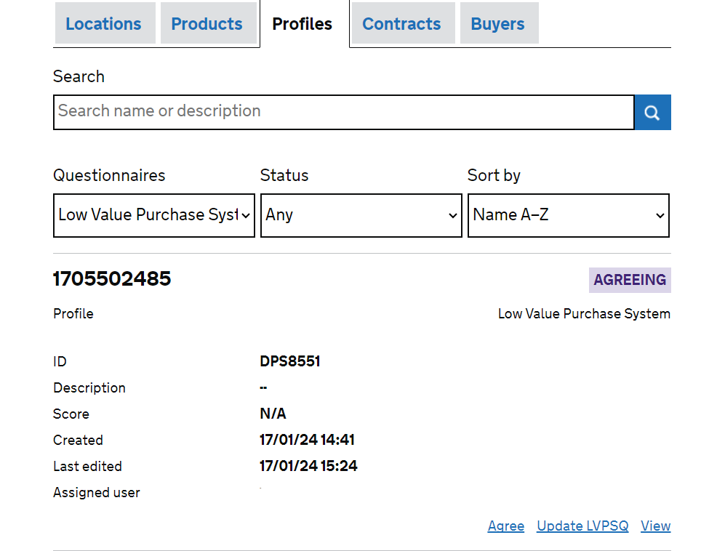
Please note that this image is for illustration purposes only, what you see in the system may look slightly different.

Electronic Signature Process
  - Once you have clicked on the ‘Agree’ link you will be taken to the page shown below, here you can review the LVPS Appointment Form, the Privacy statement, your Suitability Assessment Questionnaire answers, and the LVPS Access Pack. If you are happy to progress, you then check the ‘I agree’ box and click on the orange highlighted ‘Join LVPS’ link. This will now change your status to ‘Appointed’.

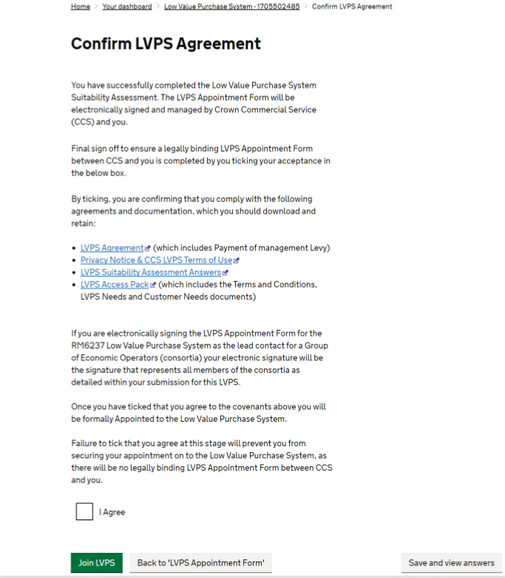
Please note that this image is for illustration purposes only, what you see in the system may look slightly different.

NB – Please refer to Annex A for full details of the status flags and the order that they will appear through the application process.

Updating Answers relating to your Deliverables:
  - You are able to update your responses as described in the sections below, however please be aware that all bidders who update their Service requirements will re-enter into the ‘assessing’ stage, to enable us to monitor changes to submissions to ensure an effective audit trail.
  - Once you have completed the update answers process, we will contact you by email from info@crowncommercial.gov.uk to confirm approval of the requested change and to advise that your status is in ‘Agreeing’ stage. You are then required to complete an electronic sign off within the Supplier Registration Service portal as directed.
Following completion of above, your status will revert to ‘appointed’.
Assessing
  - Your organisation will automatically enter into the assessing stage as detailed below, and following our assessment of your Suitability Assessment Questionnaire, if we are not satisfied with the response(s) you have provided, we will transfer your organisation from the ‘Assessing’ stage to ‘Registered 1’ stage.
  - Once your submission has been returned to ‘Registered 1’ stage, you will be able to update your answers to the questions relating to your non-medical goods and or services.
  - To update these answers select the ‘Respond’ option which can be located on ‘Your Dashboard’ by setting your ‘Questionnaires’ filter to ‘RM6237 LVPS’, and your ‘Status’ filter to ‘Assessing’.
  - All your previous answers will be pre-populated and you can navigate through the Suitability Assessment Questionnaire, where you can amend your response(s) as appropriate and re-submit your submission to us for further assessment.
Agreeing
  - If your organisation successfully meets all of the suitability assessment criteria for RM6237 LVPS, we will advance your LVPS submission from the ‘Assessing’ stage to the ‘Agreeing’ stage, which will require your sign off to enable appointment to the LVPS.
  - Once your submission has been assessed and is in the ‘Agreeing’ stage, you will be able to update your answers relating to your non-medical goods and or services and/or contact details only within the Suitability Assessment Questionnaire.
  - To update your answers in the above section, select the ‘View’ option on your LVPS submission, which can be located on ‘Your Dashboard’ by setting your ‘Questionnaires’ filter to ‘RM6237 LVPS’, and your ‘Status’ filter to ‘Agreeing’.
  - By completing the above process, you will be navigated to an overview of your answer sheet, where you are required to select ‘Update ‘RM6237 LVPS’ from the ‘Options’ section on the right hand side of the screen.
  - All your previous answers will be pre-populated and you can navigate through the Suitability Assessment Questionnaire where you can amend your response(s) as appropriate and re-submit your submission to us.

Appointed
  - If your organisation is successfully appointed to the LVPS, you can update your answers relating to your non-medical goods and or services and/or contact details provided in the Suitability Assessment Questionnaire.
  - To update your answers in the above section, select the ‘View’ option on your Suitability Assessment Questionnaire submission, which can be located on ‘Your Dashboard’ by setting your ‘Questionnaires’ filter to ‘RM6237 LVPS’, and your ‘Status’ filter to ‘Appointed’.
  - By completing the above process, you will be navigated to an overview of your answer sheet, where you are required to select ‘Update RM6237 LVPS’ from the ‘Options’ section on the right hand side of the screen.
  - All your previous answers will be pre-populated and you can navigate through the Suitability Assessment Questionnaire, where you can amend your response(s) as appropriate and re-submit your submission to us.

If we accept your Request to Participate:
  - Once your response has been fully electronically assessed and is considered as having met the published suitability criteria, you will be appointed to the LVPS.

The LVPS Appointment Form sign-off:
  - If you are successful and therefore ‘Appointed’ on to the LVPS, the LVPS Appointment Form will be electronically signed and managed by you and us.
  - The LVPS Terms and Conditions that you agreed to comply with as part of the Suitability Assessment Questionnaire, will require your final sign off.
  - To ensure a legally binding LVPS Appointment Form between you and us is complete, you must select ‘Yes’ in the required box on the summary page that you are presented with at the end of the Suitability Assessment Questionnaire and prior to appointment.
  - Failure to select ‘Yes’ at this stage will prevent you from securing your appointment on to the LVPS for RM6237 as there will be no legally binding LVPS Appointment Form between you and us.
NB – you must either save or print a copy of the non-watermarked LVPS Appointment Form at this stage, as you cannot return and view this non watermarked version once you have pressed ‘Join this LVPS’

Suitability criteria:
  - We may reject your bid or exclude you from the competition at the suitability stage for any of the following reasons:
    - If you receive a “Fail” for any of the suitability questions. We will reject your request to participate if you:
        - Fail to accept the LVPS Appointment Form;
        - Fail to provide criminal records declaration;

    - Where any of the information you have provided proves to be false or misleading.

    - Where you have broken any of the competition rules (as detailed in this LVPS Supplier Access Information document), or not followed the instructions given.

  - We will tell you if your bid has been rejected or if your organisation has been excluded at the Suitability Assessment Stage via info@crowncommercial.gov.uk

What is a Low Value Purchase System (LVPS) Appointment Form?
  - An LVPS Appointment Form sets out terms and conditions for you satisfying the suitability criteria and therefore accepted onto the LVPS and for Buyers when awarding contracts (Competition Procedure) throughout the entire duration of the LVPS.
  - If you are a successful bidder, the LVPS Appointment Form will be signed up to electronically and managed by you and us. Buyers can then use the LVPS to publish competitions to meet their individual service requirements. Each Competition Procedure contract will be signed and managed by the buyer and you. There may be multiple contract agreements under one (1) LVPS Appointment Form.
  - There are general terms and conditions for the LVPS Appointment Form. LVPS sets out the general terms and conditions for the Competition Procedure. You can see the contract terms as part of the Access Pack for this procurement.

Timelines for the request to participate
  - These are our intended timelines. We will try to achieve these but, for a range of reasons, dates can change as the competition progresses. We will tell you if and when timelines change:
Start Date - Open LVPS to bidders to request to participate | 17/03/2021
LVPS Open to buyers Competition Procedure | 31/03/2021

When and how to ask questions?
  - If you have any questions you can ask them at any point. This will give you the chance to check that you understand everything before you submit your request to participate via the link detailed above.
  - You need to send your questions through the DPS Marketplace clarification link. Try to ensure your question(s) is specific and clear. Do not include your identity in the question. This is because we publish all the questions and our responses, on the Supplier Registration System.
  - The DPS Marketplace clarification facility captures responses to all questions in relation to this LVPS. Please note it is your responsibility to monitor responses to clarification questions therefore please ensure that you access and review the LVPS clarification link on a regular basis. This will ensure you have sight of all relevant information.
  - If you feel that a particular question should not be published, you must tell us why when you ask the question. We will decide whether or not to publish the question and response or return a response to you confidentially via the SRS.
  - Remember that you can ask us questions about the LVPS Appointment Form and contract terms but please do not try to ‘negotiate’ the terms as this is not permitted within the Public Contract Regulations (PCR). All LVPS appointments will be made under identical terms.

Making the competition work
  - We run our competitions so that they are fair and transparent for all bidders. This section (Making the competition work) sets out the conditions of participation for this competition. It needs to be read together with the LVPS Appointment Form.

What you can expect from us:
  - We will not share any information from your submission with third parties, apart from other central government bodies (and their related bodies), which you have identified as being confidential or commercially sensitive. However, we may share this information but only in line with the Regulations, the Freedom of Information Act 2000 (FOIA) or any other law as applicable.

What we expect from you:
  - Make sure you have read and understood the request to participate and the corresponding Access Pack before you complete the Suitability Assessment Questionnaire.
  - Please make sure you have read through all the information available to you. This includes any of the responses provided by us to any of your questions raised.
  - You must comply with the rules in this access pack and any other instructions given by us.
  - You have not fixed or adjusted any element of the response by agreement or arrangement with any other person.
  - You have only selected the filters for the Services that your organisation can deliver.
Involvement in multiple bids
  - If you are connected with another bid for this procurement, we may make further enquiries. For example, where:
- you submit a bid in your own name.
  - This is so we can be sure that your involvement does not cause:
- potential or actual conflicts of interest;
- supplier capacity problems; or
- restrictions or distortions in competition.
We may require you to amend or withdraw all or part of your request to participate if, in our reasonable opinion, any of the above issues have arisen or may arise.

Bidder conduct and conflicts of interest
  - You must not attempt to influence the Request to Participate process. For example, you must not directly or indirectly at any time:
- Collude with others over the content and submission of bids.
- Canvass our staff or advisors in relation to this competition.
- Attempt to obtain information from any of our staff or advisors about another bidder or bid.
  - You must ensure that no conflicts of interest exist between you and us. If you do not tell us about a known conflict, we may exclude you from the competition. We may also exclude you if a conflict cannot be dealt with in any other way.
Confidentiality and Freedom of Information
  - You must keep the contents of this Access Pack confidential (including the fact that you have received it). This obligation shall not apply insofar as:
- enabling you to submit a bid; or
- compliance with a legal obligation.
Publicity
  - You must not publicise the non-medical goods and or services or the award of any individual contract unless we have given express written consent. For example, you are not allowed to make statements to the media regarding any bid or its contents.
Our rights:
  - We reserve the right to:
- Waive or change the requirements of this access pack from time to time without notice.
- Verify information, seek clarification or require evidence or further information in respect of your bid.
- Exclude you if:
  - you submit a non-compliant bid;
  - your bid contains false or misleading information;
  - you fail to tell us of any change in the contracting arrangements between your request to participate and appointment onto the LVPS. Or, if you do tell us, allowing the change in the contracting arrangements would result in a breach of law;
  - for any other reason set out elsewhere in this Access Pack;
  - for any reason set out in the Public Contract Regulations 2015.
- Terminate the LVPS Appointment Form at any time.
- Make any changes to the timetable, structure or content of the competition.

General:
Request to participate costs
  - We will not pay your request to participate costs for any reason e.g. if we terminate or amend the competition.

Warnings and disclaimers
  - We will not be liable:
- where parts of the Access Pack are not accurate, adequate or complete; or
- for any written or verbal communications.
  - You must carry out your own due diligence and rely on your own enquiries.
  - This Access Pack is not a commitment by us to enter into a contract.
Intellectual Property Rights
  - The Access Pack remains our property. You must use the Access Pack only for this competition.
  - You allow us to copy, amend and reproduce your request to participate so we can:
- run the competition;
- comply with law and guidance;
- carry out our business.
  - Our advisors, Subcontractors and other government bodies can use your request to participate for the same purposes.
Supplier Notifications to CCS
  - In the event your organisation would like to be removed from the RM6237 LVPS please contact CCS via info@crowncommercial.gov.uk to confirm.
NB – Bidders should note that if you have been awarded a contract derived from RM6237 LVPS your contractual obligations in accordance with the LVPS Appointment Form and Contract Terms, which form part of the Access Pack, will remain in place as applicable.

Competition Procedure:
  - Buyers may run a Reserved Procurement and award contracts by inviting all Bidders who have indicated that they can provide the non-medical goods and or services within the service heading, the postcode radius specified, and the SME / VCSE status that they have a requirement for. As part of the competition procedure a Buyer may ask you for means of proof as evidence of any of your answers to the suitability assessment questions.
Direct Award
  - Buyers are able to make a direct award using this arrangement provided this is compliant with their internal process and procedures, they will need to publish an Award Notice on Contracts Finder.

Third Party Agents/ Bid Writers:
  - The LVPS Appointment Form is required to be electronically signed and managed by you (the Supplier). Therefore, you may use the services of a third party/bid writer to prepare your submission but, it is you (the Supplier) who must submit the tender submission yourself because by ticking the statement “you (the Supplier) are confirming that you (the Supplier) comply with the following agreements and documentation, which you (the Supplier) should download and retain”, you (the Supplier) are entering into a legally binding contract with CCS.

Annex A – Status Flags on the Supplier Registration Service (SRS)
The information below shows the order of the status flags in which they will appear as you progress through the LVPS application on SRS.
Suitability Assessment Questionnaire (SQ) Status flags
- ‘Responding’ - Bidder is currently completing their responses to the questions in the Suitability Assessment Questionnaire and has not yet ‘sent’ their final answers to the LVPS.

- ‘Submitting’ - Bidder has ‘sent’ their Suitability Assessment Questionnaire answers and can now submit supporting evidence (if required).

- ‘Completed’ - Bidder has submitted their supporting evidence for the LVPS they are applying for.

Suitability Assessment Questionnaire Status flags
- ‘Registered’ - Bidder has started the LVPS Suitability Assessment Questionnaire but hasn’t submitted it. This flag is in two parts, the first ‘Registered 1’ means the Bidder is completing the non-updateable questions within the Suitability Assessment Questionnaire. ‘Registered 2’ means the Bidder is completing the updateable questions within the Suitability Assessment Questionnaire.

- ‘Assessing’ - The Bidder has completed the LVPS submission and now needs to be assessed by CCS.

- ‘Agreeing’ - Bidder has been ‘Approved’ in the LVPS but has not yet accepted the LVPS Appointment Form.

- ‘Appointed’ - The Bidder has now accepted the LVPS Appointment Form.

- ‘Rejected’ - Bidder has been rejected, and will need to start a new application if they apply again.

