ANNEX A - COMMAND & HOUSE PAPERS SERVICE REQUIREMENTS

CONTENTS

1. DEFINITIONS 2
2. Scope 7
3. SERVICE DESCRIPTION 8
4. THE ROLE OF THE CONTROLLER OF HMSO 16
5. Information about the Papers 17
6. ORDERING fOR BUYERS PRODUCING PAPERS 20
7. security 25
8. c&hp Account and Project Management 27
9. C&HP service options FOR BUYERS PRODUCING PAPERS 34
10. ISBNs and Bibliographic information MANAGEMENT 38
11. PRE-PRODUCTION 40
12. Alternative Formats 48
13. PRINT PRODUCTION 50
14. DISTRIBUTION 55
15. CorrectionS AND Reprints 60
16. re-use OF PAPERS’ content and information 63
17. SERVICE EVOLUTION 64
APPENDIX 1 – PARLIAMENT’S PRINT COPY QUANTITIES 65
APPENDIX 2 – PARLIAMENT’S MANAGEMENT INFORMATION 67
APPENDIX 3 – TEMPLATES FOR PAPERS’ PAGES 1 & 2 AND COVERS 70
APPENDIX 4 – TEMPLATES FOR pAPERS’ CORRECTION SLIPS 80
APPENDIX 5 – MI FOR COMMAND AND HOUSE WORKLOADS 2023/2024 85

DEFINITIONS
  - In this Annex A the expressions below shall have the following meanings:
"Advanced Laying Information" means specific bibliographic information about a Paper supplied to Parliament for planning purposes two days before the Paper is Laid;
“Alternative Format” means a Format required to meet obligations under the Equality Act 2010, and in this Annex A other Formats to meet the needs of people with specific needs;
“Authoring Organisation” means a Crown, or other responsible organisation, or its agent that is usually sponsored by government and authors Papers for which C&HP Services may be purchased;
“Bookmarked PDF” means a PDF document with links to specific document sections allowing navigation by clicking bookmark links on the side of the page instead of scrolling.
“Buyer” means the relevant public sector purchaser identified as such in the Order Form. In relation to C&HP Services a Buyer may be a) an Authoring Organisation, or another public sector organisation purchasing on behalf of an Authoring Organisation; or b) Parliament: parliamentary Buyers such as the House of Commons (Vote Office) or the House of Lords (Printed Paper Office);
“C&HP Services” mean the services in relation to the Papers to be provided by the Supplier to the Buyer specified in this Annex A. ‘C&HP’ is an acronym of Command and House of Commons Papers;
“C&HP Service Options” means the C&HP account and project management service options provided by the Supplier for Buyers producing Papers, and which as a minimum include Core Services;
“Command Papers” mean those Papers which are generally part of a numbered series that are Laid before Parliament by Command of the Sovereign, though in practice by a Minister of the Crown, concerning matters which the Government considers should be drawn to the attention of Parliament as described in Clauses 5.1 to 5.3 of this Annex A. Command Papers do not attract parliamentary privilege;
“Controller of HMSO” means the Controller of His Majesty’s Stationery Office and Kings’s Printer of Acts of Parliament, who is the Chief Executive and Keeper of The National Archives. On behalf of the Crown, the Controller of HMSO provides an intelligent client role for Papers’ production, distribution and publishing requirements;
"Copies” means copies of Papers in any Format under the relevant C&HP Services;
"Content" means all Government Data and material (including text, images, tables, graphics and colophons) submitted for inclusion in each “Paper” including Crown Copyright material, non-Crown Copyright material, assigned copyright, third party copyrights, third party copyrights, copyrights which have been licensed to the Buyers and where relevant, material and templates employed by the Supplier as set out in this Annex A;
“Core Services” means Services for Buyers producing Papers including: C&HP account and project management, expert advice about Papers’ Pre-production, Print Production and Distribution specifications and processes, confirmation of the applicable C&HP Service Option, provision and management of quotations and Timelines, guidance and layout checking of the required Content for covers, title and copyright pages, provision and checking of Publication Furniture on the copyright page, and ISBN and bibliographic information management;
“Crown Copyright" has the meaning given to it in section 163 of the Copyright, Designs and Patents Act 1988. For the purposes of this Annex A, it also includes Crown-owned Copyright and Crown-owned Database Rights;
"Database Right" has the meaning given to it in the Copyright and Rights in Databases Regulations 1997 (S.I. 1997/3032);
“Charges” means the prices applying to C&HP Services and which are set out in Framework Schedule 3 (Pricing);
“e-laying PDF” means the Format by which the relevant Authoring Organisation shall formally present the Paper to Parliament. The Format shall consist of a PDF with no crop marks, no bleed areas and is supplied as single pages in page order including blank pages. The front cover shall be the first single page, followed by inside front cover, page 1 and so on, through to the back cover. Any colour included should be in CMYK and any images high resolution at 300dpi. The purpose of the Format is to allow the Paper’s Content to be reviewed, and if necessary, printed on a desk top printer.
“Fiscal Event Document” means documents produced by HM Treasury and the Office for Budget Responsibility, for Budgets, Statements, Spending Reviews and other related events. Includes the main event document (the Spring or Autumn Budget or Statement) and the accompanying Economic and Fiscal Outlook;
“Format” means the presentation of a Paper’s Content including non-print Formats such as Word, Excel, InDesign, Google Docs, e-laying PDF; Bookmarked PDF, Web PDF, Print PDF, plain text files with Govspeak applied, other html, or hard copy Formats such as Braille and print Copies, also see Alternative Formats;
“Govspeak” means a simplified 'markup' language based on Markdown which is added to plain text files for the purposes of creating an html version of a Paper for publication on GOV.UK. More information in respect of these Papers can be found here: https://www.gov.uk/guidance/content-design/content-types#official-documents and here https://govspeak-preview.herokuapp.com/guide, and their successors;
“House of Commons Papers” mean those Papers which are part of a numbered series, administered by the House of Commons, that are Laid before Parliament, or the House of Commons only, due to a statutory obligation or as a Return to an Address and which are subject to parliamentary privilege, as further particularised in Clause 5.5 of this Annex A;
“Laid” means that a Paper has been formally presented to Parliament in the Journal Office in the House of Commons and/or the Printed Paper Office in the House of Lords;
“Official Version” means the Paper’s Web PDF published on the relevant Buyer’s official website and which must have the same Content as the Laid version, unless otherwise advised by the Controller of HMSO;
“Papers” means Command Papers, House of Commons Papers, Un-numbered Command Papers, Un-numbered Act Papers and other papers Laid before Parliament, and/or other or ancillary papers which a Buyer requires to be procured through this Annex A;
“Parliament” means individually and collectively the offices of the House of Commons and the House of Lords which may purchase Copies of Papers;
“Parliamentary Estate” means the Palace of Westminster and/or other Premises owned by or used by Parliament;
“Print PDF” means a PDF that as a minimum meets the requirements of PDF/X-1a ISO 15930-4:2003 (http://www.iso.org/iso/iso_catalogue/catalogue_tc/catalogue_detail.htm?csnumber=39938) or its successors as determined by the responsible body;
“Premises” means the location where the C&HP Services are to be supplied, as set out in this Annex A;
"Publication Furniture" means the unique Official Version’s ISBN, a Crown Copyright or best practice non-Crown Copyright statement, a printed in the UK statement including the Controller of HMSO and a Supplier ID or job number included on a Paper’s copyright page (page 2);
“Return to an Address” means a House of Commons Paper where the House of Commons Paper status is applied at the discretion of the Journal Office in the House of Commons, and which is subject to parliamentary privilege;
“Timeline” means the time period within which the C&HP Services are to be completed, which may be referred to as a ‘production schedule’, including the Timelines to produce Copies to be Laid, and other Copies, Formats and services required by Buyers;
“Un-numbered Act Papers” means those Papers which are not part of a numbered series which are Laid before Parliament, or the House of Commons only, due to a statutory obligation and do not attract parliamentary privilege;
“Un-numbered Command Papers” means those Papers which are not part of the numbered Command Paper series and which are Laid before Parliament by Command of the Sovereign, though in practice by a Minister of the Crown, that concern matters which the Government considers should be drawn to the attention of Parliament and do not attract parliamentary privilege;
“Web PDF” means a PDF that as a minimum: 1) meets HM Government standards for Viewing Documents (https://www.gov.uk/government/publications/open-standards-for-government/viewing-government-documents) in PDF, that is the requirements of PDF/A-1 ISO/IEC 19005-1:2005 (http://www.iso.org/iso/catalogue_detail?csnumber=38920), or PDF/A-2 ISO/IEC 1905-2:2011 (http://www.iso.org/iso/catalogue_detail?csnumber=50655), or their successors as determined by the relevant body; and 2) unless advised otherwise by the Buyer, meets HM Government accessibility standards for public sector websites (https://www.gov.uk/guidance/how-to-publish-on-gov-uk/accessible-pdfs and https://www.gov.uk/guidance/accessibility-requirements-for-public-sector-websites-and-apps or their successors as determined by the relevant body).

Scope

  - This Annex A describes the C&HP Services that the Supplier shall provide to the Buyer under this RM6297 Print and Digital Communications Framework Contract, in relation to the Papers.
  - Buyers shall define their requirements as part of the Call-Off Procedure.
  - There shall be no obligation for Buyers to purchase C&HP Services via this RM6297 Print and Digital Communications Framework Contract; however as a minimum, Buyers producing Papers should purchase a C&HP Service Option for numbered Command and House of Commons Papers.
  - Where the Buyer requires any C&HP Service, the Supplier shall at all times supply the C&HP Services in accordance with this Annex A, the wider Framework Contract and the Buyer’s requirements.

SERVICE DESCRIPTION

Purpose
  - C&HP Services are provided by the Supplier to help Authoring Organisations meet their fixed obligations for Papers the organisations are required to present (or lay) before one or both Houses of Parliament. The purpose of presenting Papers is to make the information contained in the Papers formally available to the Houses of Parliament.
Presented Papers
  - Authoring Organisations lay certain kinds of Papers before Parliament. Many Papers are required by law to be Laid before Parliament, or the House of Commons only. These are called Act papers and are referred to as being Laid “by Act”. The Act that requires a Paper to be Laid provides the statutory authority. Types of Act Papers are House of Commons Papers and Un-numbered Act Papers.
  - Other Papers, on matters that might be of interest to Parliament, are also made available by government, these are called Command Papers. Command papers are Laid by Government “by Command” of His Majesty under the Royal prerogative. Command Papers are normally Laid before both Houses of Parliament and are usually produced by central government departments.
  - A Paper cannot be Laid by both Act and Command, although in some cases Papers are Laid by Act in the Commons and by Command in the Lords where an Act only provides for laying in the House of Commons. Most Papers need to be Laid before both Houses of Parliament but some only before the House of Commons.
  - Once a Paper has been Laid before Parliament, it will be recorded in the official Minutes of Proceedings of each House of Parliament for that day. In the Commons, this is Votes and Proceedings:
https://commonsbusiness.parliament.uk/search?SearchTerm=Votes+and+Proceedings

In the House of Lords, this is the House of Lords Business:
https://lordsbusiness.parliament.uk/
Number of Papers and production peaks
  - Authoring Organisations produce around 550-700 Papers each year. Most are Act Papers, and around half of the yearly total can be annual reports and accounts. The busiest time is the ‘annual reports and accounts season’ which generally occurs over April - July each year, where many annual reports and accounts can be produced for laying in the third week of July. There might also be smaller peaks in Spring and at the end of the calendar year. August, September and Christmas can be quiet. Sometimes the usual peaks and troughs might not take place. For example, some annual reports and accounts may be delayed to the last quarter of the calendar year creating a flatter July peak. In addition, General Election years and coalition governments may generate fewer Papers.
  - An initial SupplierTimeline from receipt of a government Buyer’s Content in Word to creating a final e-laying PDF can be around 5 days. The exact Timeline may depend on the work needed to create a final e-laying PDF. Shorter and overnight Timelines are also commonly required. Once the final e-laying PDF is approved the Buyer may require the Supplier to create a Print PDF, a Bookmarked PDF, a Web PDF and a 20-point Arial PDF. Print Copies may also be required by government and/or parliamentary Buyers. The full range of C&HP Services including Pre-production, as agreed with the Buyer and depending on the Timeline, may be required outside of standard Working Hours.
Authoring Organisations and Buyers generally sponsored by government
  - Papers are produced by Authoring Organisations, which may be small executive agencies, museums, public corporations or large ministerial departments, as well as temporary organisations like statutory inquiries, Commonwealth Games and infrastructure development bodies.
  - These Buyers may be Authoring Organisations but may also buy C&HP Services on behalf of other Authoring Organisations, usually in their departmental family.
  - Different Buyers will require different C&HP Services to produce a Paper that can be Laid. In addition, while some Buyers know exactly what C&HP Services they require, others will be unfamiliar with the terminology, project planning, specifications, costings and scheduling affecting the Formats required. They may not have worked on a parliamentary Paper before and the Supplier may need to support them to identify risk and resolve questions.
Parliament
  - As of 2020, Parliament requires Authoring Organisations to lay papers by submitting a e-laying PDF via email to the laying offices: the Journal Office in the House of Commons and the Printed Paper Office in the House of Lords. In addition, Parliament requires that print Copies of a Paper are available in the Vote Office and/or the Printed Paper Office for release at the time of laying (see Clause 3.12). It is the responsibility of the Authoring Organisation to ensure that Copies are available at the time of laying either via the Supplier, from which Parliament buys the print Copies it requires, or by making separate arrangements for the provision, by the Authoring Organisation, of a Print PDF to Parliament in advance of laying so Parliament can print its own Copies.
Services for Parliament
  - The House of Commons and the House of Lords are parliamentary Buyers. The Vote Office in the Commons and the Printed Paper Office in the Lords may buy print Copies of Papers so that Papers are available to Members of Parliament and Peers as soon as the Papers have been Laid (Speaker’s Ruling, 25 March 2009 (HC Deb Col 307).).
  - This Annex A makes provision for Parliament to buy bulk print Copies from the Supplier, if required. Copies for Members, and Copies published elsewhere, must have the same Content as the Laid Copies. Jointly, the Houses of Parliament can be the largest Buyer of print Copies. Government print needs vary by organisation, but can be minimal.
  - The Vote and Printed Paper Offices are responsible for distributing Copies of Laid Papers, in print and/or other Formats, to Members of Parliament and Peers. Historically the offices have centralised the ordering of Papers’ print Copies through the Supplier, maintaining secure facilities for holding Copies of embargoed Papers which have not yet been Laid. The offices also have print facilities to print Copies of Papers internally. It is essential that sufficient Copies of Papers are held by the Vote Office and Printed Paper Office so that Copies can be distributed immediately on laying. Clear and timely communications from the Supplier are critical so the offices order the right quantity of Papers.
  - As well as standard print Copies, parliamentary Buyers may also require Copies in large print Format (20pt Arial) in either PDF and/or print at the same time as the standard Copies. If actioned by the Buyer producing the Paper, the Supplier produces large print versions from files created for, or supplied by the producing Buyer.
  - If parliamentary Buyers require Papers in a non-print Format (that is, other than a printed Copy), such as Print PDF, they generally receive these Formats directly from Authoring Organisations through the relevant government department’s parliamentary clerk’s team. It is critical that Authoring Organisations ensure that all Formats supplied to parliamentary Buyers (and more generally) have the same Content as the Laid Copy.
  - From time to time parliamentary Buyers may require the Supplier to supply Print PDFs of Laid Papers directly, where the Supplier holds the Print PDF.

Account and project management for Buyers producing Papers
  - The Supplier should not underestimate the high level of administration, Buyer engagement and contingency needed to provide C&HP Services.
  - Supplier account managers must be capable of guiding Buyers, regardless of Buyer experience, through the end-to-end process of producing and laying Papers, providing advice, guidance and clarification at every stage regardless of the size or complexity of any one Paper compared to another.
  - An individual Buyer’s expertise may lie elsewhere – they might not have produced a Paper before and may be new to government, parliamentary papers, and/or annual reports and accounts. The Supplier’s account manager may need to explain parliamentary requirements, C&HP Services, how timelines work, print production, and/or terminology. Buyers may need to discuss this information with colleagues which may result in additional questions for the account manager.
  - It is usual for Supplier account managers to deal with a range of individual Buyers based in teams across government, responsible for authoring one off Papers. Buyers are often in policy, governance, or finance teams and can move on before they transfer their C&HP knowledge. There is also a high turnover of Buyer contacts on yearly Papers such as annual reports and accounts.
  - Buyers may not have a specified budget for their Paper or be the budget holder. After being briefed on the Paper’s requirements, the Supplier’s resulting quotation may give rise to questions from the individual Buyer, their line manager and/or the budget holder. The account manager may need to explain the quotation, offer alternatives, highlight risk and manage expectations.
  - Some Buyers might not be initially aware that creating a final document Format to lay before Parliament can be more time consuming, complex or costly than producing print Copies. A Buyer might not be completely aware of how a Paper’s Content should be best provided to the Supplier and may need support to understand the pre-production studio work necessary to create Formats that can be Laid, professionally printed, and published online. There may not be a good understanding of managing amendments and proofing rounds, or that it is most helpful to return proof amendments in one batch.
  - The Supplier will need to build contingency into its whole C&HP Service provision but also with individual Papers and Buyers. A Paper may have a longer page extent than first anticipated, or require unplanned for services, such as correcting file types or proof reading, for example. A Paper could be approved only to be pulled from press and/or amended and printed again. Factoring in these sorts of changes, which could be completely outside even experienced Buyers’ control and occur at any stage in the process, may result in the account manager producing additional quotations and revised timelines. The account manager will need to spend time guiding some Buyers through the implications of change.
  - As a norm, Supplier account managers need to manage dependencies and the unexpected within fixed deadlines. If an account manager is working on Papers related to a large statutory inquiry, the inquiry could take up most of their time. Any Paper may be subject to a series of deadlines and Timelines which cannot change, are independent of each other and which are outside the Buyer’s control. These can include: when the Comptroller and Auditor General may sign off an organisation’s annual report and accounts, a Paper’s No10 grid slot date or laying date, or the timing of a Ministerial Statement or media event.
  - In addition, on a daily basis the Supplier, potentially through its account managers, needs to liaise with the Vote and Printed Paper Offices in Parliament about the delivery of print Copies and the provision of Advance Laying Information.
  - The Supplier’s only mechanism for cost recovery of C&H Services’ account and project management time is through the rate card.
Pre-production services for Buyers producing Papers
  - The Supplier must be able to provide the full range of Pre-production services to meet Buyers’ requirements, including outside of normal Working Hours. Buyers will have different requirements and these will be defined as part of their Call-Off Contracts and further detailed by Paper.
  - The Supplier must be able to provide dedicated flexible account management and studio resources for pre-production services to manage multiple amendment rounds and late changes to pagination and other specifications. The Supplier is required to resolve short notice changes and unplanned peaks successfully. An example could be a Cabinet reshuffle of ministerial roles, resulting in high levels of change to a number of Papers’ Content, while maintaining the original laying dates.
  - Call-Off requirements notwithstanding, the Supplier provides each numbered Command and House of Commons Paper with an ISBN, capturing details for a Web PDF, for inclusion on each Paper’s copyright page and back cover. The Supplier ensures that the copyright page includes an up to date Crown or non-Crown Copyright statement (as is relevant), printed in the UK statement, recycled fibre content statement, unique ISBN and Supplier ID or job number.
  - Buyers may provide Content to the Supplier as Print PDF or in original document Formats including Word, Excel, InDesign, Google Docs, and potentially as manuscript. Some organisations have their own Word template for officials to use for drafting publications. The Supplier may need to supply basic design, typesetting, proofing and other services to turn the supplied Content into printable and publishable Formats including the e-laying PDF, Bookmarked PDF, Web PDF, Print PDF, html (including GovSpeak), Alternative Formats and translations.The Supplier must also be able to provide secure methods for file transfer.
  - Some Buyers may require the Supplier to create fully accessible Web-optimised PDFs and other Formats , but many will create these in-house. The Supplier needs to be assured that the Formats it provides are created from the final Content approved by the producing Buyer.
  - Formats created by the Supplier which the producing Buyers will publish online, such as Print and Web PDFs, should be provided to the Buyer before the Paper is due to be Laid, or as required by the Buyer.

Operational model and Charges
  - The Supplier shall provide different C&HP Service Options for Buyers producing Papers, particularly for numbered Command and House of Commons Papers. The Supplier shall charge one C&HP Service Option per Paper, depending on the Buyer’s requirements. Charges for standalone services for Pre-production and Print Production, where applicable, are additional to the C&HP Service Option Charge unless specifically included in an Option.
  - Although there are only six Service Options, there is significant variance in Buyer requirements. There are many hundreds of individual producing Buyers and several hundred corporate Buyers. These present varying levels of expertise, different business and financial processes, and a range of fixed deadlines.
  - Buyers producing Papers are not required to use this Annex A for Un-numbered Act Papers, Un-numbered Command Papers or other documents. For these Papers, Buyers have the option to use one of the C&HP Service Options; or any standalone service included in Pre-production, Print Production or buying an ISBN; or a combination of services. Where not using one of the C&HP Service Options the Buyer, not the Supplier, may handle the delivery of bulk print Copies for Parliament, where required.
  - For each Paper, the Supplier shall refer to Appendix 1 (Parliament’s Print Copy Quantities) to ascertain print Copy quantities required by parliamentary Buyers. Such quantities are an estimate and may be amended during the Term depending on parliamentary demand. The Supplier shall provide the quantities and distribution confirmed during Parliament’s Call-Off Procedures. In addition, for known high profile Papers such as the Budget document or statutory inquiries the Supplier shall make contact with parliamentary Buyers in good time to determine how many additional Copies they may require. Charges incurred by parliamentary Buyers are charged to Parliament.
  - Where the Supplier is providing Parliament with print Copies, the Supplier supplies the Vote Office and Printed Paper Office with bibliographic information (Advanced Laying Information) about Papers due to be Laid over the next two days, relative to the security classification of the embargoed Paper. The Supplier supplies Advanced Laying Information as set out in Appendix 2 (Parliament’s Management Information) in Excel by email, or if required by Parliament, as structured data for input into parliamentary systems.
Publishing
  - Papers are officially published on GOV.UK here https://www.gov.uk/official-documents by Authoring Organisations, or sometimes by their parent or sponsoring department if an organisation does not have GOV.UK publishing permissions. Papers should be published on the day a Paper has been Laid, but only after laying has taken place. Papers are published in Web and Print PDF, and sometimes in html and Alternative Formats.
Corrections
  - From time to time an Authoring Organisation may need to amend a Paper after Print Production, laying or publishing. The Supplier provides services to support the Buyer with the appropriate correction process. The type of correction is generally decided by the Journal Office in the House of Commons, as advised to the Buyer, based on the level of change required. If the correction is made after laying, the Buyer notifies the agreed correction to the Journal Office and publishes the correction transparently on GOV.UK.
Digital Solutions and transformation
  - C&HP Services do not generally include the electronic delivery of information including data and content across multiple platforms and devices. The development and provision of digital solutions such as templates, tools, processes, systems, Formats and data to create, lay, handle or publish Papers for individual Buyers and Authoring Organisations, or on behalf of government or Parliament, are out of scope unless explicitly stated in this Annex A, or as agreed to in writing by Controller of HMSO.

THE ROLE OF THE CONTROLLER OF HMSO

  - The Controller of HMSO is the Chief Executive and Keeper of The National Archives.
  - The Controller of HMSO provides an intelligent client role in respect of C&HP Services to ensure Authoring Organisations and/or Buyers can access services to meet their parliamentary requirements.
  - The Controller of HMSO co-operates with the CCS and Supplier in the light of their respective roles and responsibilities as regards the provision of C&HP Services.
  - In addition, the Controller of HMSO is responsible for managing Crown Copyright under Letters Patent from the Monarch and has statutory responsibilities for the publication of legislation and statutory notices.
  - Papers purported to be printed under the superintendence or authority of His Majesty’s Stationery Office are receivable as evidence in legal proceedings under the Documentary Evidence Act 1882.
  - The National Archives has published guidance on producing and publishing parliamentary Papers:
https://www.nationalarchives.gov.uk/information-management/producing-official-publications/parliamentary-papers-guidance/

Information about the Papers

Command Papers
  - The main types of Command Papers include:
- Consultations (green papers);
- Major policy papers and proposals for primary legislation (white papers);
- Certain Fiscal Event Documents;
- Draft bills;
- Treaties;
- Government responses to select committee reports, consultations and other documents;
- Post-legislative assessments;
- Pay Review reports;
- Reports of Royal Commissions;
- Certain reports of inquiry;
- Certain independent review reports; and
- Certain annual reports or reviews.

  - The Controller of HMSO administers the Command Paper number series and also sets the requirements for Command Papers, including standard formatting and styling requirements (currently set out at www.nationalarchives.gov.uk/information-management/our-services/publishing-command-papers.htm).
  - Command Paper numbers have been prefixed ‘CP’ from 2019 to date. From time to time it may be necessary to introduce a new prefix or numbering sequence. The Controller of HMSO shall advise affected parties including the Supplier of the new prefix prior to its introduction. The Supplier shall support the Controller of HMSO in the application of any new prefix. Previous series prefixes are:
- C 1 to C 9550 (1870 -1899);
- Cd 1 to Cd 9239 (1900 -1918);
- Cmd 1 to Cmd 9889 (1919 -1956);
- Cmnd 1 to Cmnd 9927 (1956 -1986);
- Cm 1 to Cm 9756 (1986 - 2018); and
- CP 1 upwards (2019 - )

Un-numbered Command Papers
  - There are few Un-numbered Command Papers. They include:
- Contingent Liability Minutes;
- Treasury Minutes concerning remission of outstanding debt;
- Departmental Minutes (for example, regarding gifts to foreign countries);
- Reports of non-government bodies where Government or Parliament has a major interest; and
- Explanatory Memoranda to Treaties (which are themselves Laid as Command Papers).

House of Commons Papers
  - House of Commons Papers include:
- Certain annual reports and accounts;
- Certain Fiscal Event Papers (e.g. the Budget Document);
- Parliamentary and Health Service Ombudsman reports;
- Statements of Changes in Immigration Rules;
- Statutory inquiry reports;
- Public inquiry reports where the inquiry does not fall under the Inquiries Act; and
- Certain Law Commission Reports.

  - The Journal Office in the House of Commons administers the House of Commons Paper number series and also sets the requirements for House of Commons Papers, including standard formatting and styling requirements (currently set out at http://www.parliament.uk/documents/upload/laying-papers.pdf).
  - House of Commons Papers numbers have the prefix ‘HC’ and are numbered from ‘1’ at the beginning of each Parliamentary Session.
  - House of Commons Papers may be Laid before the House of Lords where an Act requires the Paper to be laid before Parliament. Where an Act only requires laying in the House of Commons, such Papers may be laid in the House of Lords as Command Papers.
  - The House of Commons also produces its own House of Commons Papers. These are generally outside the scope of this Annex A.

Un-numbered Act Papers
  - Un-numbered Act Papers include:
- Certain annual reports and accounts;
- Codes of practice;
- National policy statements;
- Certain business/corporate plans; and
- Certain review reports.

  - The Journal Office in the House of Commons sets the requirements for Un-numbered Act Papers, including standard formatting and styling requirements (currently set out at http://www.parliament.uk/documents/upload/laying-papers.pdf).

Other or Ancillary Papers
  - Other or ancillary papers are Papers that may include:
    - documents generally produced in relation to, or alongside, Command, House of Commons and Un-numbered Act Papers; and which can include interim reports, executive summaries, annexes, lists of recommendations, research findings and policy proposals; or
    - standalone items described in Clauses 13.12 - 13.13, which may include:
      - the King’s Speech document;
      - A4 gold embossed red card folders; and
      - the supply of A4 and A3 sheets of paper and its overprinting.

ORDERING fOR BUYERS PRODUCING PAPERS

Services
  - The Supplier shall provide the following C&HP Services as required by the Buyer, including:
- C&HP account and project management;
- C&HP Service Options;
- ISBNs and bibliographic information management;
- Pre-production;
- Alternative Formats;
- Print Production;
- Distribution; and
- Corrections and reprints.

Ordering Procedure for producing Buyers
  - The producing Buyer contacts the Supplier to initiate an order procedure through the contact methods the Supplier shall provide as set out at Clause 8.3. Prior to providing services, the Supplier shall discuss requirements with the Buyer and obtain the Buyer’s prior written approval of the proposed detailed specification and quotation, without limitation, as applicable:
    - The date the Paper is intended to be Laid;
    - Timelines for Print Production and delivery of print Copies, including Alternative Formats, of the relevant Paper;
    - Timelines for Pre-production services and delivery of non-print Formats including PDFs, Alternative Formats and plain text files with Govspeak applied to the relevant Paper;
    - Timelines for incurring additional Charges if the Buyer delays or cancels a service;
    - Print specification including number of print Copies required;
    - Requirements for Pre-production services;
    - Delivery Timelines and delivery address requirement including those for proofs, print Copies and other Formats;
    - Timelines for written confirmation of all Charges incurred on the relevant Paper to be advised to the Buyer before invoicing takes place;
    - Timelines to return Copies of final corrected Content Format files to the Buyer, where the Supplier has added or changed Content for the creation of PDFs and/or other Formats;
    - Timeline process map showing the order of services to be provided in addition to other Timelines or Timeline ranges the Buyer may require included; and
    - Any other requirements, including security requirements.
  - The Supplier shall provide the Buyer with an itemised quotation based on the Buyer’s requirements for each Paper (including any services included in a C&HP Service Option Charge). The quotation shall include, as is applicable:
    - C&HP Service Option;
    - Number of print Copies required by the Buyer;
    - Print method quoted on;
    - Whether the text pages including self-covers, shall be printed in colour or mono, and if litho how many print colours are required;
    - Whether any separate card cover shall be printed in mono or colour, and if litho how many print colours are required;
    - Paper stock quoted on for text and covers, stating the paper type, grammage and recycled content as standard, and brand name if requested by the Buyer;
    - Binding style (see Clause 13.10);
    - Pre-production services required, including the creation of a cover, title and/or copyright page;
    - Creation and supply of PDFs;
    - UK delivery address for one delivery of print Copies (Charge included in the relevant C&HP Service Options);
    - Additional delivery requirements, stating the number of Copies to be delivered, the delivery address and delivery type;
    - Any project management Charge with detailed reason for applying;
    - Any other services required by the Buyer; and
    - Timelines for each requirement.
  - The Charges included in the quotation shall be those described in Framework Schedule 3 (Pricing), as is applicable.
  - The Supplier shall apply the specifications as described in this Annex A by default to all Papers in relation to trimmed page size and orientation, creation and use of covers, and the assurance of Publication Furniture. The exception to these are the items described in Clauses 13.12 and 13.13.2 - 13.13.7.
  - For some Papers it shall be necessary for the Supplier to see the Paper’s Content before the quotation can be finalised. The Content may help the Supplier identify:
    - The Paper’s potential page extent, which shall be confirmed when the Buyer has approved the Paper’s final Content as described in Clauses 11.17-11.22;
    - Whether the Supplier shall be required to create the Paper’s cover, title and copyright pages, following the templates included in Appendix 3;
    - Colourfall;
    - Binding style; and/or
    - Provision of other services.
  - At the point of ordering, Buyers may not be in a position to specify a Paper’s exact requirements. Where this occurs the Supplier shall discuss the Paper with the Buyer in detail to identify and agree potential production and delivery requirements and associated Charges.
  - Unless the Buyer clarifies its requirements, where relevant the Supplier shall apply the default specifications described in this Annex A in relation to paper stocks, binding styles, approval of final Content, and creation and supply of PDFs and other Formats.
  - The Supplier shall provide the Buyer with additional quotations for alternative requirements if required by the Buyer at no extra cost. Additional quotations may include prices for different Timelines, services, Formats or numbers of print Copies.
  - If the Buyer notifies the Supplier of a change to its requirements, the Supplier shall provide another quotation to the Buyer. All the Supplier’s quotations to the Buyer must be consistent with the Charges described in Framework Schedule 3 (Pricing).
  - The Supplier shall provide quotations by the Timeline advised by the Buyer unless an alternative Timeline is otherwise agreed with the Buyer.
  - The Supplier shall provide Buyers with a quotation for each Paper using a quotation template. The quotation template shall include concise, clear and accurate information about the C&HP Services provided, contextual information to help steer the Buyer through the production and delivery process, and information to manage Buyer expectations and options should additional Charges become likely or Timelines liable to change.
  - The Supplier shall submit a pro forma of the quotation template to the Controller of HMSO for approval before using with Buyers. The Supplier shall use the approved template for each Paper’s quotation and add to it each Paper’s production and delivery requirements, other services and Charges as described in Clause 6.3 above and within Framework Schedule 3 (Pricing).
  - The Supplier shall retain with its project files, records of any updates and amendments should the Buyer’s requirements change. Any changes to Charges shall be communicated to the Buyer prior to additional Charges being incurred or, where this is otherwise agreed with the Buyer, prior to invoicing.
  - The Supplier shall provide the Buyer with a final quotation for each completed Paper for approval before submitting a final invoice. The final quotation shall identify the Paper’s production and delivery specifications, and itemise the C&HP Services used and relevant Charges as set out in Clause 6.3 above and Framework Schedule 3 (Pricing).
  - The Supplier shall use its best endeavours to provide advance notice to the Buyer where the Paper may incur additional, out of hours and/or overtime Charges. Except where the Buyer has failed to approve or reject the Supplier’s notification of any work which may incur additional, out of hours and/or overtime charges or it has not been possible for the Supplier to notify the Buyer, the Buyer shall be under no obligation to pay such Charges unless they have been itemised, recorded and agreed with the Buyer prior to the Supplier performing the C&HP Services or part thereof which are relevant to such charges. In the event that the Buyer incurs unapproved additional, out of hours and/or overtime charges for the above reasons, such Charges shall be reasonable and any dispute as to the reasonableness of such Charges shall be referred to within Framework Schedule 3 (Pricing)
  - The Supplier shall also comply with the order obligations set out within Framework Schedule 7 (Call-Off Award Procedure) and Framework Schedule 6 (Order Form Template and Call-Off Schedules).

security

  - In providing the C&HP Services, the Supplier shall at all times comply with the security and assurance requirements contained in Framework Schedule 1 (Specification) in particular Section 9, and Framework Schedule 9 (Cyber Essentials Scheme). Buyers that produce Papers may specify further security requirements for C&HP Services for individual Papers and in their Call-Off Contracts with the Supplier.
  - As soon as the Supplier becomes aware of a Paper being produced the Supplier shall ascertain from the relevant Buyer the Paper’s government security classification which may be higher than OFFICIAL.
  - The Supplier shall handle Papers according to their security classifications for all aspects of Pre-production, Print Production and/or Distribution; and as described in the Government Security Classification Policy; or its successor https://www.gov.uk/government/publications/government-security-classifications
  - The Supplier shall apply processes to secure Papers, including consideration of personnel, physical, information, ICT and telephony security; and if there is any doubt, agree procedures with the Buyer in writing.
  - In addition, the Supplier must not disclose the Content or any other information in relation to a Paper or Papers in aggregate, prior to the Papers being Laid or presented before Parliament. This includes Papers for which the Buyer producing the Paper has not indicated a security classification.
  - The exception to Clause 7.5 regarding information about the Papers is the provision of Advanced Laying Information to Parliament before a Paper is to be Laid, as set out in Clause 8.75. The form of the Advanced Laying Information shall take is set out at Appendix 2 (Management Information for Parliament) of this Annex A, where the Supplier shall comply with paragraph 1.
  - If the Supplier is in doubt as to what Advanced Laying Information to include because of a Paper’s security classification, the Supplier shall confirm the information in writing with the Buyer producing the Paper.
  - For the avoidance of doubt, Advanced Laying Information supplied to Parliament shall include information about a Paper, not the Paper’s Content.
  - The Advance Laying Information shall list information about Papers by provisional laying date and include: paper types, papers’ CP or HC numbers (if applicable), titles, ISBNs, and originating Authoring Organisations. The Advanced Laying Information shall also include Papers’ total number of pages, whether Papers will be printed in mono or colour, and/or have separate covers, and provide an indication of the expected level of media/public interest. Where a Paper is expected to receive significant interest, the Supplier shall make parliamentary Buyers aware of the Paper via the Advanced Laying Information at the earliest opportunity, pending approval from the Buyer producing the Paper.

  - The Supplier shall fulfil any security requirements advised by parliamentary Buyers, particularly in relation to Parliament’s delivery requirements described in Clause 14.

c&hp Account and Project Management

Services for Buyers Producing Papers
  - The Supplier shall provide Buyers producing Papers with an account and project management service in respect of the C&HP Services purchased by the Buyer, as set out at in this Annex A and as required by the Buyer for each Paper and in the Buyer’s Call-Off Contract with the Supplier.
  - The Supplier’s C&HP account and project management service shall include:
    - Account and project management in respect of the C&HP Services procured by the Buyer from the receipt of notification and/or receipt of Content from a Buyer (whichever is first) through to the Paper’s Pre-production, Print Production and Distribution; appropriate staff with the skills to ensure that the Paper is produced and distributed in accordance with the requirements of the Buyer and these C&HP Services. The Supplier shall keep the Buyer advised at all times of the Paper’s progress, the Charges incurred with reference to Framework Schedule 3 (Pricing) and ensure that the Paper is delivered in accordance with Timelines agreed with the Buyer. Given the range of Buyers, unexpected changes, short and fixed Timelines, the Supplier should not underestimate the high levels of administration required for C&HP account and project management;
    - All account and project management for the C&HP service shall be included in the C&HP Service Option Price; no additional charges shall be made in respect of account or project management unless such services are undertaken outside normal working hours or where due to the exacting or complicated requirements additional resources are required, in such circumstances any such fees shall be agreed with the Buyer during the call-off procedure;
    - Expert advice and helpful support to the Buyer so that it may manage and mitigate risk including potentially challenging Timelines and/or additional Charges;
    - Proactive suggestions to the Buyer that may reduce Timelines and/or Charges, including design suggestions for accessible Web PDFs, large print, different binding styles, printing methods or paper stocks, printing in mono instead of colour and splitting a print or bindery run;
    - Proactive communication with the Buyer on any issue that may affect a Paper’s Timelines, Charges and quality within one hour of an issue becoming apparent, whether or not the Supplier is in a position to immediately mitigate the issue’s impact, providing options to the Buyer on how the issue may be resolved;
    - Proactive communication with the Buyer; specifically issues that may affect a Paper’s Timeline within 48 hours of the Paper being Laid are reported to the Buyer within 15 minutes of an issue becoming apparent, whether or not the Supplier is in a position to immediately mitigate the issue’s impact, providing options to the Buyer on how the issue may be resolved;
    - Acknowledgement and acceptance that the Buyer may not be in a position to control or change Timelines, particularly the Timelines for the delivery of Copies and the date on which a Paper is to be Laid; and
    - Provision and management of C&HP Service Options.
  - The Supplier shall maintain appropriate procedures for direct liaison with the Buyer, which shall usually be provided from the Supplier’s Premises. Unless otherwise specified by the Buyer, the Supplier shall provide C&HP account and project management from 8am to 5.30pm on Working Days including via email, telephone and video conferencing. The Supplier shall provide a designated C&HP Services email address and telephone number through which Buyers can initiate orders and/or resolve queries during the times above. The Supplier shall also provide a 24/7 online briefing form service for Buyers to securely initiate orders online, taking into account Buyers’ production and security requirements. Buyers may also have a requirement to meet Supplier staff person.
  - The Supplier shall discuss and agree specified requirements of its liaison with the Buyer, particularly where a Buyer has a designated contact or team that produces Papers regularly. In addition, for each Buyer, account and project management shall include:
    - A single point of contact for each Paper covering each and every stage of a Paper’s Pre-production, Print Production and Distribution, which may, at the Buyer’s discretion, include working 24 hours a day, seven days a week;
    - Provision for a new single point of contact and handover, where the original contact becomes unavailable or does not meet the Buyer’s requirements;
    - Provision for a Buyer to have the same single point of contact for each Paper on request, and where it will improve the Supplier’s service;
    - Provision for a Buyer to have standing account and project management services available for hours outside 8am to 5.30pm for an additional proportionate Charge as set out in Framework Schedule 3 (Pricing);
    - Where the single point of contact is not able to be contacted during the office hours listed above at Clause 8.3 above and is only able to be contacted outside of these hours, such out of hours contact shall not be deemed to be out of hours for the purpose of Charges under Framework Schedule 3 (Pricing); and
    - Provision for a Buyer to have regular review meetings with the Supplier.
  - The Buyer may choose to use the C&HP Service’s account and project management services in a particular way, including arrangements for the Buyer:
    - To have the same single point of contact for all Services procured through this Annex A;
    - And its arm’s length bodies to have the same single point of contact; or
    - To have a designated Supplier contact for a particular Paper, which could be in addition to its usual single point of contact.

Services for parliamentary Buyers
  - The Supplier shall work with all parliamentary Buyers, consisting of the Vote Office in the House of Commons and the Printed Paper Office in the House of Lords.
  - The Supplier shall identify Parliament’s orders of print Copies so that Copies are available to Members of both Houses immediately after a Paper has been Laid. The Supplier shall:
    - Hold Parliament’s guideline minimum – maximum print Copy quantities list by Paper type as set out at Appendix 1 (Parliament’s Print Copy Quantities) of this Annex A for update at the request of Parliament;
    - With reference to Appendix 1 (Parliament’s Print Copy Quantities) establish with Parliament default print Copy distribution and quantities for each Paper type that may generally apply until the Vote and/or Printed Paper Office advise otherwise;
    - Establish with Parliament in advance (at least 48 hours) of a known significant Paper being Laid when, due to expected increased demand, print quantities in excess of the default quantities may be required, for example for Budget documents or statutory inquiry reports;
    - Establish with Parliament any Paper types or situations where Parliament may require reduced print quantities or not take print Copies, and the amount of notice Parliament may reasonably provide;
    - With reference to Appendix 2 (Parliament’s Management Information) compile and supply Advanced Management Information detailing the Papers scheduled to be Laid, 48 hours before the Papers listed are due to be Laid. The information is to be supplied as directed by Parliament in Excel via email to the Vote Office and Printed Paper Office, or as a data service (API) that makes Advanced Laying Information available to Parliament in a standard structured format (for example such as JSON or XML) as is required by Parliament. Advanced Laying Information is Crown Copyright;
    - Process reprint orders on a next day delivery service to Parliament as required in line with the Charges set out in Framework Schedule 3 (Pricing);
    - Provide Print PDFs of previously Laid Papers on request, where held. The frequency of such requests is not expected to exceed 10 times a month. The Supplier shall:
- provide PrintPDFs to Parliament via email to: [tbc] or another method agreed with Parliament; and
- if print PDFs are supplied by email, agree another delivery method for files over 10MB with the Vote Office and Printed Paper Office.
  - The Supplier shall ensure that Parliament is fully updated when deliveries of Copies are delayed due to a Default of a Buyer or Supplier and use best endeavours to achieve a positive outcome.
  - The Supplier shall provide the account management service to Parliament between 8am and 5.30pm on Working Days including an email address and a telephone contact number, and when required by either House of Parliament by video conferencing or in person. In addition, Parliament may require the Supplier to provide account management services on the rare occasions when either House may have to sit on a Saturday, Sunday or a public holiday.
  - The Supplier shall have monthly review meetings with each House, or as otherwise agreed.
  - The Supplier shall determine by reference to Parliament’s most recent default print Copy quantities list whether Parliament requires print Copies of any Paper or type of Paper and provide the relevant C&HP Services as required. Each House may, at its sole discretion, vary its print quantities, and order more, fewer or no print Copies of each Paper.
  - The Supplier shall produce and deliver reprint Copies of the Papers, including Papers produced by previous Suppliers where possible, as ordered by Parliament.
  - The Supplier shall charge Parliament for the supply of print Copies as described in Framework Schedule 3 (Pricing).
  - The Supplier shall supply Parliament with the management information set out in Appendix 2 (Management Information for Parliament) of this Annex A at no additional cost.

Services for the Controller of HMSO
  - The Supplier shall work with the Controller of HMSO in respect of C&HP Services.
  - The Supplier shall maintain appropriate procedures for direct liaison with the Controller of HMSO on Working Days within usual business hours.
  - The Supplier and the Controller of HMSO representatives shall meet for an in-depth face to face kick-off meeting within [two] weeks of Contract Award covering all aspects of this Annex A, and then at regular monthly meetings or as required by the Controller of HMSO.
  - To ensure Buyers are fully supported the Supplier shall provide plans for C&HP Services within the Timelines below to the Controller of HMSO and the CCS. The Supplier shall provide plans in writing to:
    - Transition and implement C&HP Services within [four] weeks of Contract Award;
    - Resource C&HP Services through business as usual and contingency requirements, business continuity and disaster recovery, Supplier staff annual leave and sickness, production peaks and troughs within [four] weeks of Contract Award;
    - Train account and project management staff to deliver C&HP Services within [six] weeks of Contract Award;
    - Specifically manage the annual reports and accounts peak within [eight] weeks of Contract Award;
    - Engage with Buyers, including a Buyer communications strategy applicable for the first year of the contract until 30th September, within [eight weeks] of Contract Award; and
    - Implement, transition and exit C&HP Services to a successor contract, supplier and/or arrangements within [12] months of Contract Award, including how the requirements contained in Section 12 of Framework Schedule 1 (Scope and Specification) shall be met.
  - The Supplier shall submit a pro forma of the quotation template to the Controller of HMSO for approval before using with Buyers, as described in Clause 6.13.
  - The Supplier shall work collaboratively with the Controller of HMSO on communications including emails and seminars aimed at supporting Buyers purchasing C&HP Services. Specifically the Supplier shall provide a Buyer communications strategy to the Controller of HMSO for each year of the Term. The strategy should detail how the Supplier shall engage with Buyers throughout the year, including specifics for Buyers producing annual reports and accounts. The strategy should be submitted to the Controller of HMSO for approval by 31st August, to apply from 1st October to 30th September of each year.
  - The Supplier shall provide the Controller of HMSO with a list of up-to-date Buyer contacts in the first week of March and the fourth week of September for the duration of the Term. The list should include each Buyers’ contact names, email addresses, organisation and whether the contact relates to annual reports and accounts only. The Supplier shall make clear to Buyer contacts in writing, for example in quotations to Buyers, that Buyer contact details shall be shared with the Controller of HMSO. The Buyer contact details described in this Clause are Crown Copyright. The Controller of HMSO shall be an Independent Controller of any Personal Data (as such terms are defined in Joint Schedule 11 (Processing Data)) provided by the Supplier in relation to this Clause 8.21. Accordingly, CCS shall ensure that the Controller of HMSO complies with paragraphs 18 to 29 of Joint Schedule 11 as if the Controller of HMSO was a Party to the Contract. If, under paragraph 26 of Joint Schedule 11, the Controller of HMSO is a Request Recipient, the Supplier shall provide assistance to the Controller of HMSO in accordance with paragraph 26(a) of Joint Schedule 11.
  - The Supplier shall provide Management Information about the Papers and C&HP Services to the CCS as set out in Framework Schedule 5 (Management Charges and Information), and as otherwise requested by the CCS.

C&HP service options FOR BUYERS PRODUCING PAPERS

Option Overview

  - Through its C&HP account and project management service the Supplier shall provide these C&HP Service Options for producing Buyers, as required by Buyers:
CH&P Service Option |  | Summary
1 | Core Services only | Buyer provides the Supplier with information about the Paper for the Supplier to provide Publication Furniture to the Buyer.  Where the Supplier knows that Parliament does not require print Copies.
2 | Core Services and  Pre-production | Buyer provides the Supplier with the Paper's Content for the Supplier to provide Pre-production services for non-print formats (e.g. e-laying PDF, Print PDF, Web PDF, Bookmarked PDF, html or alternative formats etc.) as required by the Buyer  Where the Supplier shall check if Parliament requires print Copies.
3 | Core Services,  Pre-production  and print Copies | Buyer provides the Supplier with the Paper's Content for the Supplier to provide Pre-production services for non-print formats (e.g. e-laying PDF, Print PDF, Web PDF, Bookmarked PDF, html or alternative formats etc.) and print Copies as required by the Buyer.  Where the Supplier shall check if Parliament requires print Copies.
4 | Core Services  and print Copies | Buyer provides the Supplier with the Paper's Print PDF to use to produce print Copies as required by the Buyer.  Where the Supplier shall check if Parliament requires print Copies.
5 | Core Services and Supplier receipt of  Buyer's print PDF | Buyer provides the Supplier with the Paper's Print PDF for the Supplier to produce print Copies for Parliament (but not for the producing Buyer).  Where the Supplier knows that Parliament requires print Copies.
6 | Core Services and Supplier receipt of  Buyer’s print Copies | Buyer provides the Supplier with print Copies of the Paper for the Supplier to forward to Parliament.  Where the Supplier knows that Parliament requires print Copies.

  - The Supplier shall apply one C&HP Service Option per Paper in relation to the Services required by the Buyer and knowledge of Parliament’s print Copy requirements with reference to Appendix 1 (Parliament’s Print Quantities). No more than one C&HP Service Option Charge shall apply to each Paper. Other Charges apply as per Framework Schedule 3 (Framework Prices) as required by Buyers, The Supplier understands and acknowledges that the framework rate card is the only mechanism available for the cost recovery of account and project management time.
  - The Supplier shall also offer:
    - C&HP Service Options listed in Clause 9.1 for Papers or projects that are not Command or House of Commons Papers, but which may be Laid before Parliament and/or are other/ancillary Papers as required by producing Buyers; and
    - Services in addition to the relevant C&HP Service Option, as set out in Framework Schedule 3 (Framework Prices), as required by Buyers.

Option Detail
  - The Supplier shall provide C&HP Service Options, the Charges of which shall include:
    - Core Services:
- C&HP account and project management;
- Expert advice about Papers’ Pre-production, Print Production and Distribution specifications and processes;
- Confirmation of the applicable C&HP Service Option;
- Provision and management of quotations and Timelines;
- Guidance and layout checking of the required Content for covers, title and copyright pages as described in Clauses 11.8 - 11.9 and Appendix 3 (Templates for Title Pages, Copyright Pages and Covers);
- Provision and checking of Publication Furniture on the copyright page; and
- ISBN and bibliographic information management.

    - Pre-production:
- Management of Pre-production services;
- Insertion and checking of Publication Furniture on the copyright page;
- Provision of spine width measurement for print Copies, if required;
- Management of proofing and sign-off of final Content;
- Creation and provision of Print PDFs, including a contract post-ripped proof of the Paper for the Buyer to approve before supply of the Print PDF;
- Creation and provision of Web PDFs (where PDFs meeting the requirements of Clause 11.30.2 may incur an additional Charge);
- Management of services for Alternative and other Formats; and
- Return of any final corrected digital files to the Buyer where the Supplier has added or changed Content prior to creating PDFs and/or Alternative or other Formats.

    - Print Copies (Print Production and Distribution):
- Management of Print Production;
- Provision of spine width measurement for print Copies;
- Provision of a contract post-ripped proof of the Paper to be printed for the Buyer to approve before production;
- Delivery of print Copies to one UK address, as advised by the producing Buyer;
- Management of other delivery or Distribution requirements;
- Management of Print Production for parliamentary Buyers if required, (these services charged to parliamentary Buyers).

    - Management of other services as required by the Buyer:
- Including for example, storage of print Copies or services for Corrections.

  - Where C&HP Service Option 1 is applied, the Supplier shall, at no extra cost:
    - Obtain from the producing Buyer sufficient information to create Title Information for the Paper’s Official Version’s Web ISBN. The Supplier shall provide this information to Nielsen’s ISBN Agency, or its successor, meeting the ISBN Agency’s requirements for Title Information; or
    - Create Title Information from the Paper’s officially published Web PDF if the Buyer does not provide the Supplier with the required information. If after using best endeavours the Supplier is not in a position to provide the ISBN Agency with Title Information within one week of the Paper being Laid the Supplier shall advise the Controller of HMSO.
  - Where C&HP Service Option 5 is applied, the Supplier shall at no extra cost:
    - Advise the Buyer of the Timeline the Buyer should provide Print PDF/s to the Supplier, so that print Copies can be available to Members of Parliament and Peers immediately after the Paper is Laid;
    - Provide the Buyer with the spine width measurement for the print Copies cover;
    - If necessary, provide a contract post-ripped proof for the Buyer to approve before Print Production; and
    - From the supplied Print PDF/s produce and deliver print Copies for parliamentary Buyers, as required by Parliament.
  - Where C&HP Service Option 6 is applied, the Supplier shall at no extra cost:
    - Advise the Buyer of the:
    - Number of print Copies the Buyer should deliver to the Supplier for onward delivery to parliamentary Buyers;
    - Timeline by which the Buyer should deliver print Copies to the Supplier, so that print Copies can be available to Members of Parliament and Peers immediately after the Paper is Laid; and
    - Parliamentary packing, delivery and labelling information for print Copies to be delivered to the Supplier for parliamentary Buyers.
    - Accept, consolidate and deliver print Copies for parliamentary Buyers, as required by Parliament.
    - Accept deliveries of print Copies of Fiscal Event Documents where the Buyer is HM Treasury or the Office of Budget Responsibility on the day a Paper is to be Laid or presented to Parliament, for onward delivery to Parliament which may be on the same day and outside usual Working Hours; and
    - Obtain advance information from the Buyer if the service described in Clause 9.7.3 above is required so the Supplier can manage Timelines and the volume of the Copies to be delivered. The Supplier may apply an additional Charge for the service described in Clause 9.7.3.
  - The Supplier shall provide the CCS and the Controller of HMSO with Management Information on Charges, specifications, and volumes by Paper, split by parliamentary and producing Buyers. This information should advise the C&HP Service option applied, Buyer, services used, and Formats created. The structure and regularity of the Management Information is to be agreed with the CCS and the Controller of HMSO.

ISBNs and Bibliographic information MANAGEMENT

  - On behalf of and as the Controller of HMSO’s agent the Supplier shall purchase sufficient ISBNs with the same series prefix (the “C&HP ISBN Series”) to uniquely identify each Paper likely to be produced through this Annex A. The C&HP ISBN Series prefix shall identify HM Government as the Papers’ publisher and the series shall be subject to Crown Copyright.
  - If the Supplier has purchased the complete set of ISBNs associated with a prefix, it shall sell for a reasonable charge to the Controller of HMSO, an agent of the Controller of HMSO or a successor Supplier, at the Controller of HMSO’s request; single or multiple ISBNs. The Supplier shall advise the Controller of HMSO of the series prefix at the earliest opportunity before using it in accordance with this Annex A.
  - The Supplier shall only use ISBNs it has purchased in accordance with Clause 10.1 above for Papers within the scope of this Annex A and whilst the Supplier is contracted to provide this Annex A.
  - The Supplier shall make arrangements for the regular electronic supply of title or similar information about the Papers’ Official Web PDF versions to the Nielsen ISBN Agency, or its successor as required by the ISBN Agency or its successor.
  - The Supplier shall also provide the Controller of HMSO, the British Library and other recipients at the request of the Controller of HMSO with information about the Papers. The information shall be supplied in Excel format or as agreed with the Controller of HMSO by 12pm every Working Day for the Papers Laid the Working Day and/or day/s immediately preceding. The information shall be provided cumulatively and for each Paper list: Laid date, Series details (CP, HC, or un-numbered Paper where applicable), Series number for CP and HC Papers, title, corporate author (Authoring Organisation), individual author (if a person’s name is associated with the Paper) and ISBN.
  - The information provided for in the requirements in Clauses 10.4 and 10.5 shall also clearly indicate:
    - Corrections Slips, withdrawn Papers, and withdrawn and reissued Papers for Papers produced previously; and
    - Errors and omissions in information that has been supplied previously that has been rectified.
  - Before proceeding with the requirements in Clauses 10.4 - 10.6 above the Supplier shall supply sample information to the Controller of HMSO for approval.
  - The Supplier shall ensure that an appropriate C&HP ISBN Series ISBN is included on the copyright page of each Command and House of Commons Paper, and in other Papers as is required by the Buyer.
  - Buyers shall not incur an additional Charge for an ISBN provided through a C&HP Service Option.
  - If it is not clear whether a Paper should have a C&HP ISBN Series ISBN purchased in accordance with Clause 10.1 above, the Supplier shall clarify with the Controller of HMSO.

Supply of ISBNs as standalone service
  - The Supplier shall also sell ISBNs for a proportionate Charge as a standalone service. The standalone service is not generally relevant to single volume numbered Command or House of Commons Papers attracting a C&HP Service Option.
  - If a Buyer requires an ISBN for a Paper not being produced through a C&HP Service Option that otherwise meets definition of Papers in Clause 1, the Supplier shall provide the Buyer an ISBN with a prefix from the C&HP ISBN Series described in Clause 10.1.
  - If a Buyer requires an ISBN for a document that does not meet the definition of Papers in Clause 1, the Supplier shall provide an ISBN with a prefix that is not from the C&HP ISBN Series.
  - The Supplier shall make arrangements for the regular electronic supply of title or similar information about the Papers requiring ISBN’s as a standalone service to the Nielsen ISBN Agency, or its successor as required by the ISBN Agency or its successor.
  - The Supplier shall forward any ISBN queries it cannot resolve to the Controller of HMSO.

PRE-PRODUCTION

Supply of Papers’ Content
  - Buyers producing Papers may supply the Content in a variety formats, electronic or hard copy, and generally in Word, InDesign, Excel, Google Docs or equivalent.

Pre-production Services
  - The Supplier shall, if required by the Buyer, provide the Pre-production services set out at Framework Schedule 1 (Scope and Specifications) without limitation in respect of a Paper. For C&HP Services, these services may include:
    - Basic design, art working and page layout;
    - Typesetting;
    - Indexing;
    - Editorial services and management;
    - Conversion of files into e-laying PDFs, Bookmarked PDFs and Web PDFs;
    - Creation of accessible Web PDFs;
    - Creation of Alternative Formats;
    - Conversion of files into Microsoft Word;
    - Production of plain text files with Govspeak applied;
    - Production of other html Formats;
    - Conversion of files into Print PDF;
    - Hard copy proofs including delivery of proofs; and
    - ISBN and bibliographic information management.

  - Where the Supplier is required to provide typesetting or basic design, artworking and page layout services, before proceeding it shall agree any style guides, templates, typefaces and font sizes to be used with the Buyer, which may include the application of:
    - HM Government accessibility standards for public sector websites: https://www.gov.uk/guidance/accessibility-requirements-for-public-sector-websites-and-apps;
    - HM Government branding guidelines: https://gcs.civilservice.gov.uk/guidance/branding-guidelines/; or
    - Their successors determined by the responsible bodies.
  - The minimum size for all type should be 12pt, unless specifically agreed with the Buyer. In addition, the Supplier shall apply the default specifications, including trimmed page size and orientation, as set out at Clauses 13.6 - 13.8.
  - If the Content for the title page, copyright page and/or cover is not supplied by the Buyer, the Supplier shall refer the Buyer to the relevant template as set out in Appendix 3 (Templates for Title Pages, Copyright Pages and Covers) of this Annex A in order for the Buyer to supply the missing Content.
  - The Supplier shall ensure the Publication Furniture on a Paper’s copyright page is correct. If the Buyer has not included Publication Furniture in the supplied Content the Supplier shall insert Publication Furniture by applying the templates for the copyright page set out in Appendix 3 (Templates for Title Pages, Copyright Pages and Covers) to this Annex A. The Supplier shall not charge for inserting Publication Furniture if a relevant C&HP Service Option applies.
  - Where the Supplier is required to create a finished title page, copyright page and/or cover, the Supplier shall ensure that the required Content is included as set out in Clauses 11.8 - 11.9 (as is applicable) and apply the templates set out at Appendix 3 (Templates for Title Pages, Copyright Pages and Covers) to which the Publication Information Performance Indicators set out at Framework Schedule 4 (Framework Management) shall apply.
  - Where a separate cover is necessary:
    - Title page (first page), excluding cover:
- The Royal Arms (as applied to Command Papers), or its successor;
- Title of Paper;
- Presentation line (as applied to Command Papers);
- Presentation line and ‘Ordered by the House of Commons to be printed’ line (as applied to House of Commons Papers);
- Month and Year (as applied to Command Papers); and
- Number of Paper and Command or HC prefix.
    - Copyright page (second page):
- One copyright statement:
            - Crown Copyright papers – the latest statement obtained from the Controller of HMSO; or
            - Non-Crown Copyright Papers – the latest best practice statement obtained from the Controller of HMSO unless the Buyer is using its own statement;
- Website address, currently https://www.gov.uk/official-documents, or its successor;
- Official Version ISBN and Supplier ID or job number;
- Printed in the UK statement which has been approved in writing by the Controller of HMSO; and
- Recycled fibre content statement (applied to Copies printed and/or distributed by the Supplier).
    - Outside front cover:
- Optional inclusion of the Royal Arms (as applied to Command Papers), or its successor;
- Optional inclusion of Authoring Organisation’s colophon (where Royal Arms is not being used);
- Title of Paper;
- Optional inclusion of the presentation line (as applied to Command Papers);
- Optional inclusion of the presentation line and ‘Ordered by the House of Commons to be printed’ line (as applied to House of Commons Papers);
- Optional inclusion of Month and Year (as applied to Command Papers); and
- Optional inclusion of the number of Paper and Command or HC prefix as is applicable.
    - Outside back cover:
- ISBN and Supplier ID or job numbers as is applicable; and
- Additional content that may be supplied by the Buyer.
  - Where a separate cover is unnecessary:
    - Title page (first page) which, in this instance, also functions as the outside front cover:
- The Royal Arms (applied to Command Papers only), or its successor;
- Title of Paper;
- Presentation line (as applied to Command Papers);
- Presentation line and ‘Ordered by the House of Commons to be printed’ line (as applied to House of Commons Papers);
- Month and Year (as applied to Command Papers); and
- Number of Paper and Command or HC prefix, as appropriate.
    - Copyright page (second page):
- One copyright statement;
- Crown Copyright Papers – the latest statement obtained from the Controller of HMSO; and
- Non-Crown Copyright Papers – the latest best practice statement obtained from the Controller of HMSO unless the Buyer is using its own statement.
- Buyer Website address, currently https://www.gov.uk/official-documents or its successor;
- Official Version ISBN and Supplier ID or job number;
- Printed in the UK statement which has been approved in writing by the Controller of HMSO; and
- Recycled fibre content statement (applied to Copies printed and/or distributed by the Supplier).
    - Last printed page which, in this instance, also functions as the outside back cover:
- ISBN and Supplier ID or job numbers as is applicable; and
- Additional content that may be supplied by the Buyer.
  - The Supplier shall not add any Content to a Paper that is not detailed in Clause 11 of this Annex A without written approval from the Controller of HMSO.
  - Where the Supplier is providing Pre-production services, where relevant it shall provide the Buyer with one round of PDF proofs and up to two rounds of amendment PDF proofs for the Charges set out in Framework Schedule 3 (Pricing).
  - If requested by the Buyer, the Supplier shall provide hard copy proofs by courier applying the Charges set out in Framework Schedule 3 (Pricing).
  - The Supplier shall charge for Pre-production services as set out in Framework Schedule 3 (Pricing), except where a relevant C&HP Service Option applies.
  - The Supplier acknowledges that all Formats of a Paper should have the same final approved Content as the Laid Paper. This is unless there is a valid reason why this requirement would not apply, for example Easy Read Content.

Location of Services
  - As required by the Buyer the Supplier shall supply staff to provide Pre-production services, proofing services and/or approval of final Content at the Buyer’s Premises and/or those of the Buyer’s agent. It may be necessary to provide these services outside of normal Working Hours.
  - As required by the Buyer, the Supplier shall host Buyer staff and/or those of the Buyer’s agent on Supplier Premises while a Paper is in Pre-production or Print Production. The Supplier may need to provide the Buyer or its agent with secure Premises, office space, stationery, ICT and telephone facilities for specific periods of time generally while a Paper requires Pre-production and proofing services leading up to the approval of final Content. It may be necessary to provide these services outside of normal Working Hours.

Final Approval of Content
  - The Supplier shall provide a contract post-ripped proof of the Paper, generally a PDF, at no additional cost to the Buyer, including any Content inserted by the Supplier, for the Buyer to approve before printing and delivery. On occasion hard copy post-ripped proofs may be required by the Buyer, which may incur a Charge if included in Framework Schedule 3 (Pricing).
  - A Buyer may require the Supplier to deliver hard copy proofs for final Content approval within a Timeline based on a certain number of minutes, for example 30 minutes of the proofs being ready for despatch. This Timeline may be outside usual Working Hours. This requirement may be particularly relevant to Fiscal Events.
  - On return of the proof of the Paper, the Buyer may need to make amendments or require the Supplier to make amendments. Following any amendments the Supplier shall supply a revised proof of the Paper to a Timeline agreed by the Buyer.
  - Where agreed between the Parties, the Supplier shall manage the Timeline in order to accommodate last minute changes and updates. It is possible that Buyers may require unavoidable last minute changes to Content.
  - Where a Buyer waives the approval of a contract post-ripped proof of the Paper the Supplier shall confirm this in writing with the Buyer.
  - The Supplier shall ensure that all Timelines are met, including those for the delivery of PDFs and print Copies.

Print PDFs
  - Where the Supplier creates a Print PDF of a Paper, it shall provide the Buyer with a copy of the unlocked Print PDF with all fonts embedded, with trims and bleeds, of the final approved Paper at no additional cost, so that the Buyer may make the PDF publicly available.
  - The Supplier shall ensure that the Print PDFs it creates meet as a minimum the requirements of PDF/X-1a ISO 15930-4:2003: (http://www.iso.org/iso/iso_catalogue/catalogue_tc/catalogue_detail.htm?csnumber=39938) or its successors as determined by the responsible body.
  - Early on in the Paper’s production Timeline the Supplier shall agree with the Buyer a Paper’s Print PDF:
- Delivery Timeline so that the Buyer is in receipt of PDFs before the production of Print Copies has commenced or to another Timeline required by the Buyer; and
- Delivery method which shall be informed by file size, security classification and Timeline.
  - The Supplier shall provide Buyers buying Pre-production services with Print PDFs at no extra cost.
  - The Supplier shall use its best endeavours to ensure that the Print PDFs created by the Supplier have the same final approved Content as the Laid Paper. The Content of print Copies and/or a Print PDF of a Paper provided to Parliament for release to Members of Parliament and Peers at the time of laying must be identical to the Content of the PDF of a Laid Paper and to the Content of the published PDF of a Paper. If the Supplier is providing print Copies of a Paper to Parliament, the Copies must have identical Content to the PDF of the Laid Paper, and it is the Buyer’s responsibility to ensure this.
  - The Supplier shall hold Print PDFs it has created or received in relation to the C&HP Services so that Copies of the PDFs may be provided in an orderly way to a successor Supplier and the Controller of HMSO on the expiry of this Framework Contract. This includes any Print PDFs the Supplier has received from Buyers (whether directly or through the Buyers previous Suppliers). The Supplier shall not apply an additional Charge to hold, copy or provide the PDFs to a successor Supplier and the Controller of HMSO as part of framework transition and exit. The Supplier shall agree the date and method of PDF provision with the CCS and the Controller of HMSO.

Web PDFs
  - Where the Supplier has provided C&HP Services Options including Pre-production services it shall offer to create and supply a Web PDF of the final approved Paper to the Buyer so that the Buyer may make the PDF publicly available.
  - The Supplier shall ensure that the Web PDFs it creates and supplies to Buyers meets:
- HM Government standards for Viewing Documents in PDF (https://www.gov.uk/government/publications/open-standards-for-government/viewing-government-documents), that is, the requirements of:
    - PDF/A-1ISO/IEC19005-1:2005 (http://www.iso.org/iso/catalogue_detail?csnumber=38920); or
    - PDF/A-2ISO/IEC1905-2:2011 (http://www.iso.org/iso/catalogue_detail?csnumber=50655); or
    - their successors as determined by the responsible body; and
- Unless advised otherwise by the Buyer in writing, HM Government accessibility standards for public sector websites, that is the requirements for:
    - https://www.gov.uk/guidance/how-to-publish-on-gov-uk/accessible-pdfs; and
    - https://www.gov.uk/guidance/accessibility-requirements-for-public-sector-websites-and-apps; or
    - their successors as determined by the responsible body.
  - Early on in the Paper’s production Timeline the Supplier shall agree with the Buyer if a Web PDF of the Paper is required. If a Web PDF is required the Supplier shall agree with the Buyer the Web PDF’s:
- Accessibility standards and whether the Supplier shall provide services to ensure that the Web PDFs meet HM Government accessibility standards as set out at Clause 11.30.2 above;
- Charges for ensuring Web PDFs meet HM Government accessibility standards as set out at Clause 11.30.2 above;
- Delivery Timeline so that the Buyer is in receipt of Web PDFs before the production of Print Copies has commenced or to another Timeline required by the Buyer; and
- Delivery method which shall be informed by file size, security classification and Timeline.
  - If the Supplier provides the Services described at Clause 11.30.2 above for accessible Web PDFs the Charges at Framework Schedule 3 (Pricing) shall apply. If the Buyer does not require the services described at Clause 11.30.2, the Supplier shall provide Web PDF files at no extra cost.
  - The Supplier shall use its best endeavours to ensure that the Web PDFs have the same final approved Content as the Laid Paper. The Buyer must ensure that the Content of a Web PDF of a Paper that is published is identical to that of the PDF of the Laid Paper.

Alternative Formats

  - Where required by Buyers, the Supplier shall provide products for people with specific needs, as well as Alternative Formats provided for in the Equality Act 2010. These include but are not limited to:
    - Braille – Unified English Braille (default) and Standard English Braille (on request) in Braille Type 1 un-contracted and Type 2 contracted;
    - Audio – CD, audio cassette and MP3;
    - Large print – 16 pt. as standard plus other font sizes available on request, as a Print PDF and/or print Copies;
    - Colour paper / colour font;
    - British Sign Language (BSL) video – including BSL only, BSL with subtitles, and BSL with subtitles and voiceovers; usually produced from a summary of the relevant Paper;
    - Easy Read, usually produced from a summary of the relevant Paper;
    - Welsh and other languages;
    - Web accessible PDF documents that meet HM Government standards: https://www.gov.uk/guidance/how-to-publish-on-gov-uk/accessible-pdfs; or its successor; and
    - Accessible communication formats listed here: https://www.gov.uk/government/publications/inclusive-communication/accessible-communication-formats; or its successor.
  - The list provided at Clause 12.1 above may change over the Term.
  - To maximise potential Alternative Format production Timelines, the Supplier shall determine early on in a Paper’s Timeline as to whether the Paper needs to be produced in Alternative or other Formats. The Supplier shall seek this information initially from the Buyer.
  - If the Supplier has been advised by a parliamentary Buyer of an Alternative Format requirement, the Supplier shall advise the potentially affected Buyers producing the relevant Paper/s and liaise with these Buyers to determine feasible Timelines and other requirements. The parliamentary requirement might apply to one Paper or types of Paper, for example all Papers produced by a particular Authoring Organisation.
  - If required, the Supplier shall produce Alternative Formats required for Parliament using best endeavours to meet Parliament’s delivery Timeline.
  - If Parliament requires print Copies of a Paper in large print (typically in 20pt Arial) the Supplier must provide these print Copies under embargo to the Vote Office in the House of Commons and the Printed Paper Office in the House of Lords at the same time as these offices’ bulk delivery of print Copies of the Paper to be Laid.
  - Pre-production Services to create an Alternative Format are charged to the Buyer producing the Paper. If Parliament requires print Copies of Alternative Formats, these print costs are charged to the parliamentary Buyer.
  - The Supplier understands and acknowledges that it is currently most efficient to meet Parliament’s large print requirement if the original Paper is created in Microsoft Word. It is then usually possible for the Supplier or Buyer producing the Paper to create a large Print PDF or print Copies from the Word PDF file to be ready at the same time as the relevant Paper’s print Copies.
  - To help Buyers meet their commitments under the Equality Act 2010 and other specific user needs, the Supplier shall provide regular subject matter expertise to ensure industry standards are met, and take a flexible and innovative approach to improving the delivery of Alternative Formats.

PRINT PRODUCTION

Buyers’ Print PDFs
  - Where the Buyer producing a Paper requires the Supplier to produce print Copies from the Buyer’s PDF, the supplied PDF shall be of the Paper’s final Content, print-ready with all fonts embedded, with trims and bleeds. The Supplier shall offer the Buyer a contract post-ripped proof, generally a PDF proof, from the supplied Print PDF, at no additional cost, for the Buyer to approve before printing and delivery. Where a Buyer waives the approval of a contract post-ripped proof the Supplier shall confirm this in writing with the Buyer.

Print Copy Quantities
  - The Supplier shall ascertain the print Copy requirement of the producing Buyer before performing any of the required Print Production and delivery services. This Buyer may vary its print Copy requirements and order more, fewer or no print Copies of each Paper. The Supplier shall charge the Buyer for print Copies, including the Charge for the required paper stock to be printed, as described in Framework Schedule 3 (Pricing).
  - Where the Buyer is Parliament, the Supplier shall refer to Parliament’s print Copy requirements at Appendix 1 (Parliament’s Print Copy Quantities) of this Annex A. The Supplier shall also obtain from parliamentary Buyers their default print Copy distribution and quantity requirements, and confirm that these requirements are up up-to-date before performing any of the required C&HP Services in relation to Parliament. Parliamentary Buyers may, at their sole discretion, vary print distribution and quantity requirements and order more, fewer or no print Copies of each Paper. The Supplier shall charge parliamentary Buyers for print Copies required as described in Framework Schedule 3 (Pricing).
  - A Buyer may require the Supplier to produce print Copies and distribute them to a Timeline within a short period of time (i.e. 4 - 6 hours) of final Content approval being given. The length and quantities of the Copies to be delivered to this Timeline will vary, for example the Paper may be up to 160 pages long, with 2000 copies required within 6 hours. This Timeline may be outside usual Working Hours. This Clause may apply to any Paper but is particularly relevant to Fiscal Event Documents.

Print Specifications
  - In providing print Copies under this Annex A the Supplier shall comply with the following specifications in Clauses 13.6 - 13.10 in relation to each Paper, as is applicable.
  - Paper Size and Number of Pages
    - Trimmed page size: each Paper shall be 297mm x 210mm (A4 portrait).
    - Page extent: a Paper may consist of any number of pages.
    - The Supplier may be required by the Buyer to add pages to the Paper’s overall length as follows:
- If the Paper is under 32 pages: a self-cover and/or a copyright page (page 2), and/or up to two pages (three blank sides) to make up a folding section; and
- If the Paper is 32 pages and over: a title page (page 1), a copyright page (page 2), and/or up to two pages (three blank sides) to make up a folding section.
  - Cover
    - A separate coated card cover is required where a Paper is 32 pages or over.
    - The cover may be printed on all four pages, but no substantive information should appear on the inside front or back covers. In addition, perfect bound covers shall be printed on the spine.
    - Where the Buyer has specified coated card stock, those covers shall:
- have a water based varnish; and
- shall not be laminated.
  - Colourfall
    - A Paper’s text pages and/or cover may be mono or colour, as specified by the Buyer. Mono means printing one colour black (K). Colour means printing more than one colour of CMYK, pantones, metallics and/or special colours.

  - Stock
    - Meeting the requirements of Section 10 contained in Framework Schedule 1 (Scope and Specification), the Supplier shall apply default paper stocks for text pages and covers included in the Paper’s print price matrices and shall use default paper stocks if a Buyer has not specified stocks. The defaults are:
- Text pages and self covers: From a range of 90gsm to 120gsm coated stock for Papers with colour text pages. From the same gsm range uncoated stock may also be used for Papers with mono text pages and self covers.
- Separate card covers: From a range of 170gsm to 250gsm coated card stock.
    - When using default paper stocks the Supplier shall use stocks appropriate to the relevant Paper and its Content, and which shall minimise show through and set off.
    - Any stock used for the Papers must include 100% recycled fibre content for uncoated stock and 40% recycled fibre content for coated stock. Stock requirements may change throughout the Term as agreed with the Crown Commercial Service and the Controller of HMSO.
    - The exception to this is where the Buyer requires specific stocks for the items set out in Clauses 13.12 and 13.13.
    - Where specified by the Buyer, the Supplier shall meet the requirements of the Forest Stewardship Council’s Chain of Custody certification https://fsc.org/en) and its successors.
  - Binding
    - Papers’ binding shall be as follows depending on page extent:
- Papers up to and including 72 pages are saddle stitched, unless perfect binding is specified by the Buyer;
- Papers over 72 pages must be perfect bound; and
- The Buyer may exceptionally specify that Papers over 96 pages be section sewn.
    - Some Papers may consist of more than one volume, either due to technological requirements, such as the page extent, or as specified by the Buyer.
    - The Supplier shall ensure that the glue used in perfect binding is strong enough for pages not to fall out on handling.

Other or Ancillary Papers
  - The Supplier shall provide services for the items in Clauses 13.12 - 13.14, which may vary from time to time, as required by the Buyer.
  - Cabinet Office item:
        - Queen’s Speech – trimmed page size 237mm x 181mm portrait (362mm x 237mm sheet folded in half on long edge), page extent determined by Content supplied by the Buyer, self-cover, printed mono throughout on Goatskin Parchment 160gsm archival stock provided by the Supplier, folded, drilled three times and threaded with dark blue cord; and
  - Foreign and Commonwealth Office Treaty Section items:
        - Treaties: text pages and self covers Sovereign White Wove Recycled 80gsm archival quality supplied and printed by the Supplier; separate card covers supplied and printed by the Supplier to comply with the default specifications described in Clauses 13.5-13.10 above;
        - Signature copies: text pages and self covers Conqueror A4 paper, 210mm x 297mm, Cream, 100gsm supplied by the Buyer and printed by the Supplier; separate card covers supplied and printed by the Supplier to comply with the default specifications described in Clauses 13.5-13.10 above. Where perfect binding is required the glue shall be of sufficient strength to prevent pages falling out with manual handling and the application of handwritten signatures;
        - Full Powers papers: single sheets of Goatskin Parchment 160gsm archival stock, finished size 230mm x 330mm, supplied by the Buyer. Supplier to emboss crest in gilt metallic gold (26mm x 24mm embossed area);
        - Queen’s Full Powers, Warrants and Instruments of Ratification: Goatskin Parchment 160gsm archival stock supplied by the Buyer. Supplier to create self-cover A4 booklet from folded A3 sheets 420mm x 297mm and print mono on the front cover and inside right side only, page extent determined by Content supplied by the Buyer;
        - Full Powers folders: Supplier to create finished size 235mm x 340mm red uncoated red stock (currently from J Muir Bookbinders Ltd) supplied by the Supplier, with inside flap glued on inside right and gold foil crest to front cover (68mm x 62mm foiled area);
        - Treaty Paper printed: single sheets of A4 297mm x 210mm 100gsm Conqueror branded stock supplied by the Buyer. Supplier to overprint one side with a red border (no bleed); and
        - Treaty Paper embossed: single sheets of A4 297mm x 210mm 100gsm Conqueror branded stock supplied by the Buyer. Supplier to emboss crest in gilt metallic gold (26m x 24mm embossed area).
  - For the items listed in Clause 13.13 above, the Buyer:
        - Will agree a Timeline with the Supplier to provide the Supplier with bulk paper stocks ahead of printing and finishing where relevant; and
        - May change its paper stock requirements from time to time, and may require the Supplier to provide additional relevant paper stocks.

DISTRIBUTION

Delivery Times
  - The Supplier shall meet the delivery times agreed with the Buyers for the Paper’s print Copies, PDFs, Alternative Formats, and other goods and services with critical Timelines.
  - The Timeline for delivery is dependent on the urgency required by the Buyer, including the time of receipt of the final contract proof.
  - The Supplier shall provide regular trackable and/or timed deliveries of Copies to Buyers on request.
  - Where a Default of the Buyer results in a failure to meet an agreed Timeline, the Supplier shall make its best endeavours to provide the services as soon as possible following resolution of the Default. The Supplier shall not bear responsibility for a Default of the Buyer.

Packaging, Labelling and Deliveries to Buyers
  - The Supplier shall provide a delivery service as required by Buyers for the distribution of printed proofs, sheets or print Copies of the Papers.
Proofs or sheets
  - lf proofs or sheets are supplied before a Paper is Laid, either as hard copy proofs for approval or as printed sheets prior to binding, they are to have the following label affixed, pre-printed with the appropriate time and date for release:
Embargoed - Privileged Information

Not to be made public until

*..….am/pm on….….……..day ………...…… 20XX

* Delete as appropriate

In case of query contact
[Supplier name, contact and telephone number]

Print Copies
  - The Supplier shall deliver embargoed final print Copies of the Papers before the Paper is Laid and ensure all consignments are accompanied by an itemised delivery note.
  - The delivery address for each consignment will be specified by the relevant Buyer.
  - The Supplier shall be able to track the progress of deliveries and update Buyers about their deliveries on request. In addition, the Supplier shall provide the relevant Buyer with written proof of each delivery ordered including time, place of delivery and recipient.
  - All consignments of print Copies must be packaged in a manner appropriate to the size and quantity of the contents in order to deliver the Papers securely and without damage. All packaging must be consistent with the requirements contained in Framework Schedule 1 (Scope and Specification).
  - Consignments must be packed as follows:
    - Maximum size of parcel, box or carton - 250mm wide x 380mm long x 150mm high;
    - Maximum weight of parcel, box or carton - 10 kilos, the actual weight of each parcel, box or carton to be indicated;
    - Parcel, boxes or cartons must be rectangular in shape;
    - All parcels must be securely wrapped in strong paper and be fastened with gummed tape or carton sealing tape at least 50mm wide;
    - Shrink wrapped parcels are acceptable as long as the wrapping gives adequate protection and does not bend or distort the contents, and complies with Clause 13.10 above;
    - Only purpose built boxes (cases or cartons) are acceptable;
    - Second-hand or sloganised boxes (cases or cartons) are not acceptable;
    - One piece fibreboard cases whether made wholly of solid or corrugated fibreboard, should be used; and
    - Contents must completely fill the depth of the case; if any case is only partially filled it is to be stuffed out or cut down (to prevent damage to the contents by compression whilst in transit or during storage). Cases must be sealed adequately with tape completely covering the length of the joint and extending not less than 50mm down the ends of the carton.
  - Deliveries which do not meet these requirements will not be accepted by the Buyer.
  - All parcels, boxes or cartons and individually cartoned Copies must be clearly labelled on one small end. The labels must be fastened to the parcel, box or carton in such a way that they cannot become detached. The use of single or double sided cellulose tape will not be accepted.
  - The labels must show the following information:
    - Text advising ‘Not to be opened until the Journal Office or Printed Paper Office has confirmed the Paper as Laid’ and ‘Embargoed Copies until Laid;
    - Supplier contact details;
    - Command or HC number including prefix, as applicable;
    - Official Version’s Web PDF ISBN;
    - Month and year of Print Production;
    - Number of Copies contained in the parcel and parcel weight;
    - Parliamentary Session.

NOT TO BE OPENED UNTIL THE JOURNAL OFFICE (IN THE COMMONS) OR PRINTED PAPER OFFICE (IN THE LORDS) HAS CONFIRMED THE PAPER AS LAID

EMBARGOED COPIES UNTIL LAID

In case of query contact
[Supplier name, contact and telephone number]
_________________________________

CP/ HC [insert number]

ISBN [insert number]

MM/YYYY

10 Copies 5 Kg

SESSION YYYY/YYYY

  - The Supplier shall seek written approval from the Buyer producing the Paper before applying additional information, logos, emblems or symbols to the packaging materials in which the Papers are wrapped.

Additional details for the Delivery Requirements in Relation to Parliament will be provided following the signing of a non-disclosure agreement

Other Distribution and Delivery Requirements
  - The Supplier shall use its best endeavours to ensure that all deliveries it makes directly or via an agent meet the Buyer’s delivery requirements including Timelines.
  - The Supplier shall track deliveries and provide regular progress reports to the Buyer as to whether a delivery is on schedule.
  - If the Supplier or its agent is unable to meet the Buyer’s delivery requirements the Supplier shall advise the Buyer as soon as a problem becomes apparent, providing options on how the requirements may be met.

CorrectionS AND Reprints

Correction Services
  - The Supplier shall provide correction services as required by Buyers producing papers, so that the Buyer may correct a Paper after the Paper has been printed, Laid or published. These services shall include:
    - Correction slips;
    - Stickering;
    - Reprints and redistribution, including the confidential secure shredding and disposal of print Copies;
    - Creation of additional or replacement Web and Print PDFs; and
    - Correction of the Paper’s bibliographic information where a correction is needed to ensure the accuracy of that Paper’s bibliographic information, including supply of information to the UK ISBN Agency.
  - If the Buyer producing a Paper requires a correction to be made to a Paper due to an error in the Paper, then:
- If the error is due to a Default of the Supplier that is capable of being remedied the Supplier shall correct the Paper at its own expense and in accordance with the Contract, as required by the Buyer including correcting the Paper in all the formats and media held by the Supplier; or
- If the error is due to a Default of the Buyer that is capable of being remedied, the Supplier shall undertake the correction service required by the Buyer to the Timeline agreed with the Buyer. The Supplier shall provide a quotation for any charge in accordance with Framework Schedule 3 (Pricing) for approval by the Buyer before correction services commence to correct the Paper in all formats and media held by the Supplier.
  - The Supplier shall include information about the Papers for which it has provided correction services in its Management Information provided to the CCS.
Stickering
  - Stickers may be used to correct a Paper that has been printed but not yet Laid, where the Buyer has agreed this with the Journal Office in the House of Commons. Where the Buyer orders stickers, and the Timeline before laying allows, the Supplier shall print and/or appropriately adhere the stickers to the Paper’s print Copies prior to delivery.
  - The Supplier shall arrange sufficient stickers to match the original print quantity of the Paper and deliver as required by all Buyers, including parliamentary Buyers.

Correction Slips
  - Corrections slips may be used to amend a Paper after the Paper has been Laid. If required by the Buyer that has produced the Paper, the Supplier shall apply the templates agreed with the Controller of HMSO at Appendix 4 (Templates for Correction Slips) of this Annex A.
  - The Buyer may provide the Supplier with corrected Content to include in the correction slip template or provide a completed correction slip. The Buyer will also obtain the necessary approvals to ensure the correction slip can be notified to, and accepted by the Journal Office in the House of Commons.
  - On approval from the Buyer the Supplier may be required to print sufficient correction slips to match the original print quantity of the Paper and distribute to the producing Buyer and parliamentary Buyers. The Supplier shall also provide the Buyer producing the Paper with a digital copy of the correction slip if the correction slip was finalised by the Supplier, to the Timescale required by the Buyer.

Reprint and Redistribution of Corrected Papers and Content
  - The Buyer may require services to support the withdrawal, or withdrawal and reissue of a Paper after the Paper’s original version has been produced, Laid and/or published.
  - The Supplier shall provide services to support these requirements including, where required, the secure shredding of confidential waste (high security) as contained in Framework Schedule 1 (Scope and Speciation) and secure disposal of print Copies as required by the Buyer.

Supply of Reprint Copies
  - Where the Buyer requires a previously printed Paper to be reprinted without amendment, the Supplier shall print and deliver the relevant Copies as required by the Buyer. The Charges for such reprints shall apply as set out in Framework Schedule 3 (Pricing) and shall not include a C&HP Service Option Charge.
  - The Supplier shall include information about reprints it has provided to Buyers in its Management Information provided to the CCS.

re-use OF PAPERS’ content and information

  - The Content of Papers Laid before Parliament may be re-used for commercial and non-commercial purposes by third parties, including the Supplier, outside this Annex A where copyright licencing terms and conditions permit.
  - Before re-using a Paper’s Content the Supplier shall:
    - Ensure that the relevant Paper has been Laid before Parliament; and
    - Not despatch, deliver, disseminate or publish Copies of the Paper or information about the Paper, including marketing, sales or pricing information in any format or version or location outside this Annex A until [9am] of the Working Day after the Paper has been Laid. This requirement excludes information about the Paper already made publically available by the relevant Authoring Organisation and/or its Buyer.
  - The exception to Clause 16.2.2 is where a Paper has been published before [9am] of the Working Day after the Paper has been Laid, in which case the Supplier may despatch, deliver, disseminate or publish copies of the Paper and information about the Paper.
  - The Paper will be deemed published if a Paper’s:
    - Web PDFs are available on www.gov.uk; and/or
    - Web PDF is available on the relevant Buyer’s official website for Papers produced by these statutory bodies: the Electoral Commission, the Independent Parliamentary Standards Authority, the Local Government Boundary Commission and the Parliamentary and Health Services Ombudsman.
  - The Supplier shall make relevant Buyers, Authoring Organisations and/or other interested parties aware of the Supplier's obligations set out at Clause 16 should any of these parties not fully understand the Supplier's obligations and expect the Supplier not to comply with Clause 16. If any of these parties do not understand the Supplier’s obligations the Supplier shall inform the Controller of HMSO.

SERVICE EVOLUTION

  - The Supplier acknowledges and accepts that Buyers’ requirements for C&HP Services may change throughout the Term and that the demand for a service may increase, decrease or become zero. For example purposes only, the demand for print Copies may reduce and fluctuate, and the demand for html files may increase.
  - The Supplier shall adapt to changes in the demand for C&HP Services, providing robust resources, processes and contingency to support changing requirements over the Term, recognising that changes may be outside of the control of Buyers.
  - The Supplier shall provide detailed plans and options setting out how the Supplier shall continue to provide C&HP Services should the demand for a service change, or may potentially change, or on request by the CCS.
  - The Supplier acknowledges and accepts that C&HP Services do not generally include the electronic delivery of information including data and content across multiple platforms and devices. The development and provision of digital solutions such as templates, tools, processes, systems, formats and data to create, lay, handle or publish Papers for individual Buyers and Authoring Organisations, and/or on behalf of government or Parliament, are out of scope unless explicitly stated in this Annex A, or agreed to in writing by Controller of HMSO.

APPENDICES 1 – 4

APPENDIX 1 – PARLIAMENT’S PRINT COPY QUANTITIES

- The Houses of Parliament will set default print Copy distribution and quantities for each paper type through their Call-off Procedures, including the possibility to amend print quantities, which from time to time may fall outside the minimum - maximum range in Table 1 below.
- The number of Copies of any Paper ordered may vary, on the instruction of the Vote Office or Printed Paper Office (for their respective House), to take account of predicted demand. The default distribution quantities for each Paper type and/or office may be altered; the minimum notice period for a change to the standard quantities will normally be two weeks.
- See Table 1 below for a list of parliamentary Buyers’ guideline minimum - maximum number of print Copies and distribution.

APPENDIX 1 – PARLIAMENT’S PRINT COPY QUANTITIES
- Table 1
 | House of Commons |  | House of Lords | PRINT COPY TOTALS
PAPER TYPE | Vote Office -  Palace of  Westminster | Vote Office -  Portcullis  House | Printed  Paper  Office | Minimum  guideline | Maximum  guideline*
HC General* | 20 to 1000 | 10 | 0 to 300 | 30 | 1250
Main Estimates | 20 to 30 | 10 | 0 | 30 | 43
HC/CP Dept Report & Accounts | 15 to 30 | 5 | 0 | 20 | 38
HC/CP Law Commission | 10 to 20 | 5 | 0 to 10 | 15 | 30
CP General* | 20 to 1000 | 10 | 0 to 400 | 30 | 1440
CP FCO Treaty & Misc | 0 to 15 | 0 to 5 | 0 | 0 | 23
Unnumbered Acts | 0 to 30 | 0 | 0 | 0 | 30

* For illustration purposes only: the maximum guideline print quantities may be potentially required around 10 times a year for some Budget documents, major inquiries and very high profile policy documents. Most print Copy quantities will be towards the minimum guideline total.

APPENDIX 2 – PARLIAMENT’S MANAGEMENT INFORMATION

- Advanced Laying Information
  - The Supplier shall provide an Advanced Laying Information service to the Vote Office and the Printed Paper Office in respect of C&HP Services as set out in Clause 7.6. The Supplier shall provide the Advanced Laying Information 48 hours before a Paper is due to be Laid.
  - The information may only include Papers where the Supplier has provided print Copies to the Buyer producing the Paper and/or Parliament. As a minimum, the information will include, where applicable: intended date and time of laying, series details (CP, HC, or un-numbered Paper where applicable), series number for CP and HC Papers, title and corporate author (authoring organisation) or individual author (if an individual’s name is associated with the Paper).
  - The Supplier will update the information in a timely manner so that the Houses of Parliament have the latest information with which to plan their provision of Papers to Members and Peers.
- Invoice information
  - The Supplier shall provide the Vote and Printed Paper Offices with an email including an attachment of a letter with the name of the organisation in the heading, and providing bank details for payments and the contact details for financial queries and, if different, for management information queries.
  - The House of Commons will then provide the Supplier with a contract number.
  - At the beginning of each financial year on 1 April, the House of Commons will raise a purchase order for the Papers it is to receive during that financial year. For the first year of the new arrangements, if those arrangements commence mid-financial year, a purchase order will be raised which will apply until the end of the financial year 31 March 2021. The purchase order number must be shown on each invoice for the House of Commons.
  - The House of Lords does not have purchase orders and shall pay within the statutory 30 days of receiving an invoice (or agreeing that an invoice is correct, whichever is the later).
  - The Supplier shall email monthly Management Information to [tbc following contract award] (for the Commons) and to [tbc following contract award] (for the Lords) detailing the charges incurred by the Houses respectively, at no additional cost. This Management Information shall include, by Paper:
    - Title;
    - Date of invoice;
    - Invoice number (on which item charged);
    - Date delivered;
    - Category of Paper;
    - Paper number;
    - Number of Copies;
    - Number of pages including cover, number of colours cover (1 or 4), total number of pages text, number of colours text pages (1 or 4);
    - Cost of each Paper; and
    - Total costs.
  - Parliament may make adjustments to the items reported as required.
  - The Supplier shall provide the House of Commons (Vote Office) and the House of Lords (Printed Paper Office) each with its own monthly invoice detailing the charges incurred by that particular office.
  - The Supplier shall provide other offices in Parliament with their own separate invoices should these offices purchase Papers. The Supplier shall include this information on each invoice:
    - Date delivered;
    - Category of Paper;
    - Title of Paper;
    - Paper number;
    - Number of Copies;
    - Number of pages including cover, number of colours cover (1 or 4), total number of pages text, number of colours text pages (1 or 4);
    - Cost of each Paper;
    - Total invoiced cost; and
    - Purchase order number (House of Commons only).
  - The Supplier shall provide invoices within three Working Days of the beginning of each calendar month by the following means:
    - PDF copies of invoices for the House of Commons should be emailed to [tbc following contract award] and blind copied to [tbc following contract award]; and
    - Invoices for the House of Lords should be emailed to [tbc following contract award].

APPENDIX 3 – TEMPLATES FOR PAPERS’ PAGES 1 & 2 AND COVERS

- With reference to Clause 11 the Supplier shall ensure that each Paper’s title page, copyright page and back cover follow the templates as set out below.
- Page 1 (title page), for:
      - Command Papers (numbered);
      - Command Papers (un-numbered);
      - House of Commons Papers; and
      - Un-numbered Act Papers.
- Page 2 (copyright page), for:
  - Crown Copyright Papers, page 2 (copyright page); and
  - Non-Crown Copyright Papers, page 2 (copyright page).
- Back covers, for:
  - Papers with ISBNs and/or Supplier IS or job numbers
- Buyers may vary fonts and the typographical arrangement.

- Command Paper (numbered) , page 1 (title page):



- Command Paper (unnumbered), page 1 (title page):



- House of Commons Paper, page 1 (title page):
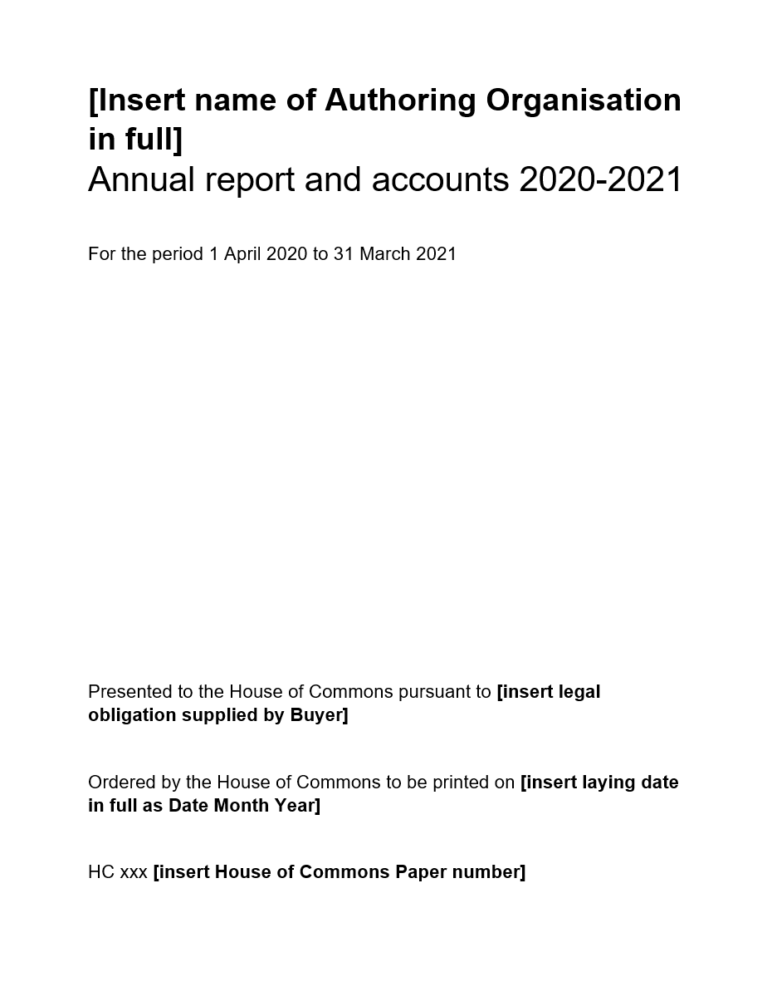

- Un-numbered Act Paper, page 1 (title page):

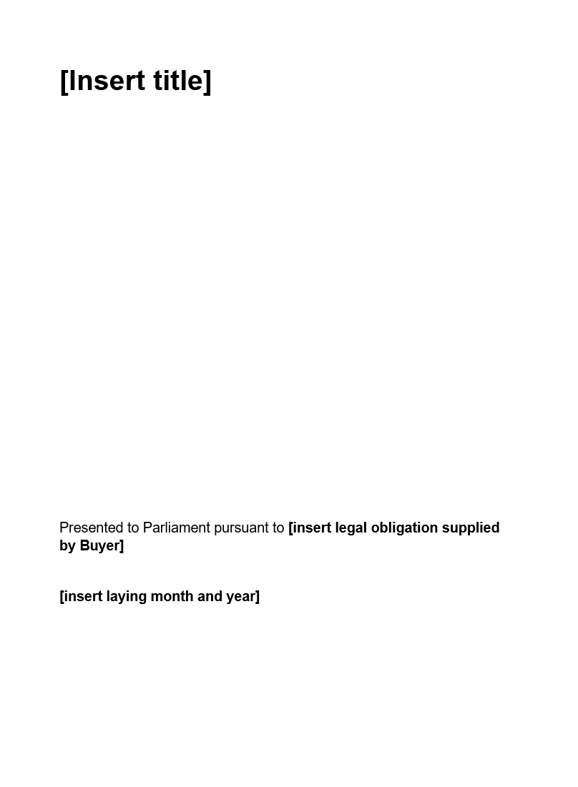

- Crown Copyright Paper, page 2 (copyright page) with ISBN:

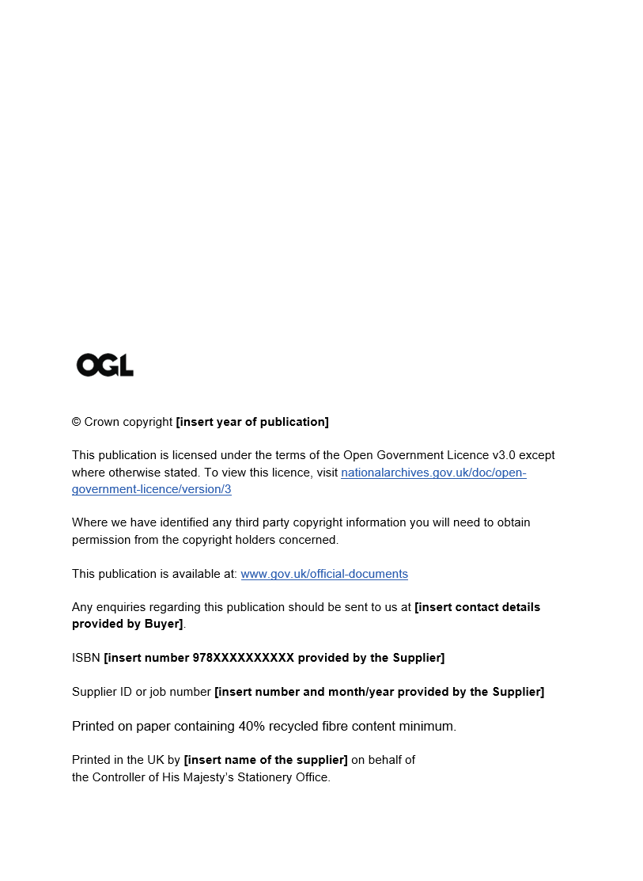

- Non-Crown Copyright Paper, page 2 (copyright page) with ISBN:

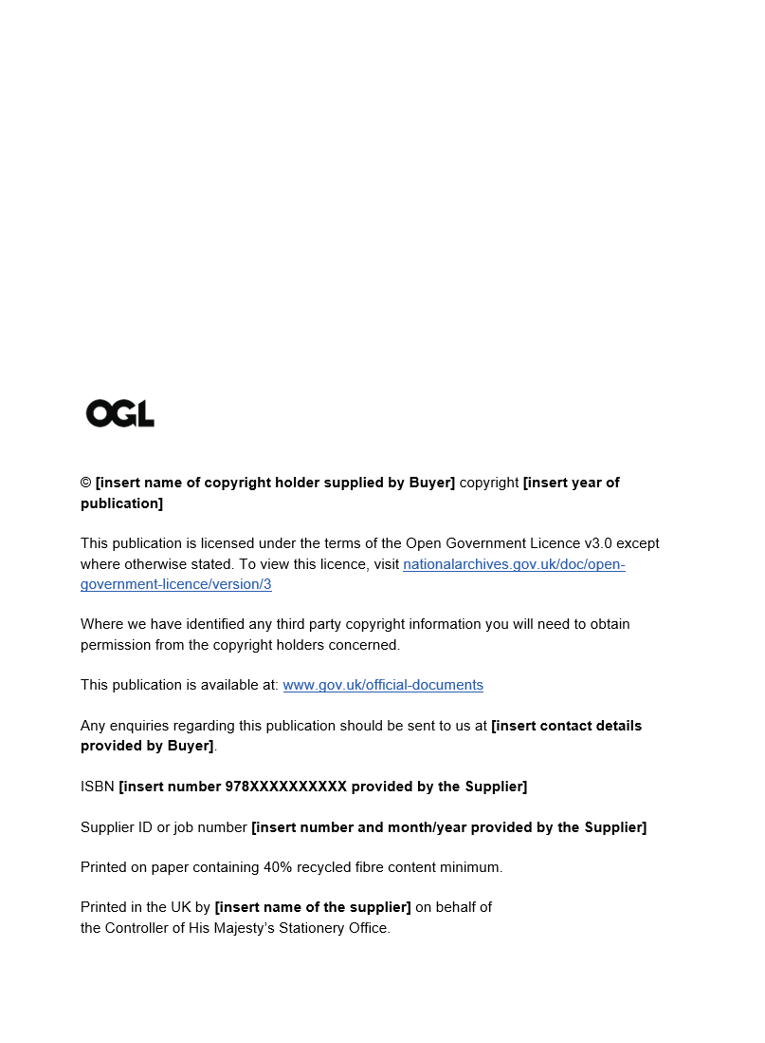

- Back cover, for Papers with an ISBN and/or Supplier ID or job number:



- The Supplier shall ensure that each Paper has one copyright statement on page 2.
- The Supplier shall ensure that Crown Copyright Papers include the latest Crown Copyright statement, as issued by the Controller of HMSO. The Controller of HMSO may vary the statement from time to time.
- Non-Crown organisations will supply their own copyright statement, or where a statement is unavailable, the Supplier shall recommend that the statement below be used. The Controller of HMSO may vary the statement from time to time.
- Where a Buyer provides a statement including ‘All rights reserved’, the Supplier shall draw the Buyer’s attention to the copyright holder’s potential obligations under the Re-use of Public Sector Information Regulations 2015. The Supplier shall also advise the Controller of HMSO.
- The current Crown copyright statement is (the current recommended non-Crown statement follows):



© Crown Copyright [insert year of publication]
This publication is licensed under the terms of the Open Government Licence v3.0 except where otherwise stated. To view this licence, visit nationalarchives.gov.uk/doc/open-government-licence/version/3.
Where we have identified any third party copyright information you will need to obtain permission from the copyright holders concerned.
This publication is available at: www.gov.uk/official-documents.
Any enquiries regarding this publication should be sent to us at [insert contact details].

- The current recommended non-Crown statement is:

© [insert name of copyright holder] copyright [insert year of publication]
This publication is licensed under the terms of the Open Government Licence v3.0 except where otherwise stated. To view this licence, visit nationalarchives.gov.uk/doc/open-government-licence/version/3.
Where we have identified any third party copyright information you will need to obtain permission from the copyright holders concerned.
This publication is available at: www.gov.uk/official-documents.
Any enquiries regarding this publication should be sent to us at [insert contact details].

- Any copyright and licensing queries should be put to the Controller of HMSO, as in exceptional circumstances other copyright statements should be used.

APPENDIX 4 – TEMPLATES FOR pAPERS’ CORRECTION SLIPS

- The Supplier shall apply templates when a Paper requires amendment through the correction slip process.
- The Controller of HMSO has made templates available for Buyers and the Supplier to use on The National Archives website:
http://www.nationalarchives.gov.uk/information-management/producing-official-publications/parliamentary-papers-guidance/correct-paper/

- Template for House of Commons Papers:

CORRECTION SLIP
Title: XXXXXXXXX
Session: Year/Year
HC XXX
ISBN 978XXXXXXXXXX
Ordered by the House of Commons to be printed Day Month Year

Correction
Text currently reads:
<insert details of current incorrect text>
Text should read:
<insert corrected text>

Date of correction: Day Month Year

- The Supplier shall adapt the House of Commons Paper template in respect of Un-numbered Act Papers.

- Template for Command Papers:

CORRECTION SLIP
Title: XXXXXXXXXX
Session: Year/Year
CP XXXX
ISBN 978XXXXXXXXXX
Date Laid: Month Year
Authoring Organisation

Correction
Text currently reads:
<insert details of current incorrect text>
Text should read:
<insert corrected text>

Date of correction: Day Month Year

- The Supplier shall adapt the Command Paper template in respect of Un-numbered Command Papers.

APPENDIX 5 – MI FOR COMMAND AND HOUSE WORKLOADS 2023/2024

Data covers Mar 2023 to Feb 2024. Month indicates month of invoicing, not necessarily the month activity took place (due to delays in provision of POs).
Data provided to demonstrate workload and variations in workloads between Mar 2023 and Feb 2024 and does not guarantee activity levels through RM6297 Print and Digital Communications.

Client Services
 | Department | % of Total Activity
1 | Foreign, Commonwealth and Development Office | 10.9%
2 | Home Office | 8.7%
3 | Cabinet Office | 4.0%
4 | HM Treasury | 3.6%
5 | Northern Ireland Department of Finance | 3.6%
6 | Ministry of Justice - Main MoJ | 3.5%
7 | DEFRA | 2.9%
8 | Department for Levelling Up, Housing Communities (DLUHC) | 2.8%
9 | Department for Business, Energy & Industrial Strategy | 2.5%
10 | Department of Health and Social Care | 2.3%
11 | Department for Education | 2.0%
12 | Department for Transport | 2.0%
13 | Department for Work and Pensions | 1.7%
14 | The Department for Culture, Media & Sport | 1.6%
15 | Department for Business & Trade | 1.2%
16 | Department for Energy Security and Net Zero | 1.2%
17 | The Financial Reporting Council Ltd | 1.2%
18 | Department for Digital, Culture, Media and Sport | 0.9%
19 | Independent Parliamentary Standards Authority (IPSA) | 0.9%
20 | Ministry of Defence | 0.9%

Figure 1: Table showing top 20 Departments by % of Total Activity (Papers Laid).
Total Papers Laid = 750

From the total of 233 Departments, two Departments (FCDO and Home Office) were responsible for circa 20% of total activity in Mar 2023 to Feb 2024 (based on 750 Laid Papers).
Number of Laid Papers | Number of Departments
82 | 1
65 | 1
30 | 1
27 | 2
26 | 1
22 | 1
21 | 1
19 | 1
17 | 1
15 | 2
13 | 1
12 | 1
9 | 3
7 | 3
6 | 1
5 | 5
4 | 5
3 | 12
2 | 34
1 | 156
 | 233

Figure 2: Number of Papers Laid by Departments (total of 750 Papers)
Figure 2 shows that 156 Departments only Laid one paper during Mar 2023 to Feb 2024.
One Department laid 82 papers.

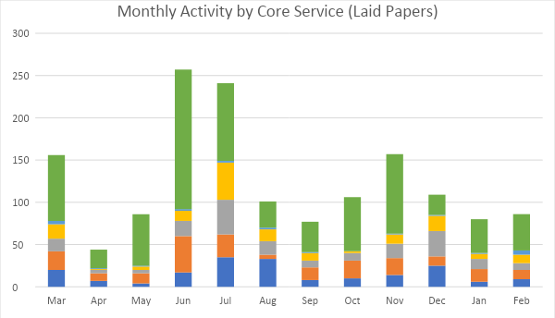
Figure 3: Monthly Activity Processed by Client Services (Laid Papers). Mar 2023 to Feb 2024. Date based on Invoiced Date. There was no activity for MS6 Core Service 6 during this period.

Core Service | Total
MS1 Core Service 1 | 188
MS2 Core Service 2 | 211
MS3 Core Service 3 | 182
MS4 Core Service 4 | 148
MS5 Core Service 5 | 21
Grand Total | 750

Figure 4: Table showing Total Activity (Laid Papers) by Core Service. Mar 2023 to Feb 2024.

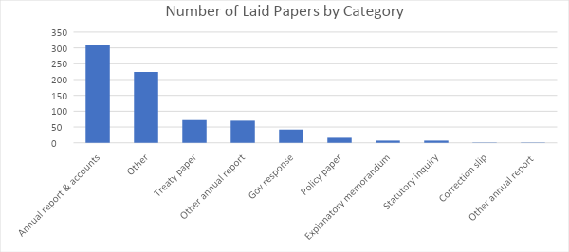
Figure 5: Number of Laid Papers Mar 2023 to Feb 2024 by Paper Category.

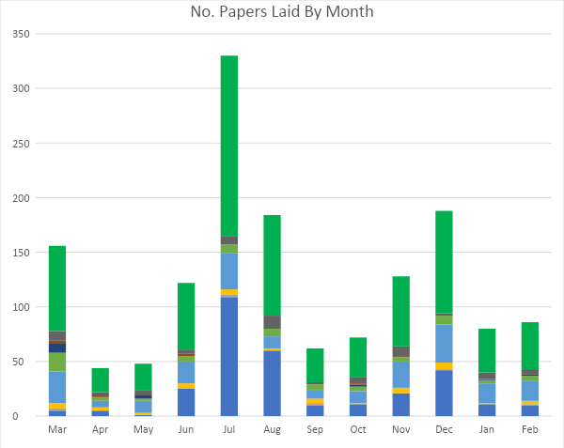
Figure 6: Number of Papers Laid By Month. Mar 2023 to Feb 2024.

Service Level Option | Total
20pt only | 2
Copy edit + Print | 2
Copyedit and Typeset | 3
Design | 1
Design & print | 2
Design, typeset | 4
design, typeset, print | 2
design, typeset, web +20pt, print | 1
edit, design, typeset, print | 2
Indesign to web + 20pt | 1
ISBN & print PDF | 8
ISBN & print PDF + 20pt + Govspeak | 1
ISBN & printed copies | 91
ISBN & Printed copies & Mail | 1
ISBN & Web only | 1
ISBN + 20pt | 11
ISBN + Print PDF + 20pt + Govspeak | 1
ISBN + print PDF +20pt | 1
ISBN + Word to PDF | 5
ISBN + Word to PDF + printed copies + Web | 1
ISBN and artworking | 1
ISBN only | 128
ISBN, printed copies & 20pt | 6
ISBN, Word to PDF, web, 20pt, printed copies | 2
ISBN+Word to PDF+Printed copies | 2
Master A/W, print, web and 20pt | 1
Print PDF + 20pt + web + Govspeak | 1
Print PDF + GovSpeak | 1
Print PDF + studio check + web | 1
Print PDF + web + 20pt | 2
Print PDF, Word file for web | 1
print, plus 20pt from InDesign | 1
Print-ready PDF | 96
Print-ready PDF + 20pt | 13
Print-ready PDF + 20pt + Welsh translation | 1
Print-ready PDF + Web PDF | 3
Print-ready PDF + Web PDF + 20pt | 2
Translation, Typesetting + web | 1
Typesetting | 4
Typesetting & web | 7
Typesetting + 20pt | 15
Typesetting + 20pt + web | 21
Typesetting + 20pt + Welsh Translation | 1
Typesetting + copyediting + web + 20pt | 1
Typesetting + web + Govspeak | 1
Web PDF + 20pt only | 1
Word to PDF | 18
Word to PDF + 20pt | 93
Word to PDF + 20pt + EasyRead + Welsh | 1
Word to PDF + 20pt + HTML | 2
Word to PDF + 20pt + web | 83
Word to PDF + 20pt + Welsh + Easy Read | 1
Word to PDF + 20pt + Welsh translation | 1
Word to PDF + GovSpeak | 1
Word to PDF + PDF supplied + Web | 1
Word to PDF + print | 5
Word to PDF + Web | 77
Word to PDF + web + 20pt + Govspeak | 3
Word to PDF + web + 20pt + other accessible products | 2
Word to PDF + web + 20pt + printed copies | 1
Word to PDF + web + printed copies | 2
Word to PDF + Welsh + 20pt | 1
Word to PDF + Welsh + HTML | 2
Word to PDF, standard and 20pt only | 1
Grand Total | 750

Figure 7: Table Showing Service Level Option for Monthly Activity Processed Mar 2023 to Feb 2024.

Studio
Deliverables
Average jobs per month: 44.6
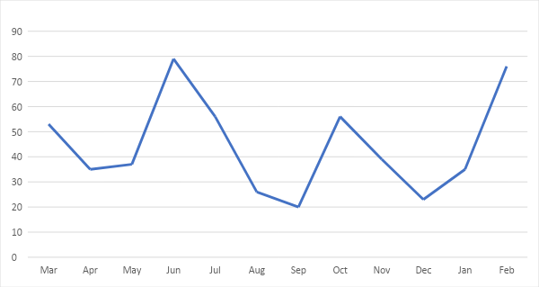

Figure 5: Studio jobs by month. Date based on start date.

Studio produced a total of 535 jobs. The difference between the number of laid papers and the number of Studio deliverables is due to the papers that do not require Studio services such as ISBN only, client supplying print files or their own printed copies.

