

RM6347 - Transport Technology
Digital Platform Buyer guidance: AWOC process

V1.3

Change Control

Version | Date | Amendments
1.0 | 14/112025
1.1 | 28/11/2025 | Removing some yellow highlighted sections
1.2 | 11/06/2026 | The GCA logo was added, and all references to CCS were amended to read 'GCA.' Additionally, the examples included in the screenshots were updated to align with current Basware capabilities.
1.3 | 23/06/2026 | Added a Summary feature allowing users to export all offers directly to Excel for easy comparison.

Introduction:

This guidance is to support buyers through the Digital Platform AWOC procedure through the Digital Platform (known as Basware) under the Transport Technology (RM6347) agreement.

The AWOC procedure will enable buyers to procure SERVICES and GOODS, however, goods without services can not be procured.

Please also read Framework Schedule 7 (Call-Off Award Procedure) for full information on the various compliant procurement routes to market.

Registration process:
To register for the Digital Platform please complete the form on the following page: https://www.crowncommercial.gov.uk/emarketplace-registration-form/

Once you are registered you will be able to login using the following link:

https://buyers.mpuk.basware.com/ui/admin

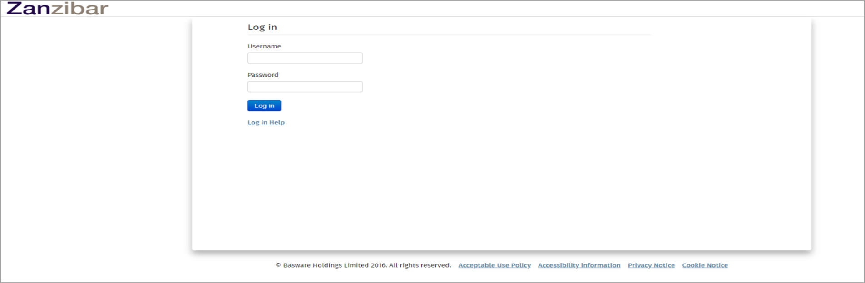
Once you have logged in you will see the following landing page where you can navigate to ‘Shopping’:

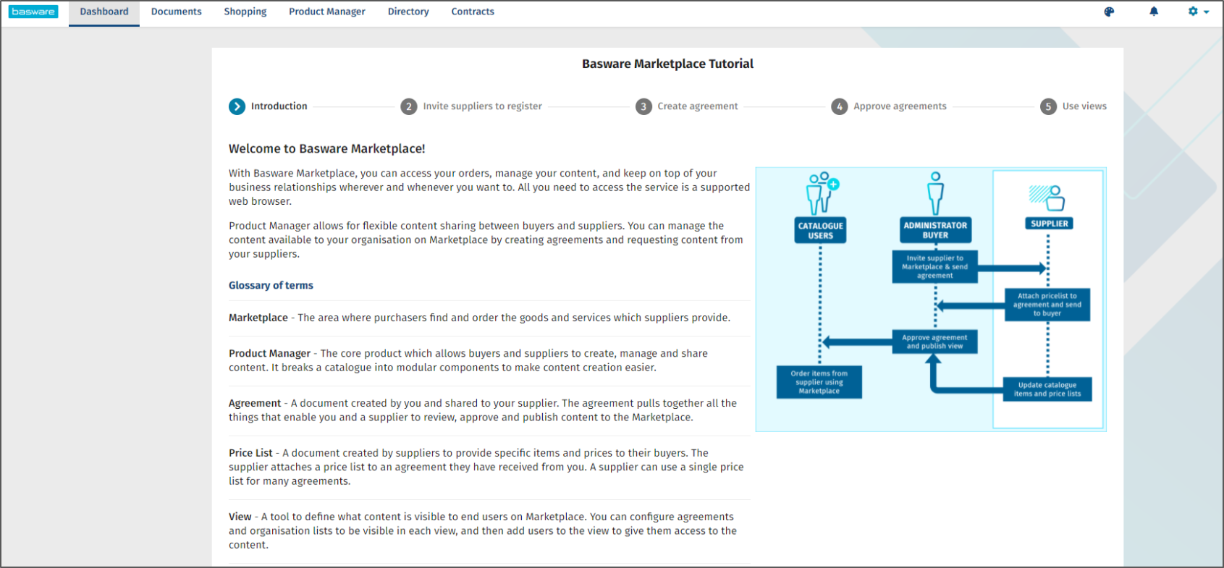

You will be taken to the ‘Marketplace’ tab where you can enter search terms into the search bar at this screen. We recommend you search using ‘RM6347’ but you can also search on any of the keywords detailed in the supplier’s full service offer template:

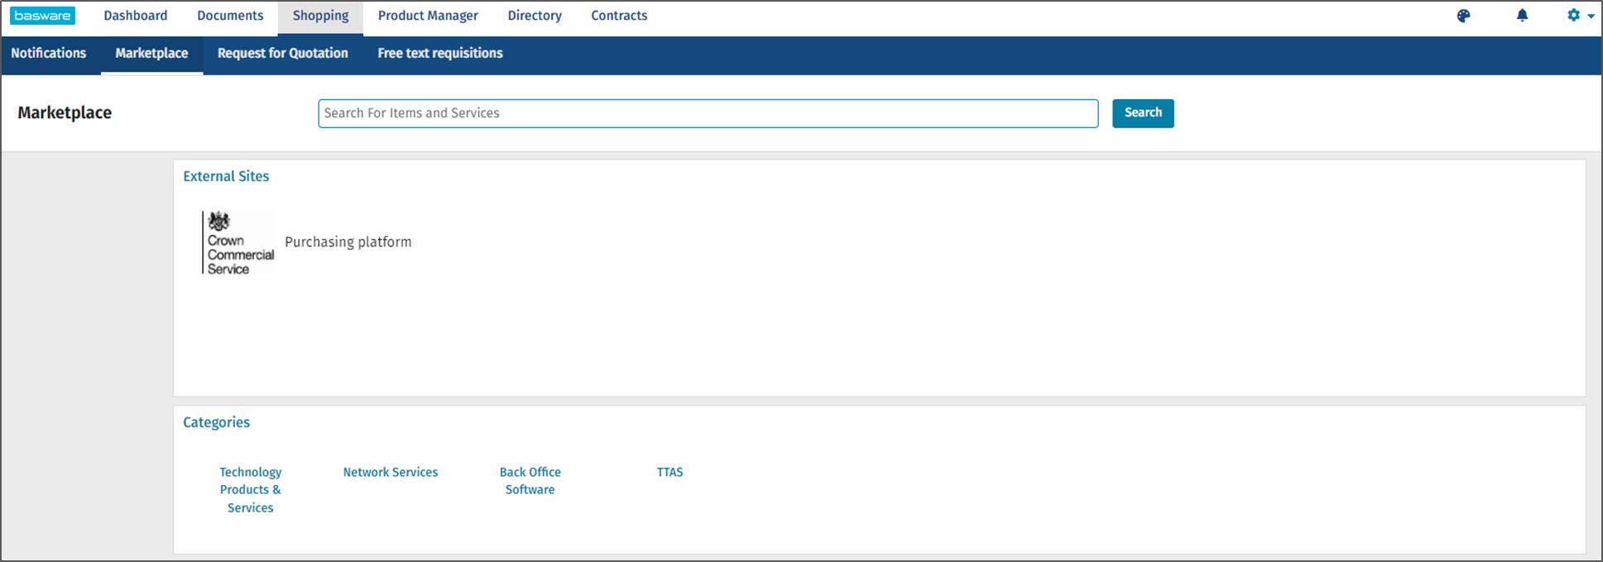
On the left hand menu, you will see a Contract Reference filter where you will select the procurement route (AWOC or Digital Comp) you wish to take:

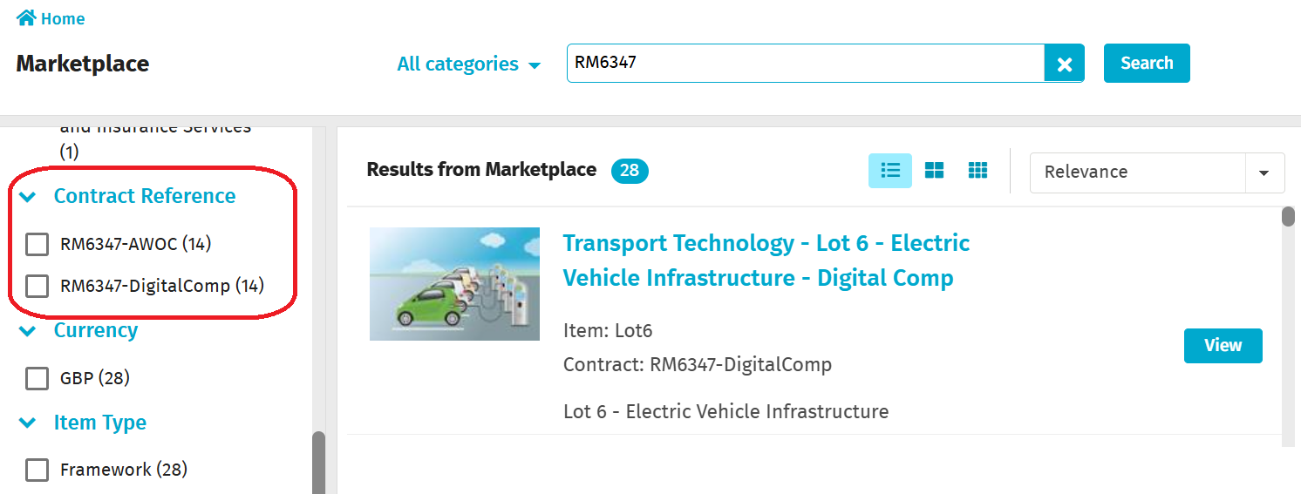
Once you have selected your procurement route, all the available offers will be visible for you to choose. The example on this screen is the AWOC route, and there are 14 offers:

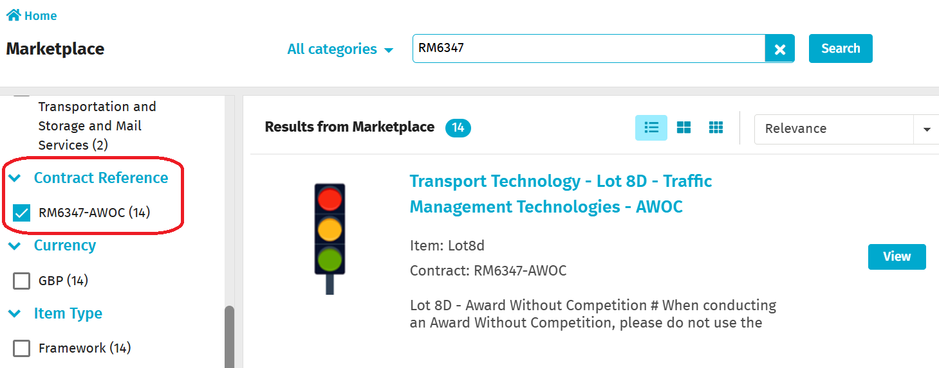

Find the Lot that you are interested in and Click on the View button. Here we will use Lot 4.

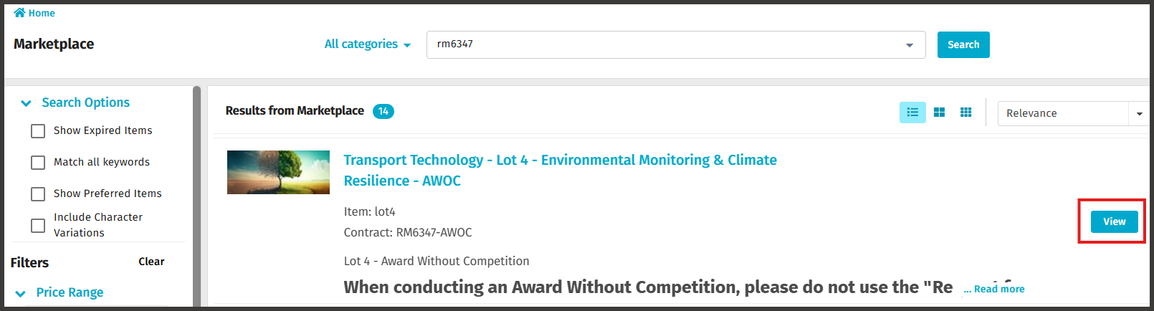

At this screen you will be able to select the suppliers who have published an offer against your chosen capabilities on this Lot.

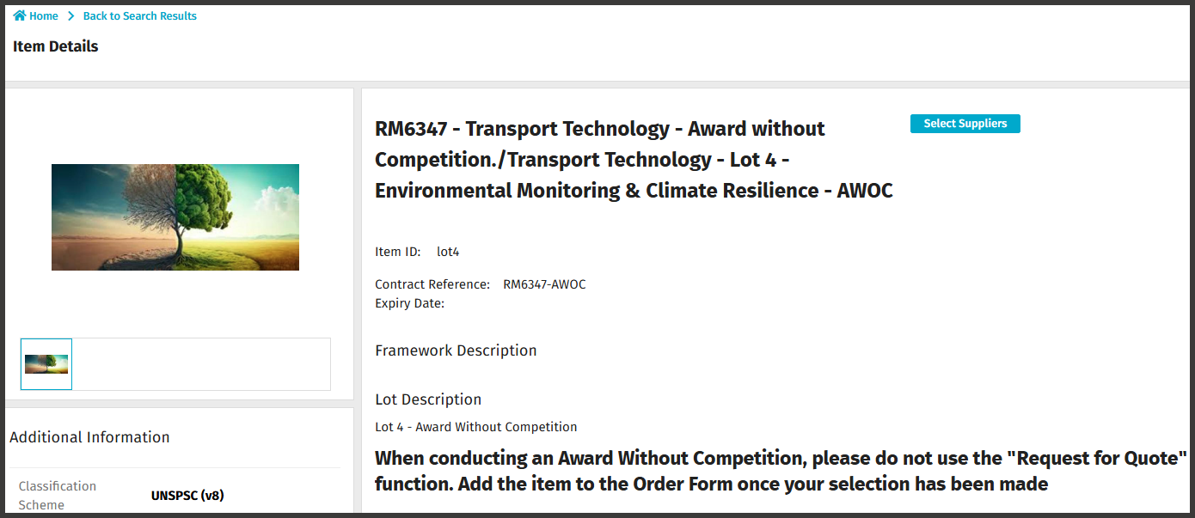

At this screen, you will need to select the ‘Capabilities’ that are relevant to your requirement. The full list of capabilities can be found in Framework Schedule 1 (Specification)

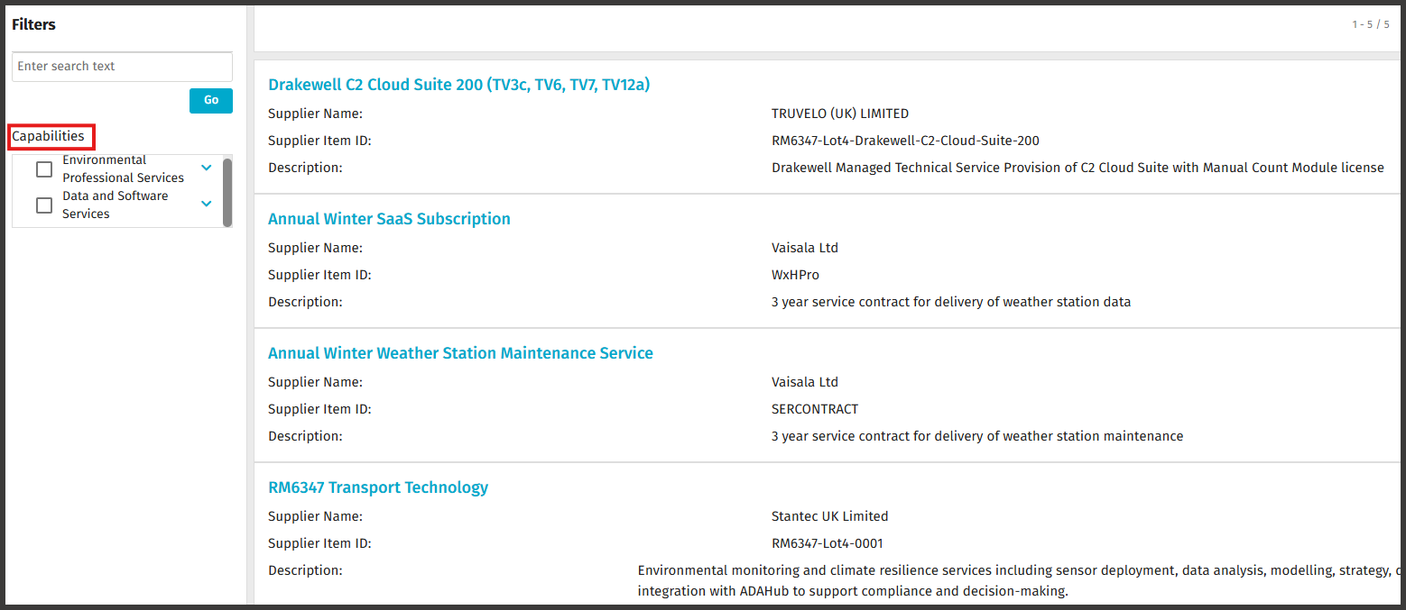

The example capability on this screen is ‘Environmental Professional Services’, and you will see the list of Suppliers who can provide this service. You will be able to click on ‘Export Items’.

Please note that this function will not export attachments, such as Full Service offers, that have been uploaded by suppliers for offer evaluation. In order to download attachments, you will need to click on each supplier’s offer separately.

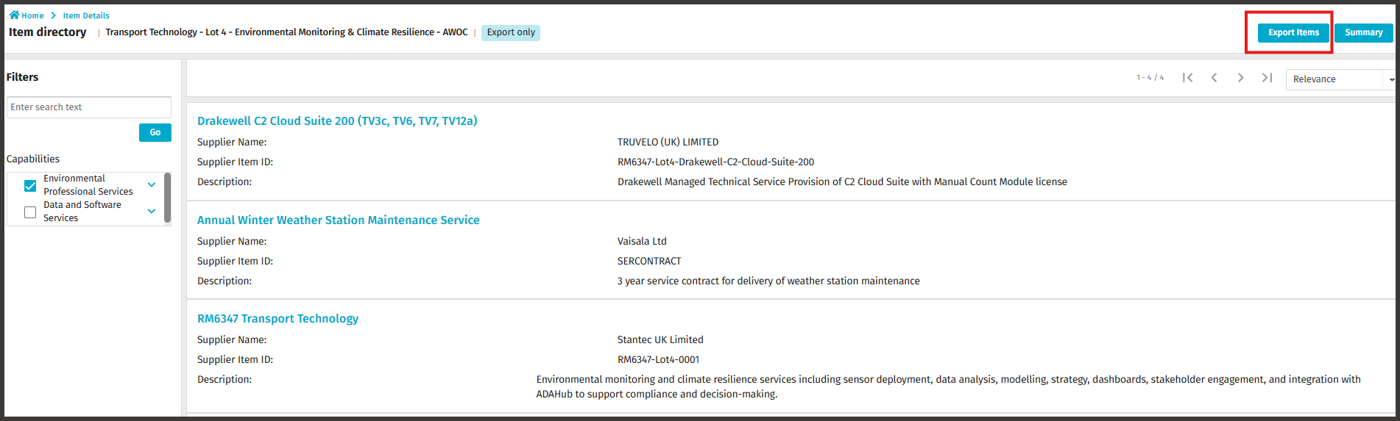

Alternatively, the Summary button consolidates the main information into a single spreadsheet for quick comparison of rates and services. For deeper insights, you can click on each offer individually to download its complete Full Service Offer attachment.

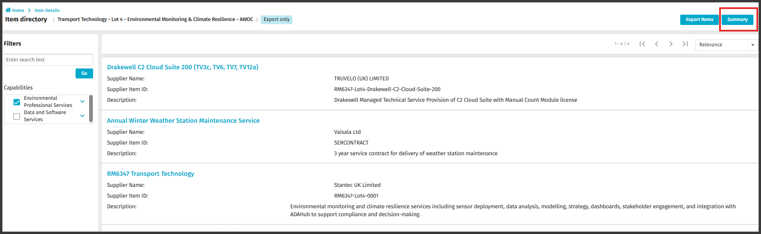

The Buyer must review the AWOC Full Service Offers to determine which ones meet their requirements. The evaluation should be based on the lowest Total Price of Day Rates rather than the Total Contract Price.

Award and complete the Order Form:
To make an AWOC award you must complete the Order Form at Framework Schedule 6 and send it to the successful supplier.

The Order Form must be completed in accordance with the Supplier’s AWOC offer.

Buyers must not include additional requirements to those as set out in the AWOC offer because the order will then be based on an invalid Service Offer which the Supplier can decline.

When the Order Form has been completed, signed and dated by both the Buyer and the Supplier, it will act as the binding call-off contract for the duration of the term.

If you need to amend your signed Call-Off Contract, it must be completed through formal Contract Variation Joint Schedule 2.

Contact points:
If you have any system based queries, there are 3 ways you can do this:
1. Contact the Basware Service Desk by raising a support ticket on:
Catalog Item (public) - Basware Customer Support

From the ‘How can we help you?’ dropdown please select ‘I need help with the UK Marketplace’.
2. Call 0330 822 8278
3. Use the chat option on the Basware website at:

https://www.basware.com/en/contact-us

However, if your query is around the actual process or compliance, please contact the GCA Transport team on infor@gca.gov.uk

Useful links:
Log in:
https://buyers.mpuk.basware.com/ui/admin
Supplier guide:
https://basware.service-now.com/bw?id=bw_kb_article&sys_id=9bc5fac81bad5418570fc9506e4bcb42

Customer Service Portal
Customer Service Portal - Basware Customer Support

