

RM6347 - Transport Technology

RM6347 Digital Platform Supplier Guidance - Responding to a Request for Quote (RFQ)

v1.1

Change Control

Version number | Date | Changes made
v1.0 | 23/10/2025 | - Original publication
v1.1 | 24/04/2026 | - Added instructions on how to turn on notifications  - Crown Commercial Services logo has been replaced with Government Commercial Agency

Introduction:

This guidance is to support suppliers through the process of responding to an RFQ on the Transport Technology (RM6347) agreement in the GCA Digital Platform – known as Basware.

Buyers will have published an RFQ following the Digital Platform Competitive Selection Process. If you have not published any offers on the platform, you will not be eligible to respond to the RFQ.

It is recommended that suppliers read Framework Schedule 7 (Call-Off Award Procedure) and the guidance which details how suppliers can publish their offers.

Registration process:
To register for the Digital Platform, please follow the instructions in the invite sent to you from either Basware or GCA. Once you have registered, you will receive emails containing your username and password. You can then login and begin creating your content:

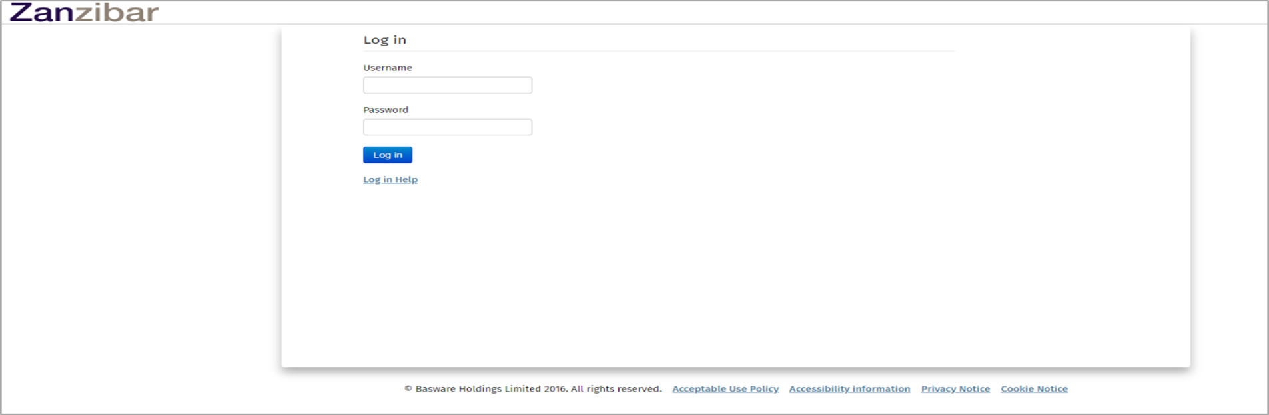

Once you have logged in and arrived at the following landing page, you will need to select the ‘Quotes’ menu:

You will then see your ‘Quick Quotes’ Dashboard at the following page. From this page you will be able to see your key document count as well as any outstanding or upcoming tasks such as ‘Watched requests’. By selecting the ‘See all’ or the ‘Documents’ tab you will be able to view all the documents that you have sent or received from the buyer regardless of status:

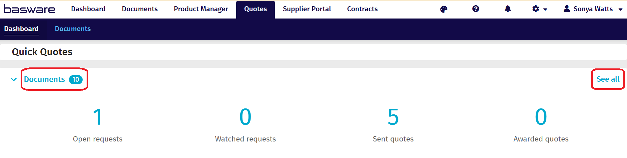

When responding to an RFQ, you will have received an email from the Digital Platform alerting you that an RFQ has been sent to you from a buyer, providing email notifications were enabled.
You can find the RFQ by clicking on the ‘Open requests’ at the following screen:

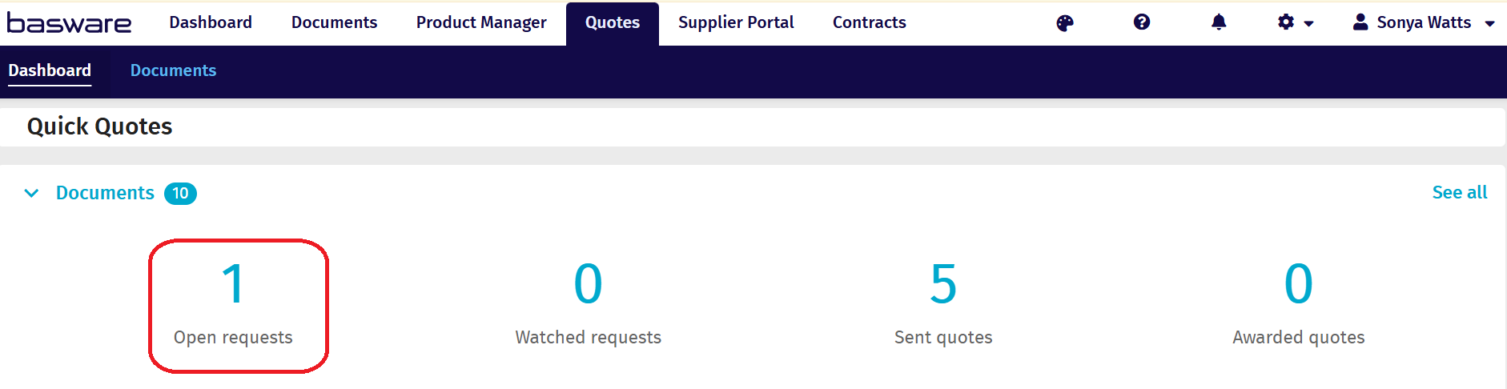

From this page you can either view the RFQ using the blue arrow or withdraw from the competition by selecting the 3 ellipses and then ‘Withdraw’:

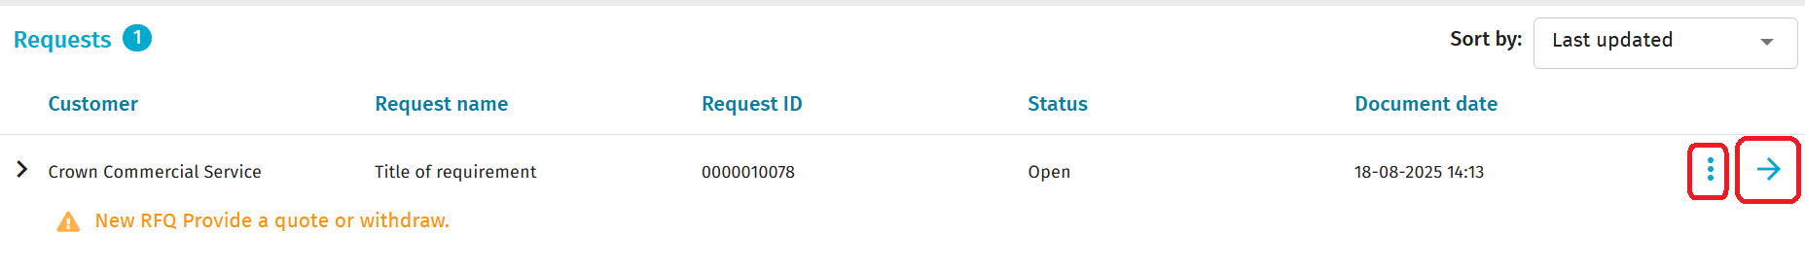
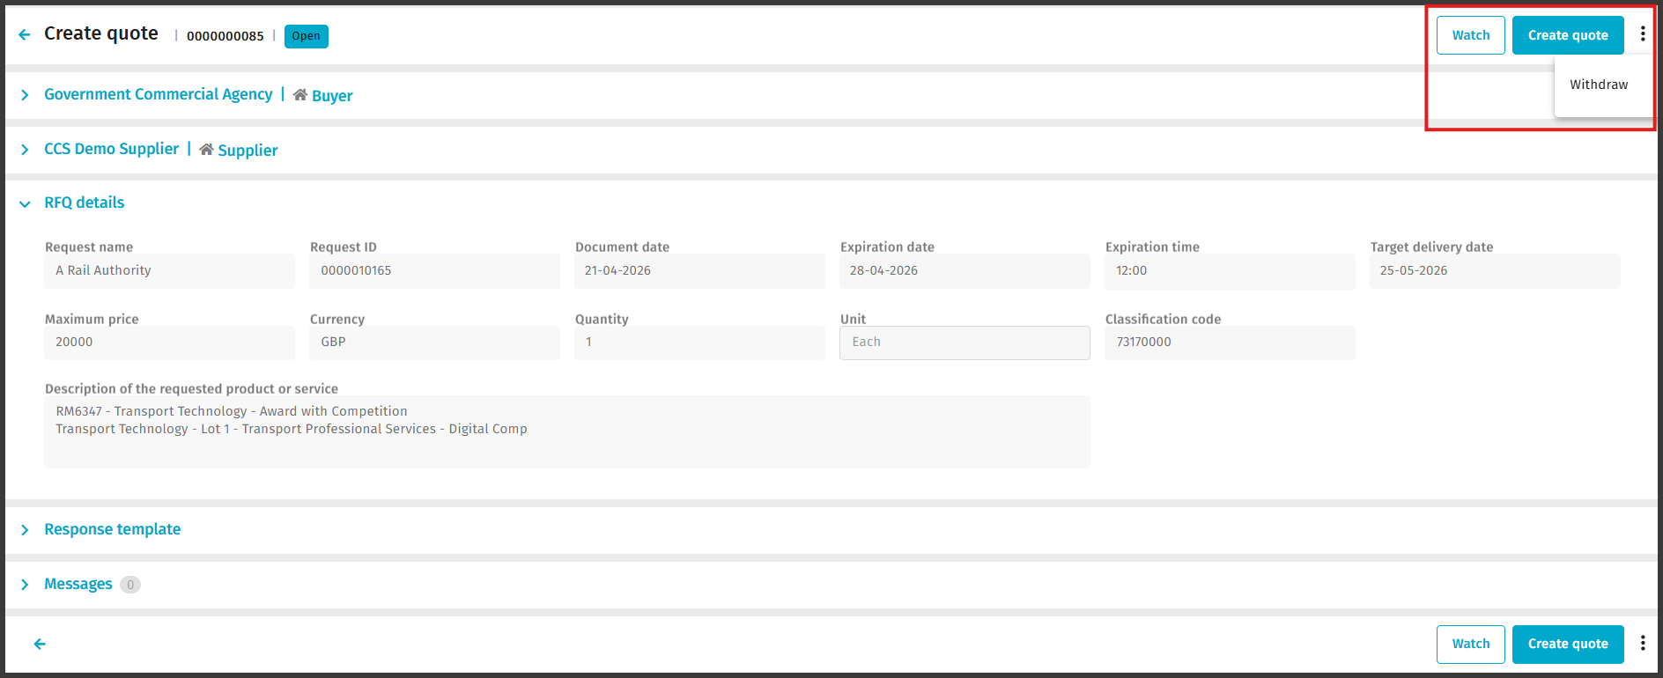

If you click on the blue arrow you will see a screen with the following headings:
- Buyer – this is the buyer who sent the request (collapsed as default)
- Supplier – these are your details (collapsed as default)
- RFQ details – these are the details of the request and the dates
- Response template - this shows the individual lines to quote against if the Buyer has requested it
- Messages – this is where you can send a message to the buyer if you have any queries. This is also where buyers can send messages to you. Please note that messages should not be used for negotiation but for clarification purposes only.

To expand any collapsed sections, you can either click in the white area lateral to the menu, the menu title or on the blue > arrow.
Using the bar at the top or at the very bottom you can decide whether to ‘Watch’, ‘Create quote’ or click on the ellipsis to ‘Withdraw’ from the competition:

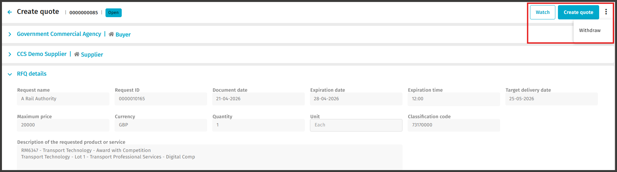
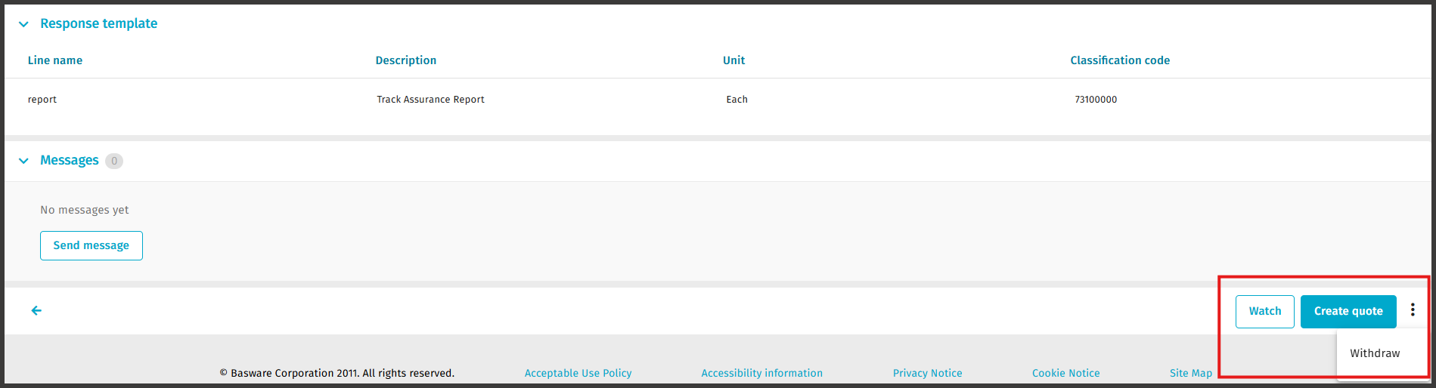

If you wish to provide a quote to the RFQ, click the ‘Create quote’ button and you will see a screen very much like the Request page, however if you scroll down, you will see 2 extra sections called ‘Quote Details’ and ‘Quote Lines’.
On the ‘Quote details’ select the pencil on the right-hand side if you wish to change the Quote ID. Changes to Delivery cost will be ignored. All prices should be contained with your RFQ response. Please note that the Quote ID is automatically numbered so if you wish to change it to your own quote number then this is the section to do it.
The ‘Quote Lines’ is where you will add your pricing.
The mandatory fields are marked with a red asterisk. Please note that some of the fields may not be amendable if they have been fixed by the buyer. An example might be the ‘Unit’.
Click ‘Save’ once you have made the changes to this section:

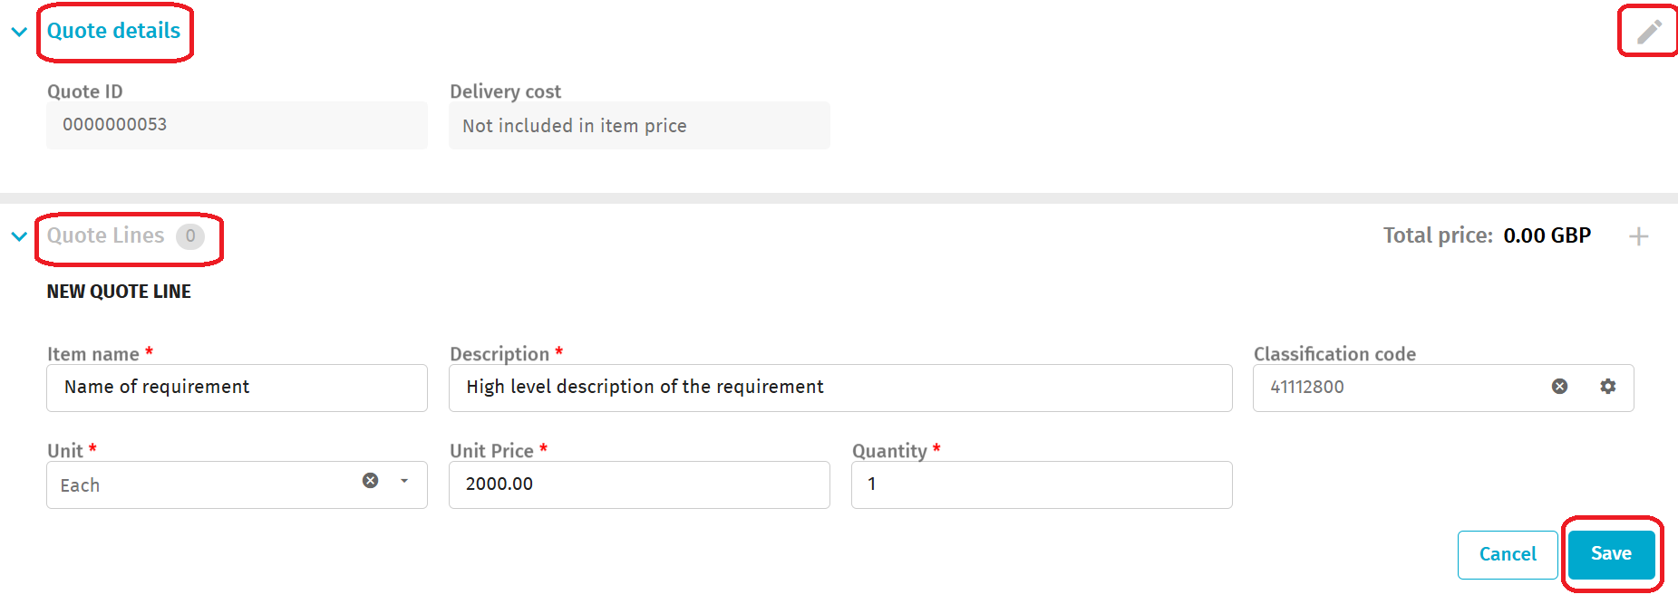
- Item Name is pre-populated but editable, we recommend this is not edited.
- Description can be edited to show your approach to this
- Classification Code is mandatory so please use 81101500 under UNSPSC (v19) which we’ve elected as “Engineering and Research and Technology based services”. This code will be generic for all supplier uploads and will not change the visibility of your RFQ
- Unit should be entered as “Each”
- Unit Price should be inserted as your total price submission in response to the RFQ
- Quantity should be left as “1”

Add an attachment (or multiple attachments) to detail your pricing to the Buyer, complying with paragraph 4.2.2 of Framework Schedule 1 - Specification.
Expand the ‘Attachments’ section by clicking on the blue down arrow. Here you can drag and drop single or multiple documents or select from a location. You can add up to 20 documents in multiple formats shown on the screen:
To provide pricing at this stage, you must upload a Full Service Offer Template, which will detail your precise offering in response to the RFQ. You may also upload your own quote to supplement the Full Service Offer document if necessary. For instance, if your initial platform offer included multiple products, you can use this to specify for the Buyer exactly which products you will be supplying to meet their requirements.
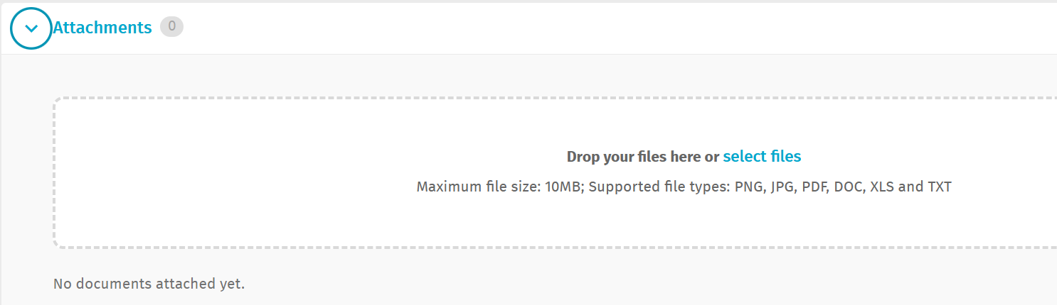

Note - if you have populated all the fields and uploaded your documentation but the “Send quote” option is greyed out, click “Quotes” at the top of the page and return to the open quote. This will not affect your progress but should resolve the issue.
You can also include a message to the buyer by opening ‘Messages’ via the blue > button:

You will then see a message pop up confirming that your quote was updated successfully. You will then be able to click on the ‘Send quote’ button:

You will then see a message pop up confirming that your quote was successfully sent to the buyer.
If you then go back to your dashboard, you will see that the number of ‘Sent quotes’ will have increased and the number of ‘Open requests’ will have decreased as per the following screen:

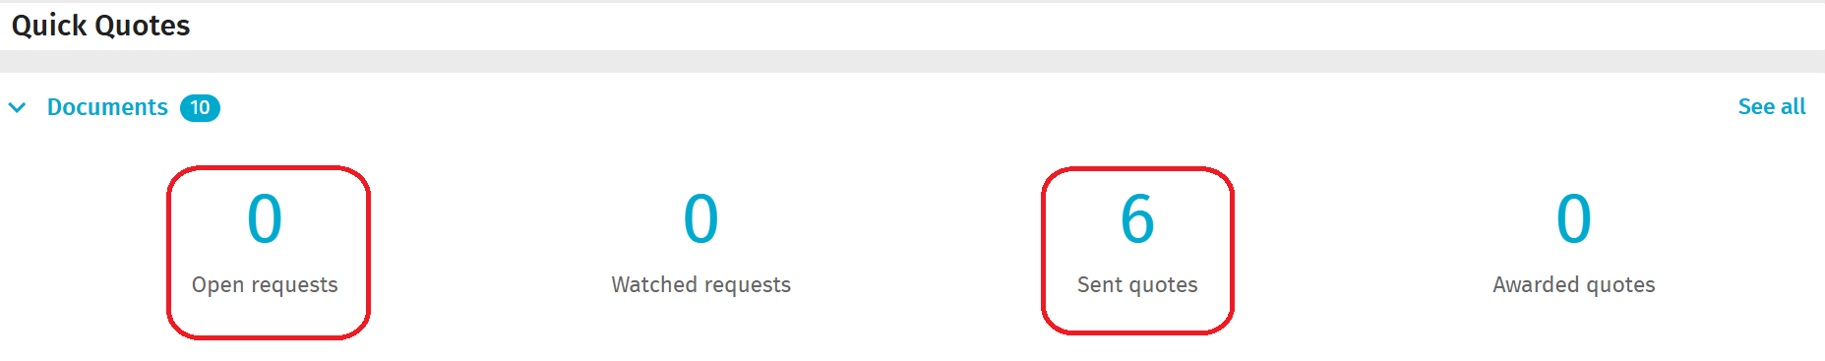

The buyer will then review your RFQ response. If you are successful, you should receive a notification (providing notifications are enabled), from the Digital Platform confirming the RFQ has been awarded to you.
Log into the Digital Platform and click on the ‘Quotes’ menu. At this screen you will see that you have an ‘Awarded quotes’.
Please note that the buyer does have the option to not send an award notification to the supplier through the Digital Platform. If this is the case, you will be notified by the buyer when they send you their completed Framework Schedule 6 Order Form.
If you fail to win the award, you might also not get a notification via the platform.

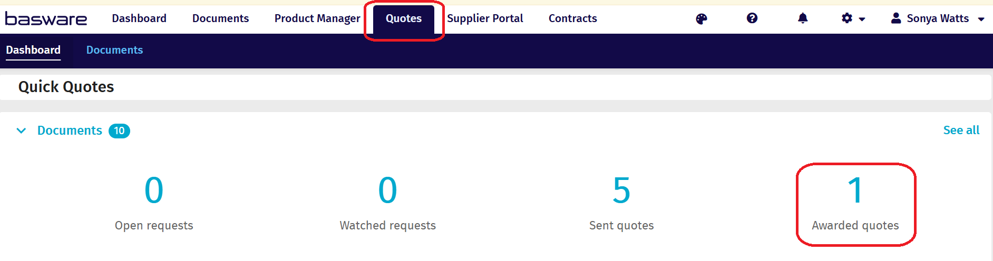

If you click on the ‘Awarded quotes’ you will then see this screen which confirms the ‘Status’ as ‘Awarded - Quoted’. If you then click on the blue arrow, you will see the full details of the RFQ and any messages that the buyer might have sent:

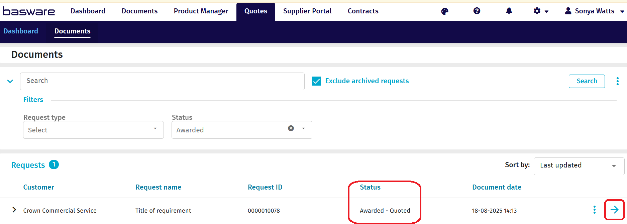
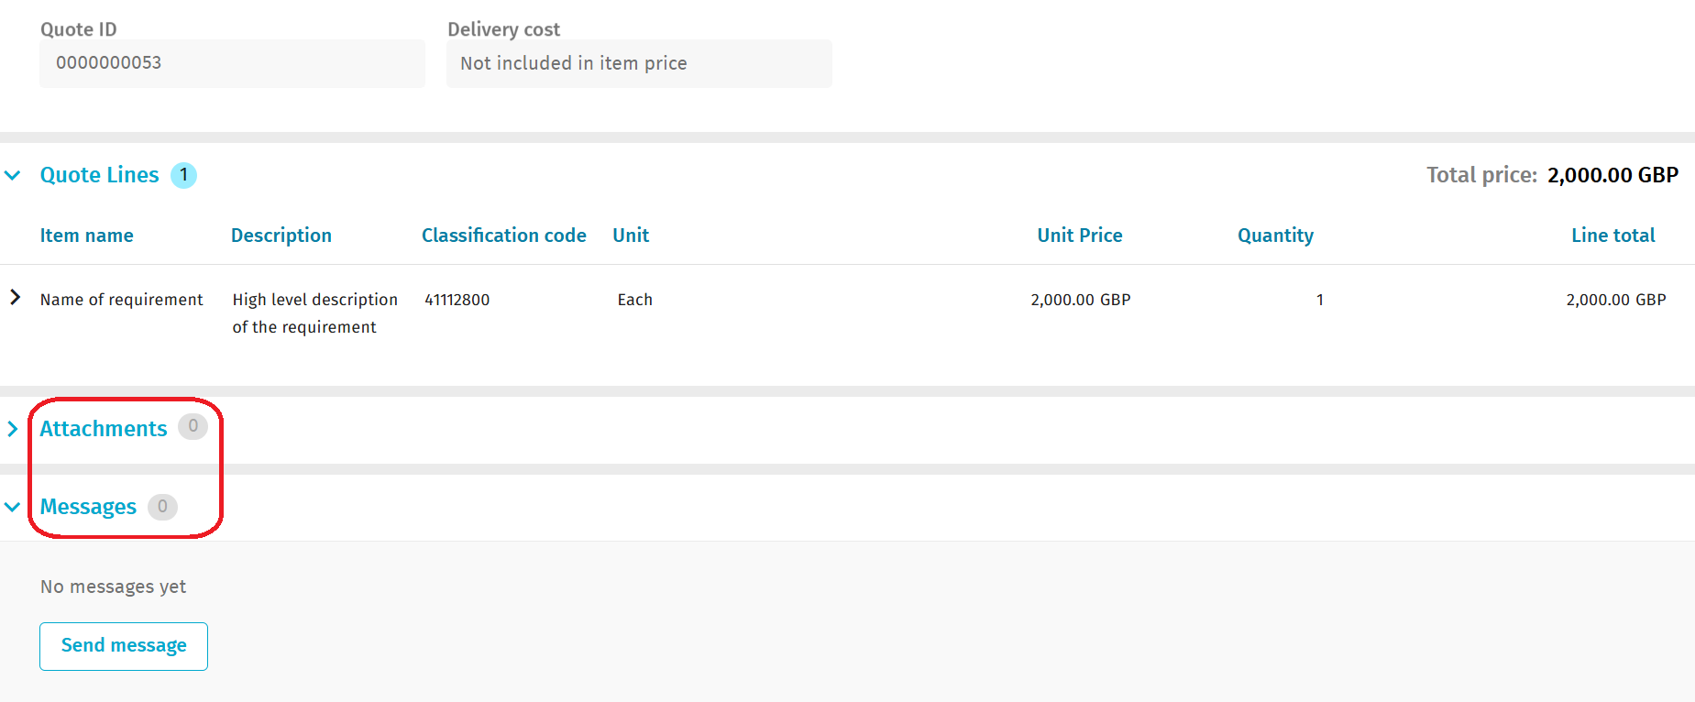

The supplier can now log out of the Digital Platform because the next stage will be done offline by working with the buyer to complete and sign the contractual order form at Framework Schedule 6.

Additional information you might find useful:

How to search for a document:

If you just want to search the RFQs to remind yourself of their status, you can click on the ‘Search’ button in the ‘Quotes’ menu and then click on either the ‘Request type’ filter or the ‘Status’ filter dropdowns:

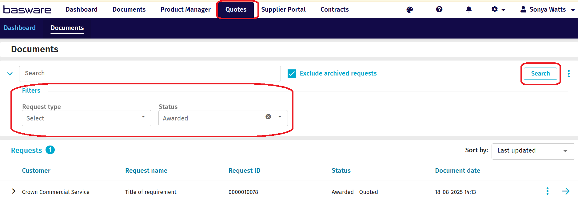

How to enable notifications:
Click on the settings button (cog symbol) on the top right of the page.
From the drop-down menu, press 'Organisation management'.
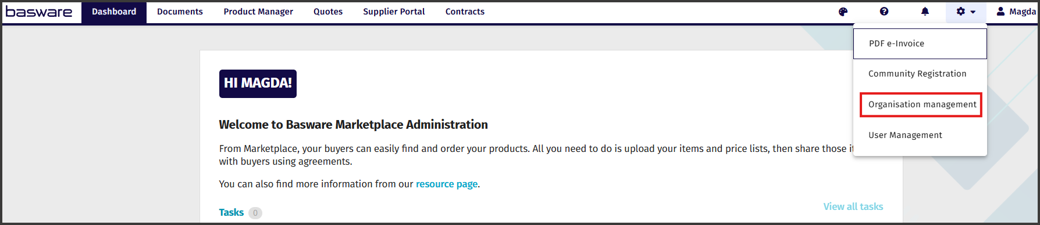
Click 'Contact information' to expand this section.
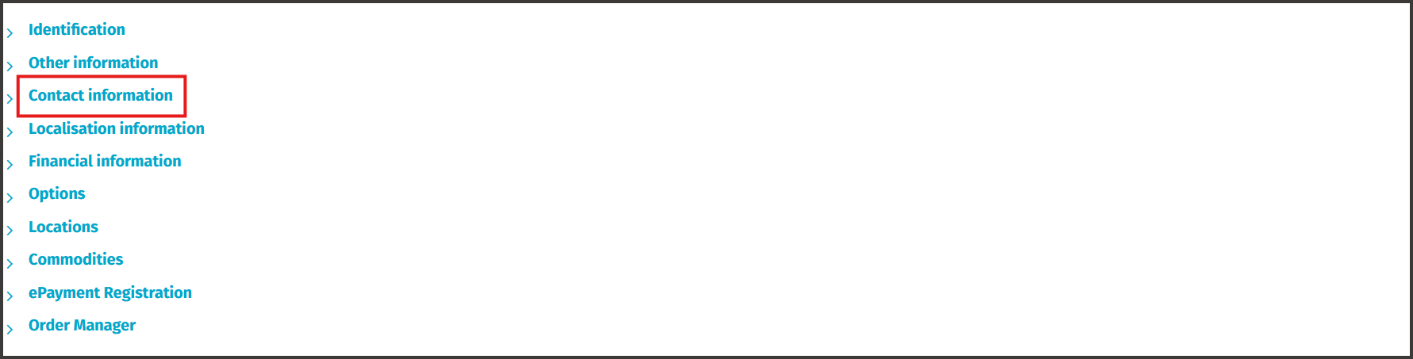
In this section, find the field titled 'Notification recipients:', add an email address to it.
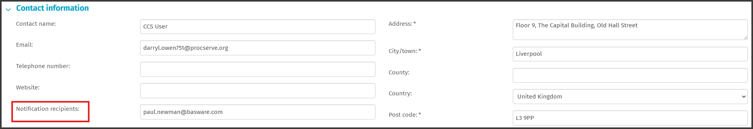
Then press 'Save' in the top right corner of the page.

Contact points:
If you have any system-based queries, there are 3 ways you can do this:
1. Contact the Basware Service Desk by raising a support ticket on:
Catalog Item (public) - Basware Customer Support

From the ‘How can we help you?’ dropdown please select ‘I need help with the UK Marketplace’
2. Call 0330 822 8278
3. Use the chat option on the Basware website at:

https://www.basware.com/en/contact-us

However, if your query is around the actual process or compliance, please contact the GCA Transport team on transporttechnology@crowncommercial.gov.uk.

Useful links:
Log in:
https://buyers.mpuk.basware.com/admin/login/auth

Supplier guide:
https://basware.service-now.com/bw?id=bw_kb_article&sys_id=9bc5fac81bad5418570fc9506e4bcb42

Customer Service Portal
Customer Service Portal - Basware Customer Support

