

RM6347 Transport Technology

RM6347 Digital Platform Supplier guidance - Publishing Offers

v1.1

Change Control

Version number | Date | Changes made
v1.0 | 23/10/2025 | - Original publication
V1.1 | 24/04/2026 | - Crown Commercial Service renamed with Government Commercial Agency.  - Pages numbered  - Change Control record added

Key Steps:

Register | Agree T&Cs | Create your service offer | Publish your offer

Introduction:

This guidance is to support suppliers with creating and publishing compliant offers for the Transport Technology (RM6347) agreement into the GCA Digital Platform – currently Basware.

Your offers will provide buyers with an easy and compliant route to procure simple goods and services and will minimise intervention from GCA for non-compliance.

It is recommended that suppliers read Framework Schedule 7 (Call-Off Award Procedure).
All published offers on the Digital Platform must:
- meet the requirements of either the Digital Platform Competitive Selection (paragraph 7 of Framework Schedule 7) or the Digital Platform AWOC procedure (paragraph 6 of Framework Schedule 7),
- be set out using the relevant Digital Platform Item Template (paragraph 14.1 of Framework Schedule 7) called Full Service Offer Template,
- be available on the platform for a minimum of 30 calendar days (paragraph 12.5 of Framework Schedule 7),
- be open to all buyers and not contain any wording that indicates it’s specific to a particular buyer.

Registration process:
To register for the Digital Platform, please follow the instructions in the invite sent to you from either Basware or GCA. Once you have registered, you will receive emails containing your username and password. You can then login and begin creating your content:

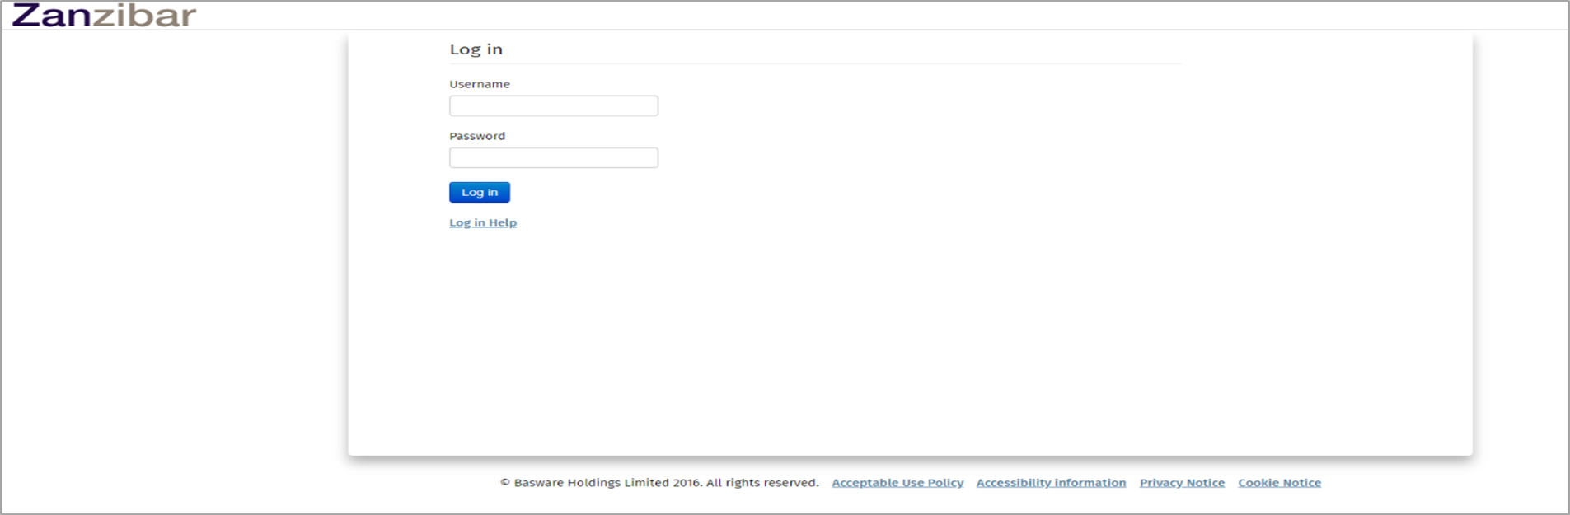

Once you have logged in and arrived at the following landing page, you will need to select the ‘Contracts’ menu.

Once you have entered this menu, you will see all the contracts available for you to publish your offers against. Search “RM6347” in the search field to find contracts related to this guidance and the Transport Technology Framework.
The contracts are another name for the RM6347 Lots which you were awarded a place on during the tender stage.
There are 28 Lots in total, and they have been broken down as follows:
- ‘AWOC’ (Award Without Competition) – Lot 1 to Lot 8E

- ‘Digital Competition’ (Digital Platform Competitive Selection Process) – Lot 1 to Lot 8E
Important note:
The AWOC procedure is for the procurement of SERVICES only
The Digital Platform Competitive Selection Process procedure is for the procurement of any deliverables as defined in Framework Schedule 1 (Specification).

Please ensure you locate the correct Lot and the correct procedure and then select the icon below in the red square. This will then open the applicable contract qualification page.
The examples below are for a Digital Comp and an AWOC under Lot 8D (Traffic Management Technologies):

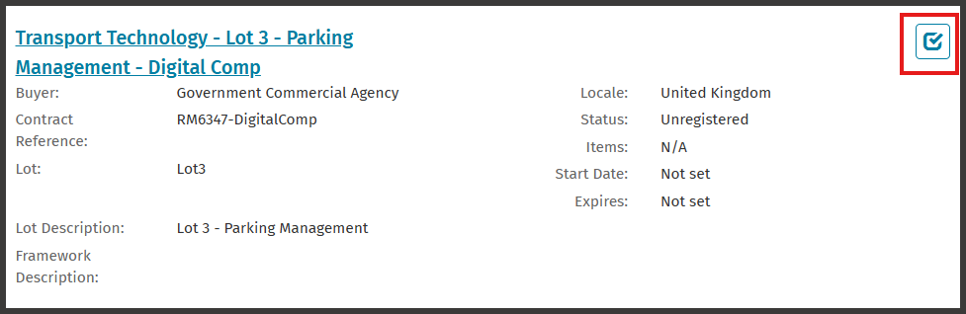

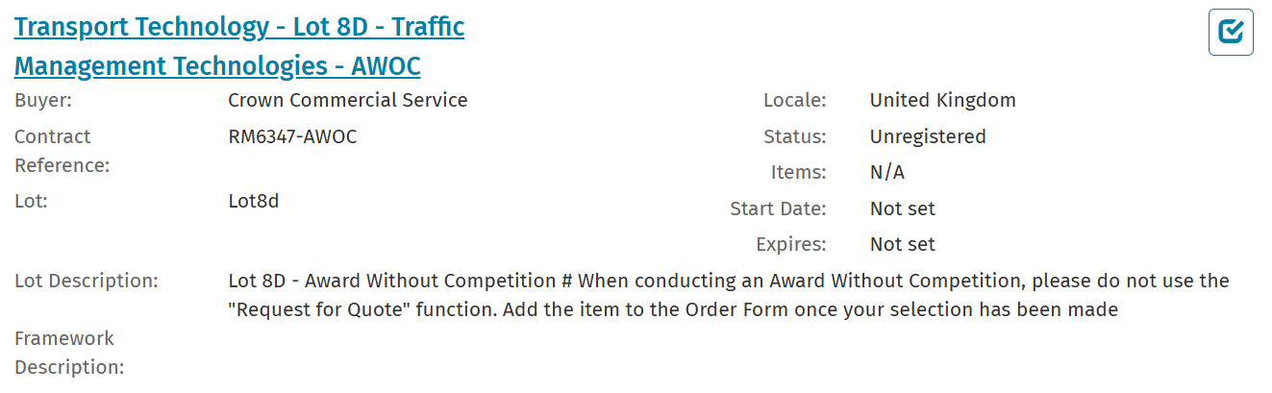

When you click on the Lot name hyperlink you will see the following screen which will ask you to enter your company email address and sign up to the Lot specific T&Cs.
PLEASE NOTE:
GCA will manage the authorisation process to access these lots, so you may be rejected for one of the following reasons:
- Declaring “No” to accepting the terms will result in rejection. If you believe this was made in error you must contact transporttechnology@crowncommercial.gov.uk
- You are not an awarded framework supplier on any lot. You will not be granted access to this platform in any capacity.
- You are not an awarded supplier for this lot but are a framework supplier. You are not permitted to sell goods or services via this lot and will be rejected and cannot be awarded a place for lot at any time
- You are or become a suspended or excluded supplier on our Framework, your access will be rejected or revoked depending on when the action is taken

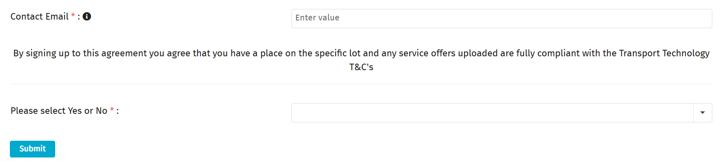

Once you have clicked on the above ‘Submit’ button, you will be placed in a “Pending” status awaiting action from GCA to validate your position and grant you access.
Whilst in the pending status you will still be able to access and populate offers. However, they will not be visible to buyers until GCA approves your lot position. We recommend that you don’t wait for Lot approval to begin the development of your offers.

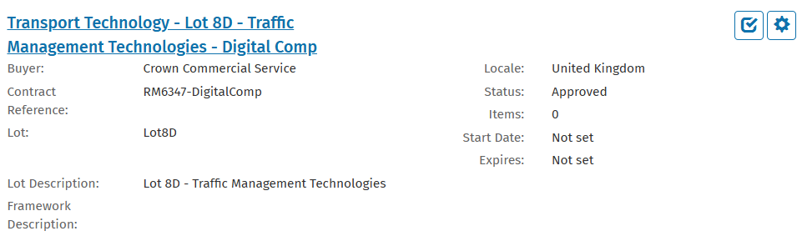

Click on the ‘Manage items’ cog in the red square box, and you will then be presented with this screen:

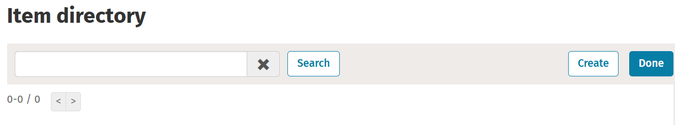
Click the ‘Create’ button on the top right, and then complete all the mandatory criteria in the following 2 screens.
The criteria will include multiple choice, single select and areas for you to type in. Those with a red asterisk are mandatory fields.
This process relies upon you having completed the full service offer template, so please refer to our guidance to get that developed to complete this process.
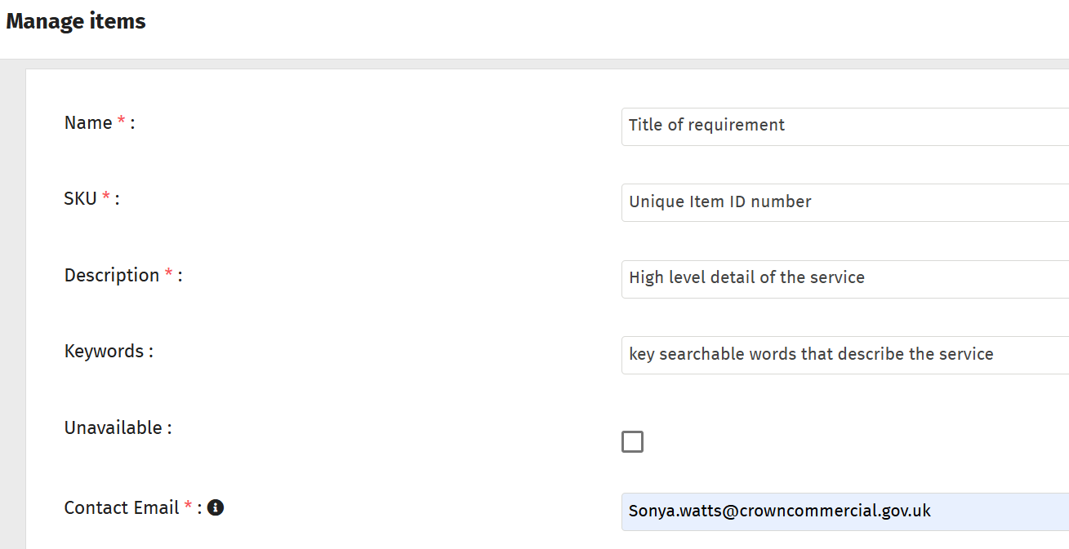

- Name is the title of your offer.
- SKU is the offer ID to fit the item format in the template provided and it must conform to the RM6347-Lot Number-Service Description naming convention
- Description is a high-level description of your services
- Keywords are search tags and a full list is available in the full service offer template. These are not mandatory but can help buyers search for offers when browsing the catalogue
- The ‘Unavailable’ box is for the supplier to make their offer invisible to buyers until they are happy for it to be visible. The default position is for this box to be unticked. Please note that this will not override the “Pending” status visibility above.
- Contact email should be the email of the supplier
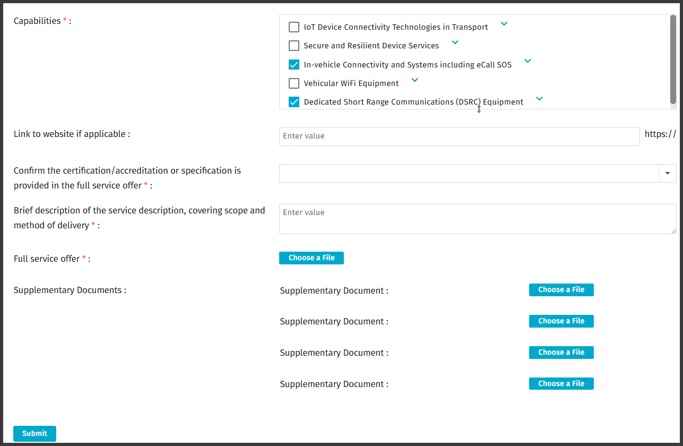

- Capabilities relate to the type of services you are offering which are directly drawn from the Framework Schedule 1 - Specification. Under these, specifications may be included that buyers can use to narrow their search. It is a supplier responsibility to ensure your offer is accurately reflected. You can select more than one, but you should not select any that your offer doesn’t cover. GCA will audit these offers periodically and will remove any offers uploaded that do not accurately reflect the capabilities selected.
  - If you offer services via a Key-Subcontractor in your offer, please ensure these are a nominated key subcontractor in your Framework award form
- Link to website allows a supplier to insert a link to their own website.
- Certification/Accreditation or specification is a confirmation that any specification details you select are evidenced in an upload. If none are selected, a “no” will not impact your offer.
- Brief description covers a high-level description
- Full service offer is where you must upload your Digital Platform Item (Full Service Offer template).
- Supplementary Documents is where you upload your specification certification, technical details or any other requirements you have. Maximum 4 documents can be uploaded.
- Choose a file button is where you will upload the GCA template which will describe your full service offer. You can also upload supplementary documents that demonstrate compliance with specifications on the platform.
Important note:
You must not include any pricing details if publishing an offer against a Digital Comp procurement. This is because you will be required to submit your pricing at a later stage following an RFQ request from the buyer.
You must submit a price for all your AWOC offers, so you will see this additional screen where you will input your total price:

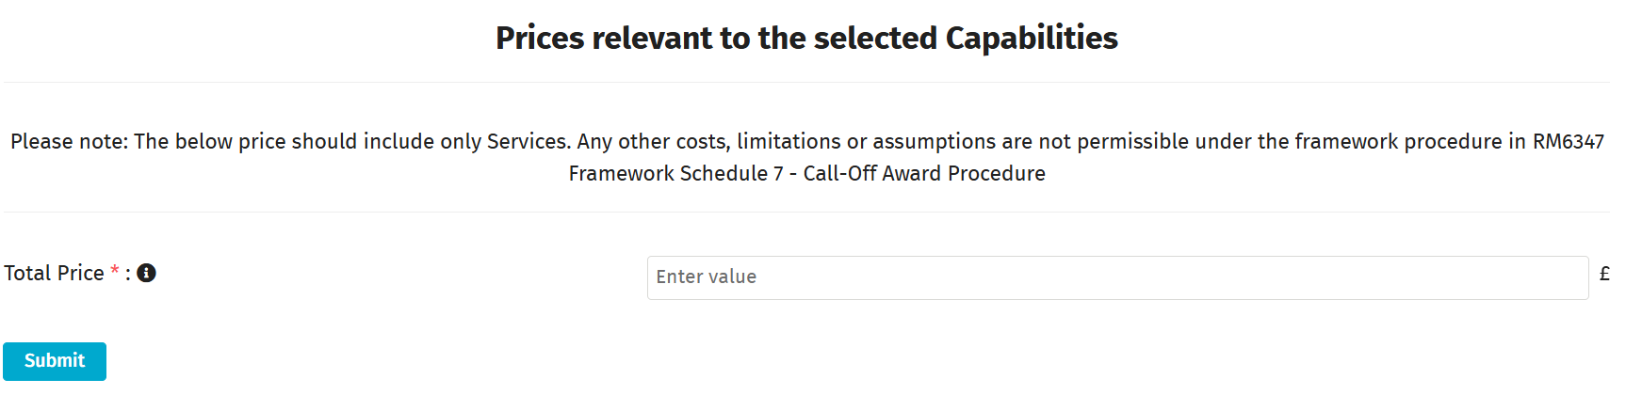

Once complete, click ‘Submit’ at the bottom of the page.
You will then be presented with this screen, so click the ‘Done’ button:

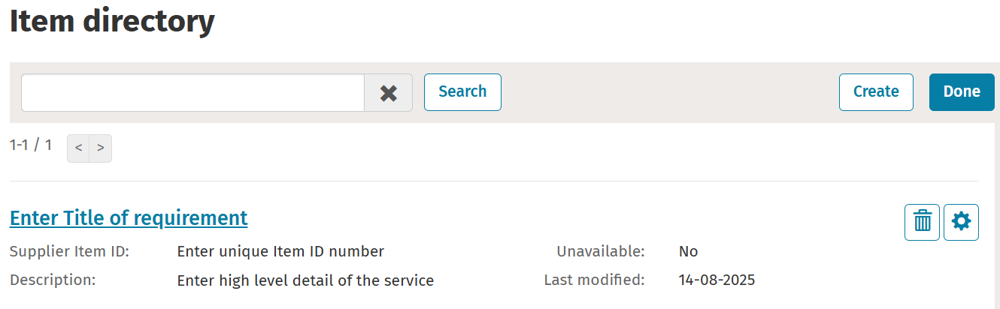

Congratulations! You have now published your offer.
If you are unsure of what the question is asking, tool tips are available on most of the questions under the icon.

Approvals:
Please note that the approvals have all been set to auto approve. GCA will periodically audit uploads to check compliance.
You will receive a notification to confirm that your offer has been approved from no-reply@no-reply.mpuk.basware.com.

Contact points:
If you have any system based queries, there are 3 ways you can do this:
1. Contact the Basware Service Desk by raising a support ticket on:
Catalog Item (public) - Basware Customer Support

From the ‘How can we help you?’ dropdown please select ‘I need help with the UK Marketplace’.
2. Call 0330 822 8278
3. Use the chat option on the Basware website at:

https://www.basware.com/en/contact-us

However, if your query is around the actual process or compliance, please contact the GCA Transport team on transporttechnology@crowncommercial.gov.uk.

Useful links:
Basware Log in page:
https://buyers.mpuk.basware.com/admin/login/auth

Supplier guide:
https://basware.service-now.com/bw?id=bw_kb_article&sys_id=9bc5fac81bad5418570fc9506e4bcb42

Customer Service Portal
Customer Service Portal - Basware Customer Support

