Call-Off Schedule 28 (Additional Works)
[Buyer guidance: The Buyer should insert further detail in Annex 1- Additional Works and Approvals Process, to reflect their requirements]
- In each Contract, unless the context otherwise requires, the following words shall have the following meanings:
“Inclusive Repair Threshold Event” | [is a single occurrence of a fault or breakdown that requires remedial action, regardless of how many Assets or components of Assets are involved, provided they are part of the same fault diagnosis and resolution process. Follow-up works that are part of the same fault diagnosis and resolution process shall be treated as the same Inclusive Repair Threshold Event]  [Buyer guidance: The Buyer may amend the above to reflect their requirements, If no further details are required by the Buyer, please remove the square brackets and yellow highlight]
- Introduction
  - This Schedule prescribes the procedure, calculations and rates to be used by the Buyer and Supplier when assessing the Charges for Additional Works.
  - For the avoidance of doubt, nothing in this Schedule shall give the Supplier exclusive rights over Additional Works and the Buyer is not required to order Additional Works from the Supplier, and is entitled to order Additional Works from other suppliers.
  - The Buyer reserves the right to vary or amend this Schedule as part of a Call-Off Award Procedure.
- Additional Works
  - All Additional Works shall follow the Additional Works and Approvals Process within Annex 1. The Buyer may at its discretion require Additional Works to be:
    - managed and executed by the Supplier;
    - managed by a Buyer third party and executed by the Supplier;
    - managed by the Supplier and executed by any Buyer third party.
  - Any estimate/quotation for Additional Works shall breakdown the costs in the categories below:
    - labour;
    - parts;
    - replacement Assets;
    - materials;
    - plant and equipment;
    - such other applicable cost categories as the Buyer may notify the Supplier from time to time;
    - Subcontractor name and total cost (including Subcontractors profit and overhead) if applicable;
    - Additional Works overhead and management costs including but not limited to:
      - processing and managing the quotation/tenders within each tier as per the Buyers process;
      - management of works;
      - management of subcontractors (where applicable); and
      - day to day administration.
    - Supplier Profit, as stated in the Pricing Matrix; (Profit is applicable to all cost components listed at 3.2.1 -3.2.8)

- Quotations and Tenders for Additional Works
  - Any Additional Works shall follow the process within Annex 1 – Additional Works and Approvals Process. Where the Buyer gives instructions to the Supplier to manage and/or execute Additional Works they shall be managed in accordance with the Buyers own policies and processes as detailed within the Annex 1 Additional Works and Approvals Process.
  - Where the Buyer allows the Supplier to both manage the tender process and tender for the Additional Works, the Supplier shall ensure appropriate Ethical Wall arrangements are in place to prevent conflicts of interest and that the Procurement Act (2023) is adhered to.
  - The Supplier shall seek Approval from the Buyer prior to proceeding to provide any Additional Works with the exception of:
    - Additional Works up to the value specified in the Order Form (Additional Works not requiring approval); or
    - Additional Works required as a consequence of a Business Critical Event.
and the Buyer shall not unreasonably withhold approval to the costs associated with such Additional Works; however the Supplier shall retrospectively commence the relevant approval process set out in Annex 1 - Additional Works and Approvals Process by the next Working Day and complete such process as soon as reasonably practicable.
  - If Additional Works are aborted by the Buyer prior to completion, any claim for costs up to the point of it being aborted shall be limited to costs actually, reasonably and properly incurred and they shall be evidenced as part of any quote for the Buyer to consider.
    - On receipt of the Supplier’s breakdown and evidence, the Buyer shall either:
      - Notify the Supplier of their Approval of the costs;
      - Request further information/evidence; and/or
      - Request a meeting to discuss/clarify the evidence provided.
  - Where the costs are agreed following the receipt of further information/evidence or following a meeting, the Buyer shall notify the Supplier of their Approval of the costs.
  - In the event that the Parties are unable to agree the costs, the Parties shall follow the Dispute Resolution Procedure.
- Projects
  - If the Buyer decides that the scope of any Additional Works are such that they require a defined project management approach, (including but not limited to the Royal Institute of British Architects (RIBA)), this shall be deemed to be a Project and the management approach shall be defined by the Buyer as part of a Call-Off Procedure.
[Buyer guidance: The Buyer is to define such requirements here or provide details of where such requirements can be located within the Bid Pack e.g. Please see Call-Off Schedule X for more information. If no further details are required by the Buyer, please consider either replacing the text with NOT USED or amend accordingly]
  - The Supplier shall provide evidence of the resource allocation required to provide any Project at the time of quotation or tender and such associated costs must be agreed as acceptable by the Buyer prior to any works which are part of a Project commencing.
  - If the Buyer aborts Projects at any stage, the Supplier may provide a full breakdown and evidence of the resource allocation utilised and associated costs to date on notification of the Buyer. Such associated costs must be agreed as acceptable by the Buyer prior to raising the invoice
    - On receipt of the Suppliers breakdown and evidence, the Buyer shall either:
      - Notify the Supplier of their Approval of the costs;
      - Request further information/evidence; and/or
      - Request a meeting to discuss/clarify the evidence provided.
    - Where the costs are agreed following the receipt of further information/evidence or following a meeting, the Buyer shall notify the Supplier of their Approval of the costs.
    - In the event that the Parties are unable to agree the costs, the Parties shall follow the Dispute Resolution Procedure.

- Inclusive Repair Threshold
  - The Inclusive Repair Threshold is the financial threshold (excluding Overhead and Supplier Profit) as specified in the Pricing Matrix, under which the costs of Reactive Maintenance Works are included in the Baseline Monthly Payment and shall apply per Inclusive Repair Threshold Event.
  - Unless otherwise defined by the Buyer within paragraph 1, the Inclusive Repair Threshold Event is a single occurrence of a fault or breakdown that requires remedial action, regardless of how many Assets or components of Assets are involved, provided they are part of the same fault diagnosis and resolution process. Follow-up works that are part of the same fault diagnosis and resolution process shall be treated as the same Inclusive Repair Threshold Event.
  - The Supplier shall note that with the exception of emergencies or Business Critical Events, no activity with a value in excess of the agreed Inclusive Repair Threshold detailed within Framework Schedule 6 (Order Form) shall be undertaken without prior Approval.
  - The Supplier shall ensure that all Reactive Maintenance Works, including those under the value of the Inclusive Repair Threshold, are all recorded within the CAFM system.
  - Where the costs of Reactive Maintenance Works exceed the Inclusive Repair Threshold, only the cost above this value shall be billed to the Buyer through the approval process as detailed in the Annex 1 Additional Works and Approvals Process.
  - The Supplier shall supply and install all parts associated with Reactive Maintenance Works at its own cost. The Supplier shall note that, for the avoidance of doubt, this requirement includes the replacement of entire Assets as well as component parts of Assets where replacement is deemed appropriate.
  - The Supplier shall source parts at the most cost-effective terms having regard to quality and delivery time requirements. The Supplier and the Buyer shall agree in advance the use of refurbished parts where they are deemed to be cost beneficial without any loss of service or as required in order to achieve required return to full operational service.
  - In the event of emergencies or Business Critical Events, the Supplier may proceed with remedial action without prior Approval from the Buyer. The Supplier shall seek formal Approval from the Buyer by [email and/or telephone] as soon as is operationally possible, and shall keep the Buyer advised at all times on the technical and financial status of the task. The Buyer shall not unreasonably withhold approval of costs arising from emergencies and Business Critical Events; however the Supplier shall retrospectively commence the relevant approval process set out in Annex 1 – Additional Works and Approval Process by the next Working Day and complete such process as soon as reasonably practicable
  - Where works fall into the following categories, they are exclusions to Inclusive Repair Threshold and charges shall be subject to review and agreement between the Supplier and the Buyer during Monthly contract performance meetings. Where charges apply, they shall be considered via the relevant Additional Works and Approvals Process set out in Annex 1. This shall include:
    - equipment Beyond Economic Repair, where costs, excluding management overhead and profit, exceed the Inclusive Repair Threshold;
    - misuse of an Asset and/or abuse of an Asset by Buyer Staff and/or Building User(s) where this can be proven by the Supplier;
    - vandalism;
    - the damage or failure if due to continued use by Buyer Staff and/or Building User(s) after fault has been diagnosed and the Supplier has advised the Buyer not to use the Asset;
    - the Buyer Staff and/or Building User(s) not following the Buyer or manufacturer’s operating procedural standards;
    - other unapproved suppliers repairing Assets;
    - water or cleaning fluid damage due to incorrect cleaning procedures by Buyer Staff and/or Building User(s);
    - damage or failure due to electrical supplies being interrupted or altered by Buyer Staff and/or Building User(s)
    - access denied to the Supplier where access had been agreed and prearranged;
    - Damage outside the control of the Supplier, for example; act of god, storm damage, floods or similar Force Majeure Event;
    - operator error by a Buyer Staff and/or Building User(s), where this can be proven by the Supplier.
  - A schedule of works arising from Business Critical Events listed in paragraph 6.9 above shall be provided to the Buyer on a monthly basis and payment shall be made through a defined approval process as agreed between the Buyer and the Supplier.

Annex 1 – Additional Works and Approvals Process

Process Map 1.1 - Requests for Additional Works

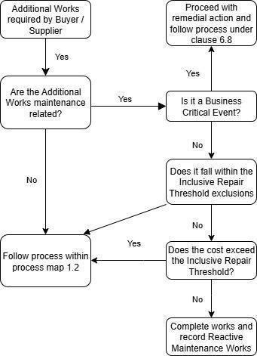

Process Map 1.2 - Issuing Quotation Process
[Buyer guidance: The Buyer should insert further detail or utilise their own process map here to reflect their requirements, if no further details are required by the Buyer, please remove the square brackets and yellow highlight]
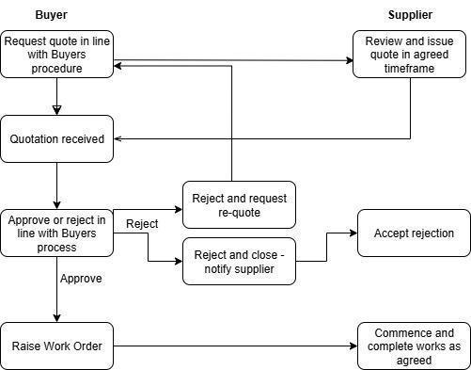

Process Map 1.3 - Buyers Approval Process
[Buyer guidance: The Buyer should insert further detail or utilise their own process map here to reflect their requirements, if no further details are required by the Buyer, please remove the square brackets and yellow highlight]
[Tier | Estimated total value range | Process
Tier One Additional Works | £1001 - £5000 | The Supplier shall provide an estimate of costs in accordance with the rates set out in Call-Off Schedule 5 (Pricing Details) or other schedule of rates as requested by the Buyer at Call-Off.  or  Where instructed by the Buyer, the Supplier shall provide at least one written quotation.
Tier Two Additional Works | £5001 - £10,000 | Where instructed by the Buyer, the Supplier shall obtain at least three written quotations.
Tier Three Additional Works | £10,001 - £25,000 | The Supplier shall obtain at least three formal tenders under the defined procurement process as agreed between the Supplier and the Buyer from time to time.
Tier Four Additional Works | Above £25,000 | The Supplier shall obtain at least five formal tenders under the Supplier’s defined procurement process]

