RM6088

Construction Works and Associated Services

A Guide to Framework Strategic Alliancing


Contents

Foreword 3
Introduction 4
Collaborative Contracting 6
The Challenge – How to Best Deliver Value Solutions 8
The Solution - The CCS Option for strategic alliancing 11
CCS FAC-1 and supporting contract documents/options available 11
Learnings from Early Adopters 19
The Outcome Case Studies 21
Case Study 1 - Nightingale Hospitals (NHS Procurement Framework Procure 22 ) 21
Case Study 2 - Ministry of Justice New Prisons Programme (CCS Construction Works and Associated Services) 21
Case Study 3 - Dudley College Institute of Transformational Technologies (Integrated Project Insurance) 23
Case Study 4 - Defence Estate Optimisation (DEO) Portfolio - (CCS Construction Works and Associated Services 2) 24
Bibliography and Further Reading 26
Appendices 27

Foreword

This document has been developed by Crown Commercial Service (CCS), as a guide to support both our clients and suppliers when considering and developing a strategic alliance through our construction frameworks. It has been developed in conjunction with our Project Improvement Alliance Focus Group Suppliers and in particular Kier Construction, Seddon Construction, ISG and GRAHAM.

“It was an honour to contribute to the creation of this guide. As a family owned regional contractor Seddon is committed to a proactive approach to collaboration, evidenced in our 126 year history. Strategic alliancing, supported by the appropriate contractual arrangement, can provide real demonstrable benefits to all. I have learnt a lot in the production of the following guidance, and it is great to be able to share this more widely with the industry.” Katy Haris, Pre Construction Director, Seddon Construction.

“Collaboration is a cornerstone of project delivery, GRAHAM are committed to delivering projects for our clients in a collaborative manner. As such we are delighted to have contributed to this Guide to Framework Strategic Alliancing. Project Alliancing is already being used on schemes that we are delivering and provides demonstrable benefits to all parties. It has been good to collaborate with other CCS Alliance Members to develop this guide to assist others on the journey.”
Keith Hayes, National Framework Director, GRAHAM

“Kier is committed to delivering high quality projects in true collaboration with our clients and in alignment with our values of being trusted, focused and collaborative.
Kier has been a pioneer in modern forms of collaborative alliances on large, nationwide contracts where all partners are aligned through a shared vision and objectives.
Alliancing has been hugely beneficial to our work, supporting both project delivery and our ability to leave a positive legacy in the communities that we work in.
We were pleased to be able to support the Crown Commercial Services team and other CCS Alliance members to develop this guide, which will support all framework clients.”
Deane Hudson, Framework Director, Kier Construction

“It has been an immensely positive experience collaborating and actively contributing, alongside industry peers and CCS, on this Guide to Framework Strategic Alliancing. As an early adopter and major supporter of alliance forms of contract over a number of years now, our teams at ISG have extensive knowledge and expertise to share with the wider industry, to support and continuously improve on process and outcomes for this progressive procurement approach. One of our core values at ISG is ‘never stop learning’ so as our own knowledge evolves, we are keen to work with industry partners to unlock the wider benefits that strategic alliancing undoubtedly brings to the construction industry and beyond.”
Louise Daville, Director - Public Sector Strategy, ISG

Introduction

The construction industry is facing unprecedented challenges in the 21st century. The complexity and uncertainty of the global market, the increasing demands of clients and stakeholders, the rapid advancement of technology and innovation, and the growing environmental and social concerns require a new approach to project delivery.

Strategic alliances have developed out of the long-term growth in collaboration that started with the Latham and Egan reports. By working collaboratively through strategic alliances, the construction sector can achieve incremental improvements in all aspects of project delivery, including quality, efficiency, sustainability, client satisfaction, and productivity. These improvements can create significant value for the sector and enhance the competitiveness and resilience of the industry in a dynamic and uncertain market.

Strategic alliances are long-term partnerships that enable alignment of the interests and objectives of the client, contractors, consultants, suppliers, and other parties involved in a project. They foster a culture of trust, transparency, and mutual benefit, and encourage the sharing of knowledge, resources, and risks.

Strategic alliances have been used in the pharmaceutical and process industries for a long time and have been proven to deliver benefits for all involved. In recent times the Nightingale Hospitals were in effect delivered using an informal strategic alliance between the NHS, P22 PSCPs, their supply chains and designers. It is currently being used by within our CCS Construction Works Frameworks by the Ministry of Justice and the Defence Infrastructure Organisation to deliver major programmes of work across the UK as well National Highways own Smart Motorways Programme. It is also being used by other organisations in the wider Public Sector including Dudley College through the Integrated Project Insurance (IPI) model of delivery.

This guide has been developed in order to provide guidance and insight to clients and contractors in order to raise awareness of strategic alliances as a procurement model. It sets out the options available to procuring bodies to maximise outcomes and increase certainty of delivery through the adoption and creation of collaborative strategic alliances between clients and contractors within the suite of our construction frameworks. It is also designed to give an insight into the options available within the frameworks and to bring this to life through case study examples of strategic alliances in action.

Collaborative Contracting

Strategic alliances are a form of collaborative contracting where the contracting authority and often a group of contractors share the risks and rewards of a project.

Strategic alliance contracts rely on a high degree of cooperation, communication and coordination. It is therefore key to ensure that the procurement process uses appropriate measures and methodologies to select the right partners. This can include the use of behavioural assessments as part of the tender process to test the potential partner teams for the right culture and behaviours.

In 2018 the Defence Infrastructure Organisation (DIO) adopted the use of behavioural assessments when establishing the Clyde Commercial Framework. KPI’s were then established and scored each month with increases possible for overall collaborative behaviour.

The parties involved need to establish a strong governance structure, shared vision and values, a common language and culture and a transparent and timely information system. They also need to monitor and evaluate the performance of the strategic alliance, using appropriate indicators and feedback mechanisms. Using the right processes at the tender stage will ensure that all parties get the maximum benefit from the collaborative environment that is created.

One of the benefits of this approach is the ability to identify, assess, manage and deliver multiple drivers for value in capital construction projects. These drivers are the factors that influence the performance, quality and sustainability of the project outcomes. They can be internal or external, tangible or intangible, quantitative or qualitative, and they can vary depending on the context and objectives of each project.

Strategic alliances, particularly on multiple projects, can unlock value through a number of avenues. These include:

- Adoption of standardised procedures

- Fully integrated teams that put the project first

- Breaking down traditional barriers between client, consultants, tier 1 contractors and the supply chain

- The ability to adapt quickly to change as a result of the integrated approach

- Innovation through investment by the strategic alliance partners

- Sharing of risk and reward across the whole strategic alliance.

The Challenge – How to Deliver Value Solutions
Clients wanting to undertake construction projects are required to consider a wide range of policy and guidance requirements, in pursuit of best value for money.
Publications including updated Procurement Policy Notes, Construction Playbook Transforming Infrastructure Performance 2030 and ultimately the updated HMT Green Book, are asking clients to continuously consider how they will deliver not only to time and cost, but also value for money, in terms of well-defined, measurable broader societal gains and whole life project benefits – for now and future generations. (fig. 1)
Changes in the Procurement Bill from Most Economically Advantageous Tender (MEAT) to Most Advantageous Tender (MAT), which reinforces the ability to be able to take account of a much broader range of evaluation criteria, will hopefully drive focus on evaluating and delivering wider value through competitive tendering.
To deliver on expectations of value, clients are encouraged to engage early with stakeholders to their projects, including often, end-users, operators, and those in supply chains.
Of the 14 policies recommended in the Construction Playbook, early supply chain engagement, longer term contracting, and the use of an outcomes-based approach in delivery models, the common feature is the move to improve public projects and programmes and value for money, by setting the expectations at the start and establishing a platform for delivery right from the outset.
Strategic alliances are one of the proven methods that can meet the needs of these policies and drive better value.
Surrey Highways Alliance recorded 12% agreed savings by establishing an Alliance over a five-year period and the current Ministry of Justice (MoJ) ‘Alliance 4 New Prisons (A4NP)’, has secured approval for its first all-electric prison, designed through the Alliance which targets to reduce by 75% of the energy use of similar facilities, saving an estimated £1m a year in running costs.
By encouraging longer term collaboration between clients, professional advisors, and supply chains, through a strategic alliance arrangement, a formal or informal strategic alliance can assist in improving project outcomes by sharing resources, expertise, standardised designs, and specifications. These gains can be driven from long term strategic alliances through mutual agreement of outcomes and the ability to collaboratively leverage longer term pipelines with the supply chain.
In taking a systematic approach to project and programme delivery, organised within a procurement regulatory environment, teams within a strategic alliance benefit through shared learning from repeated projects, using evidence based best practice and project data. When this approach is incorporated into an aggregated and defined pipeline of work, specifications and design solutions can be optimised by the strategic alliance. The result is fewer errors, less duplication, with a corresponding improvement in certainty, productivity, and whole life project outcomes.
Constructing the Gold Standard references ‘agreed efficiency savings averaging 18.5% combined with design improvements, extended warranties, improved safety, new opportunities for local and regional SMEs, environmental benefits, improved employment and skills opportunities and improved whole life value’.
There are clear links between outcomes and benefits, the features of a successful strategic alliance and industry policies and publications that act as drivers for change.

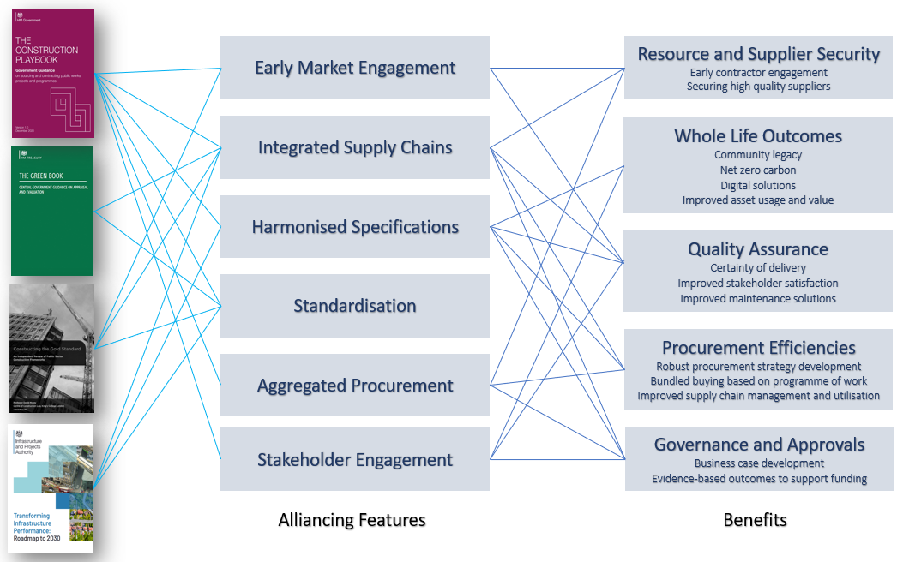
Fig 1. strategic alliancing: Policy, Standards and Guidance and their central themes:

The Solution - The CCS Option for strategic alliancing

CCS FAC-1 and supporting contract documents/options available
The legal landscape for setting up a strategic alliance within the public sector can be confusing. However, CCS have adopted a unique approach using the Framework Alliance Contract (FAC-1) that enables clients to set up strategic alliances as part of one or more construction commercial agreements through the CCS construction frameworks.

Core Characteristics of a strategic alliance
- They are typically based around long term relationships, which allow time to invest in the required goals and behaviours etc
- They focus on strategic goals, compared to a single project typically being focussed on the technical specification
- Normally, more can be achieved by aligning and working towards common goals - where “the whole is greater than the sum of the parts”
- Efficiencies and greater value are gained from the arrangement
- A strategic alliance normally requires a “critical mass” of activity if true value is to be generated.

How PCR compliant strategic alliances can be set up using CCS Construction Agreements
The relevant part of the CCS FAC-1 conditions is Schedule 5, which sets out the contracting arrangements that can be adopted when using our Frameworks. They are typically the standard suites of construction contracts issued such as JCT, SBCC, NEC, PPC2000 etc.

Schedule 5 gives a further alternative by the adoption of additional FAC-1 contract that can be used in conjunction with one of the standard forms to integrate or connect projects and parties “to increase the potential for consistency, efficiency, Improved Value and lessons learned”. The provision can be called on by either one client or by two or more clients joining together.

The contract sets out 4 specific situations where this can be done:
- Integrating or connecting a programme of work comprising more than one project, to be awarded to one or more suppliers (see Fig 3)
- Integrating or connecting the capital and operational phases of any one or more projects, to be awarded to one or more suppliers, for example as a whole life approach to procurement (see Fig 3)
- Integrating or connecting the BIM contributions of one or more suppliers and other team members in relation to any one or more projects, to be awarded to one or more suppliers
- Integrating or connecting the contributions of the supply chain members used by different suppliers on any projects or programmes of projects, to be awarded to one or more suppliers
Each of these four situations can involve one or more clients as well as typically one or more suppliers. This arrangement is enabled by the inter-relationship created by using an additional FAC-1, as well as the call off contract Strategic Alliance Templates.

To assist in establishing an effective strategic alliance CCS has developed a set of template agreements covering each of the strategic alliance scenarios that are facilitated under the framework agreements.

These are based on the FAC-1 contracts and therefore are fully compliant with the framework conditions. They are under licence from Association of Consultant Architects (ACA). So that the templates can be as clear and specific as possible all of the generic requirements related to the particular scenario are already completed.

Targeted guidance has been added to support clients in focusing on the specific requirements of their strategic alliance. CCS has also commissioned a simple template enabling clause that can be included in contracts to include suppliers that are not part of a CCS FAC-1 based framework agreement.
Recommendation 11 of the Constructing the Gold Standard also provides guidance on how Frameworks can provide for call-offs through a multi-party framework ‘sub- alliance contract’ referencing integration of framework projects, Tier 1 contractor collaboration, a timetable of strategic ESI, potential early collaborative appointments and using the strategic sub alliance as an integrator between the client, suppliers and supply chain members for the efficient use of BIM .

Combining Phased Award and Strategic Alliancing
To further support clients in setting up their strategic alliances through the CCS construction agreements it is possible to use the phased awarded mechanism in the FAC-1. The process allows clients to reduce the number of suppliers that they take through the procurement. This can be done more than once, with the aim of deriving a pool of the most capable or qualified suppliers for a particular project or programme of work (see Fig 3).

By combining the phased award and strategic alliance provisions a powerful procurement model can be developed to really drive value from multiple projects and suppliers.

Under the framework terms, all the suppliers allocated to the particular lot have to be given an initial opportunity to express an interest in a project or programme or, conversely, to declare themselves out of the competition.

The phased award process can then be used to obtain a pool of the most capable or qualified suppliers for the specific programme of work. The framework terms allow for the suppliers to work collaboratively with clients to develop out the programme detail in relation to a strategic alliance.

The client then undertakes their final procurements from this qualified pool of the most capable or qualified suppliers. The strategic alliance is created upon award of the first contract and all future awards under the programme of work include a requirement to also enter into the strategic alliance.

Fig 3: An example of using the phased award process to create a strategic alliance.
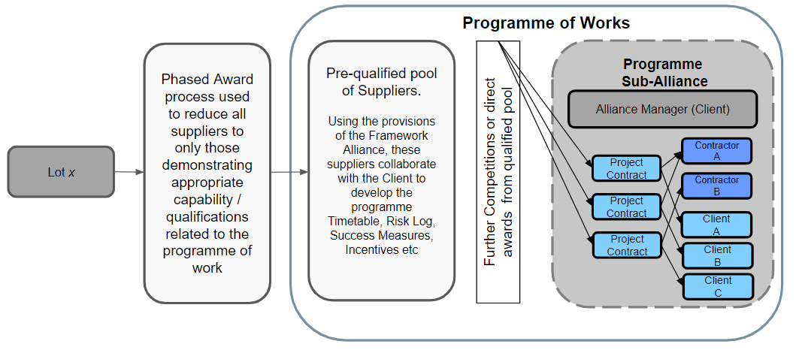

There are some important considerations to be made when adopting this model to ensure compliance with Procurement Legislation, so clients may wish to review the CCS bite-size guidance speak to the category team and seek their own legal advice if this would be of interest.

Types of strategic alliance
The most common use of strategic alliances are;
- Clients joining together to aggregate demand and generate efficiency through repetition
- Single client delivering a programme of related works
- Client and suppliers delivering a project or programme sharing an integrated supply chain
- Integrating project phases to take a life cycle approach
Fig 3: An example of the contracting arrangements for both a programme of related works (2) and life cycle (4) strategic alliance
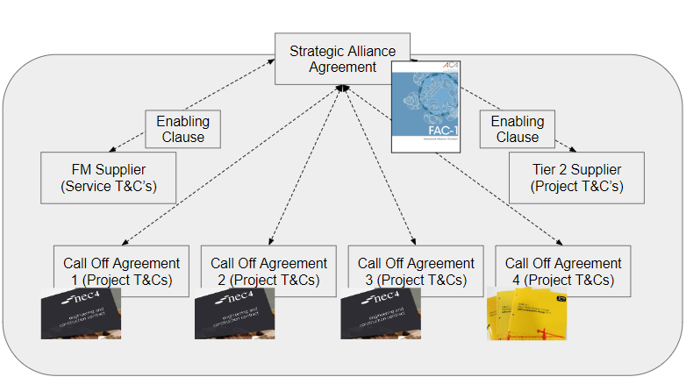

- Two or more clients join together to aggregate demand and generate efficiency through repetition
By integrating the team into a strategic alliance, pooling capability and knowledge and driving towards common goals with a longer term vision, this should lead to a significant increase in value for each of the clients.

- Single client delivering a programme of related works
This is where there is a single client, but they are carrying out a series of, possibly diverse, but related projects that together support the delivery of a strategic outcome. The client may appoint a single delivery team but have different suppliers and possibly use design and build to support the differing project types.

There may be real benefits in all parties working together as they will all have to utilise the same governance, approval and contract management & reporting processes, even though the actual works could be radically different.

By integrating the team into a strategic alliance and pooling capability and knowledge and driving towards common goals with a longer term vision, this should lead to a significant increase in value for the programme as a whole. This is the approach that the DIO has adopted to deliver their Defence Estate Optimisation programme.

- Single client delivering a programme of related works and securing the supply chain
This example builds on the one above, where there is a single client, carrying out a series of related projects that together support the delivery of a strategic outcome.

The important addition in this example is that the client has recognised a significant risk to delivery if they cannot secure the involvement and/or capacity of critical members of the supply chain.

This reflects the MoJ 4 prisons programme. A single delivery team has been appointed and 4 different suppliers are delivering 4 fundamentally identical prisons. The 4 suppliers have been brought together in a strategic alliance to provide early supplier input and support the development of the signature designs.

The 4 suppliers are also working together to develop a common supply chain and secure capacity and capability across the whole programme, rather than their individual projects. This will mitigate the significant risk identified by the contracting authority. Ultimately, key lower tier suppliers will also become strategic alliance members and work to the same collaborative behaviours and common goals.

Therefore as well as all parties working together utilising the same governance, approval and contract management & reporting processes, a fully collaborative approach is being taken to manage and mitigate delivery risks.

By integrating the team into a strategic alliance and pooling capability and knowledge and driving towards common goals with a longer term vision, this should lead to a significant increase in value / reduction in risk for the programme as a whole.

- Integrating project phases to take a life cycle approach
The final example is where there is a single client, and single project but the client wishes to integrate the various project phases to take a life cycle approach.

In this scenario, the various members of the delivery team: contracting authority; designers; contractor are brought together with the extended team which could include key tier 2 suppliers; FM providers and facility operators so that all of the main parties involved throughout the project's lifecycle are aligned to the strategic objectives of the project. This is similar to the Dudley College Case Study.

This approach allows true early involvement at all stages, for example to ensure that early design decisions don’t compromise the future operation and maintenance of the facility or even better that the design truly reflects the operational needs and provides best value.

The CCS framework has ready-made solutions to assist with the establishment of successful strategic alliances, working to drive the improved delivery of both strategic objectives and whole life project outcomes, aligned to industry policies through collaboration and the use of the FAC-1 agreement.

If you would like to find out more information about strategic alliances through CCS Construction Frameworks please contact us to speak to the team at info@crowncommercial.gov.uk.

Learnings from Early Adopters

There are a number of successful industry-leading examples of clients establishing strategic alliances to deliver real improvements to whole life outcomes. To support future strategic alliance development, CCS suppliers who have adopted a strategic alliance approach set out the key success factors and future for improvement suggestions from early adopters:

Key Success Factors:
- Bringing together comparable skill sets - underpinned by Construction Playbook principles, strategic alliances have actively enabled genuine collaboration between contractors and with their client. The benefits have seen the alignment of sector veterans with individuals entirely new to sectors – but with extensive knowledge of what works in comparable arenas.
- Creating a world-class model – strategic alliances allow for the pooling of resources, talent and knowledge, bringing the best attributes and characteristics of each organisation and blending them together for the purpose of creating a world-class model and methodology for delivering large scale social infrastructure.
- The gravitational pull of a strong team – the original pools of talent are expanded dramatically with a pull on an even more diverse range of skills, experience, knowledge and innovation into one place for a common goal.
- Effective working groups – the product of extensive collaboration can culminate in 100’s of big ideas. These ideas can review every aspect of the asset including design, delivery, longevity and future maintenance, usability and environmental performance of the accommodation, incorporating pre-fabrication, circular economy and embodied carbon principles, as well as social value enhancements. Colleagues from across strategic alliances are able to run the same exercise across every aspect of the design, delivery and performance of the new estate. The combined impact of this knowledge and expertise, channelled towards a common objective, can produce a raft of optioneering solutions for the contracting authority that would normally have taken decades to develop through a traditional, iterative design and development approach.
Future suggestions for improvement:
- Colocation of teams should always be considered first – This would have enhanced efficiency and aided quicker development of relationships in some of the examples cited.
- Use of a third party to evaluate quality of collaboration / behaviours – The introduction of a third party to review the relationship between strategic alliance members and measure meeting outcomes at key points in the process would have been beneficial. The suggestion is in addition to the role of the strategic alliance manager who primarily managed the process and not the collaboration process.
- Recognising the impact and importance of planning at the earliest point of the programme – The viability of sites on sizable schemes has led to challenges and delays on the overall major project programmes. A realism around the time taken through the appeals process on larger contentious projects needs to be factored as early in the process as possible.
- Adoption of ISO44001 – The investment in obtaining the Collaborative Business Relationship Management systems accreditation would have been a valuable addition across some of the examples cited. This would have incorporated a mechanism to measure organisational culture and behaviours within the strategic alliance. The investment would have allowed the team to understand the combined skill sets across the team within a common platform approach.

The Outcome Case Studies

Case Study 1 - Nightingale Hospitals (NHS Procurement Framework Procure 22 )

Whilst not considered a true strategic alliance model, ProCure22, a framework for procuring construction services for NHS and social-care projects in England, has seen benefits such as speed, cost certainty and quality to the clients and their supply chains.

Most recently during the challenges of the pandemic, the six appointed contractors worked with the Department of Health, the military and their supply chain to deliver the Nightingale Hospitals programme.

During this fast-paced project the contractor teams worked collaboratively, often blending together to ensure the best outcome, converting existing venues such as exhibition centres, conference halls and sports stadiums into fully functioning hospitals within weeks.

NHS Nightingale Hospitals through the P22 Framework

Case Study 2 - Ministry of Justice New Prisons Programme (CCS Construction Works and Associated Services)
An example, and perhaps one of the most widely publicised success stories of strategic alliance contracting is the alliance that the Ministry of Justice (MoJ) created to deliver the £1bn new prisons programme, delivering 6,500 additional prison places as part of its wider growth strategy following the 2021 Spending Review.

The Construction Playbook Guidance note on ‘Market, Supplier and Supply Chain Engagement in Construction’ sets out how the alliance model was beneficial to the Ministry of Justice “due to the scale and complexity of the project as well as the need for consistency in standard prison design. Beyond the cost benefits of the singular tender exercise, the alliance approach aimed to drive benefits of collective buying power, sharing of good practice, and procurement efficiencies.”

It also set out that “Crown Commercial Service adopted an innovative alliance approach on the Construction Works and Associated Services framework due to its benefits in promoting collaboration between Clients, Suppliers and Framework Managers. It encouraged use of innovative contract arrangements to procure projects or programmes of work as a strategic alliance. This approach increased consistency, efficiency, and improved value and performance. The Construction Category team provided input and support through the strategy and development phases of creating the alliance”.

“The experience has been revelatory to everyone I speak with - and importantly that pool of talent has expanded dramatically with a gravitational effect that pulls an even more diverse range of skills, experience, knowledge and innovation into one place for a common goal.

Trust and confidence levels are off the scale, and one simple way of characterising the mindset change is the number of strategic alliance colleagues that now work from their former rivals' offices to streamline efficiencies and enhance collaboration.” Craig Battye, ISG

Market, Supplier & Supply Chain Engagement in Construction (MoJ Case Study 1)
CCS Knowledge Hub:Wates 4 Prisons Case Study

Case Study 3 - Dudley College Institute of Transformational Technologies (Integrated Project Insurance)

Another example is provided by Dudley College where the integrated project insurance model (IPI) has been successfully employed in the recent procurement of their Institute of Transformational Technologies building worth £23.1m. This was the second IPI project delivered for Dudley College and the third IPI project to have utilised a number of the same partners, albeit individually secured for each project. The total value of the project was £51.8m.

IPI involves a collaborative working contract that sees all members of the integrated project team selected at the project’s inception to form an interdisciplinary ‘strategic alliance board’ that are insured together under a single loss-based insurance product. The model supports innovation by binding the team around cost, time and quality. The idea is that it promotes a culture of mutual trust, no blame/no claim and decisions being made on the basis of what is best for the project and client in the short, medium and longer term.

“IPI has transformed the College’s experience with the construction industry, and we commend it to DfE and other departments that spend public money.”
Executive Director of Estates and Capital Projects, Dudley College
Integrated Project Insurance Case Study – Dudley College IOTT – Constructing Excellence
IPI Initiatives:Turning the Construction Playbook into Oven Ready Reality

Case Study 4 – Defence Estate Optimisation (DEO) Portfolio – (CCS Construction Works and Associated Services 2)
The Defence Infrastructure Organisation (DIO), which is master planning the 10-year Defence Estate Optimisation (DEO) Portfolio capital investment for the Ministry of Defence (MoD), is the latest public sector organisation to adopt strategic alliances for major infrastructure project delivery. The strategic alliance model, where ordinarily competitive organisations pool their collective resources and expertise and work together, is rooted in smart collaboration, transparency and shared learning. Under this procurement approach, innovation and creativity are incentivised as contractors optimise efficiencies at every stage of the construction process. A significant focus is placed on maximising social value outcomes from the capital investment programme by prioritising localised procurement, and through community impact initiatives.

In May 2023 seven construction companies were appointed to the DEO’s £5.1bn investment portfolio focused on “delivering a better-structured, modern and more sustainable estate that more effectively supports military capability and aims to enhance the lived experience of our military personnel.

“The strategic alliance contract for the Defence Estate Optimisation Portfolio will allow us to capitalise on the wealth of knowledge within the construction industry and harness that expertise in a way we’ve not previously done.

“The contract will ensure we can deliver the right buildings and infrastructure for Defence that will enable our military capability and create the right environment for our people to train, work and live in. We will be delivering at pace and start to see the benefits straight away within projects being mobilised this year.”

DEO is a £5.1bn investment portfolio focused on “delivering a better-structured, modern and more sustainable estate that more effectively supports military capability and aims to enhance the lived experience of our military personnel”.
Director of MoD Infrastructure - Sherin Aminossehe

Bibliography and Further Reading
- CCS Bitesize Webinar or Strategic Alliancing

- Construction Playbook

- Constructing the Gold Standard: An Independent Review of Public Sector Construction Frameworks

- Transforming Infrastructure Performance
- The Green Book

- PPN06/20 Taking Account of Social Value

- PPN06/21 Taking account of Carbon

- Construction Sector Deal

- Market, Supplier & Supply Chain Engagement in Construction Guidance Note (contains Ministry of Justice - New Prisons Programme Case Study)

- Press Release – New Prisons Name Revealed

- Project Procurement and Delivery Guidance, Using Two Stage Open Book and Supply Chain Collaboration

- Improving Infrastructure Delivery: Alliancing Code of Practice

- Constructing Excellence Collaborative Alliancing:the Modern Way of Working Collaboratively

- Integrated Project Insurance guidance

Appendices

What is a strategic alliance?

According to A Guide to Contract Alliancing in Construction by CMS Law and Arcadis;

“There is no fixed definition of either collaborative contracting or strategic alliance. Thus, the strategic alliance “concept” encompasses a range of contract models representing varying levels of collaboration and risk sharing, from basic commitments for the parties to partner through to fully integrated “pure” strategic alliance models.”

"In broad terms, and in the context of construction and engineering projects, a strategic alliance is an agreement providing that the parties to it will act in a certain way to achieve a common goal.”

In comparison to the Framework being characterised by terms and conditions and processes dictating how that transactional activity takes place an strategic alliance is very much more about establishing common goals and setting out how various parties will collaborate and what behaviours they will adopt when they interact with each other.

There are a number of standard contracts which are based on strategic alliance principles and they are typically available when calling off from the CCS Construction Frameworks. For example:

  - PPC2000
  - JCT Constructing Excellence and
  - NEC’s strategic alliance Contract

All of these are characterised by being multi-party contracts that set out to drive those collaborative behaviours to achieve common goals.

What is a Framework Strategic Alliance Contract?
A Framework Strategic Alliance Contract takes the terms and conditions and processes dictating how the transactional activity of the Framework Agreement takes place and sets those in the collaborative environment created by a strategic alliance contract. The contract that CCS uses as a basis for all of their construction frameworks is called FAC-1 (Framework strategic alliance Contract).

What is FAC-1?
This is a standard contract, which has been published by the Association of Consultant Architects (ACA) since 2016. It was based on an analysis of successful framework contracts, including those used by the Ministry of Justice (MoJ) and Housing Associations and sets out a template for good practice when establishing a strategic alliance based Framework.

CCS adopted FAC-1 as it was felt that a collaborative strategic alliance based structure was the only way that we would be able to drive policy and industry improvement in delivering things such as the Construction Sector Deal and more recently the Construction Playbook.

FAC-1 is designed in such a way that any standard form construction contract can be used for call offs, so it allows us to create flexible agreements that match the diverse needs of our contracting authorities.

CCS construction agreements are based on a flexible contract that combines the features of a framework agreement and a strategic alliance contract and this allows CCS to manage our frameworks in a collaborative manner with our contracting authorities and suppliers to get the best results from the framework for government and the Wider Public Sector.

Constructing Excellence. Constructing the Team Sir Michael Latham (1994) https://constructingexcellence.org.uk/wp-content/uploads/2014/10/Constructing-the-team-The-Latham-Report.pdf
Constructing Excellence. Rethinking Construction - The Egan Report https://constructingexcellence.org.uk/wp-content/uploads/2014/10/rethinking_construction_report.pdf
Smart Motorways Alliance Descriptive document https://assets.highwaysengland.co.uk/specialist-information/smart+motorway+alliance/SMA+Descriptive+Document.pdf
HMNB Clyde Framework: The fun way to select your future partners https://insidedio.blog.gov.uk/2018/05/21/hmnb-clyde-framework-the-fun-way-to-select-your-future-partners/
Procurement Policy Notes https://www.gov.uk/government/collections/procurement-policy-notes
The Construction Playbook https://www.gov.uk/government/publications/the-construction-playbook
Transforming Infrastructure Performance 2030 https://www.gov.uk/government/publications/transforming-infrastructure-performance-roadmap-to-2030
The Green Book (2022) https://www.gov.uk/government/publications/the-green-book-appraisal-and-evaluation-in-central-government/the-green-book-2020
Constructing Excellence Project Horizon: https://constructingexcellence.org.uk/wp-content/uploads/2020/10/Project-Horizon_v.3.pdf
Annex 3 case studies 2, 8 and 9, Constructing the Gold Standard: An Independent Review of Public Sector Construction Frameworks https://assets.publishing.service.gov.uk/media/61b9cb41e90e07043e8ff5cc/Constructing_The_Gold_Standard_Final.pdf
https://allianceforms.co.uk/about-fac-1/
Copies of the relevant CCS FAC-1 conditions can be obtained from our website https://www.crowncommercial.gov.uk/agreements/category/construction?statuses=
These are available to our Alliance Members on request. If you are interested please speak to a member of our team. Contact info@crowncommercial.gov.uk for more information
Association of British Architects: https://acarchitects.co.uk/
This is available to our Alliance Members on request. If you are interested please speak to a member of our team. Contact info@crowncommercial.gov.uk for more information
Constructing the Gold Standard: An Independent Review of Public Sector Construction Frameworks https://assets.publishing.service.gov.uk/media/61b9cb41e90e07043e8ff5cc/Constructing_The_Gold_Standard_Final.pdf
If you are interested please speak to a member of our team. Contact info@crowncommercial.gov.uk for more information
Building.co.uk: 126 reasons why we should get excited about alliancing: https://www.building.co.uk/comment/126-reasons-why-we-should-get-excited-about-alliancing/5120005.article
Guide to Contract Alliancing in Construction December 2019 by Arcadis and CMS Law https://cms.law/en/media/international/files/publications/guides/cms-guide-to-contract-alliancing-in-construction#:~:text=An%20alliance%20contract%20seeks%20to,interest%20between%20clients%20and%20contractors.
https://allianceforms.co.uk/about-fac-1/
Construction Sector Deal 22 July 2019 https://www.gov.uk/government/publications/construction-sector-deal/construction-sector-deal
Construction Playbook 11 July 23 https://www.gov.uk/government/publications/the-construction-playbook
ISO 44001 Collaborative Business Relationship Management https://www.bsigroup.com/globalassets/localfiles/en-gb/iso-44001/resources/iso-44001-implementation-guide.pdf
Information on Integrated Project Insurance; https://www.gov.uk/government/publications/integrated-project-insurance
The Integrated Project Insurance can be used under the CCS Construction Frameworks and is covered in Schedule 5 of the FAC-1.
Section 6.6 Early supply chain involvement - Delivery model development: Early Supply Chain Involvement Guidance Note
Gov. uk Press Release: Construction starts on UK’s first all-electric prison

